新北市立土城國民中學109學年度第一學期 第一次段考 英語科（八年級）P1

●聽力測驗 ( 1-20題) 20%(每題1分)
( 本試題 共3頁 )
一、請選出聽到的單字。
1. (A) goes (B) girls (C) ghosts
2. (A) broke (B) built (C) brought
3. (A) paper (B) pair (C) power
4. (A) easy (B) busy (C) candy
5. (A) trouble (B) table (C) terrible
二、根據聽到的內容，選出正確的圖片代碼。
6.
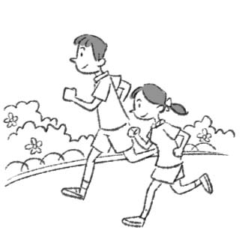  (A) | 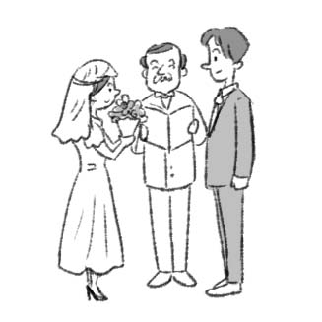  (B)  ) | 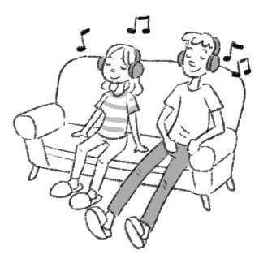  (C)  )
7.
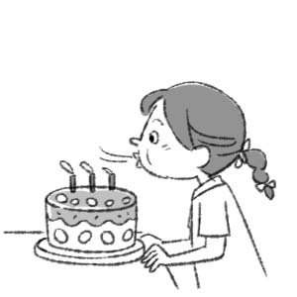  (A) |   (B)  ) | 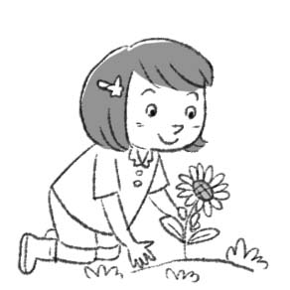  (C)  )
8.
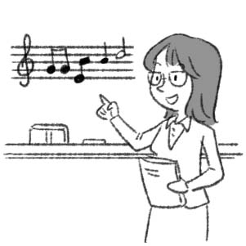  (A) | 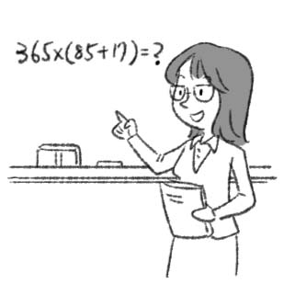  (B)  ) | 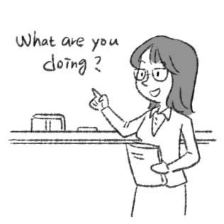  (C)  )
9.
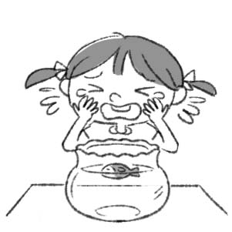  (A) | 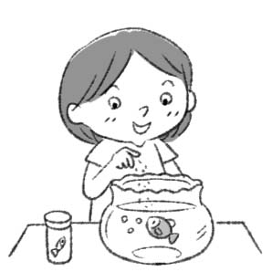  (B)  ) | 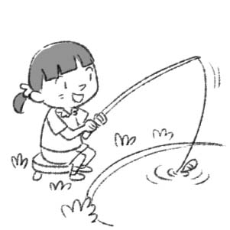  (C)  )
10.
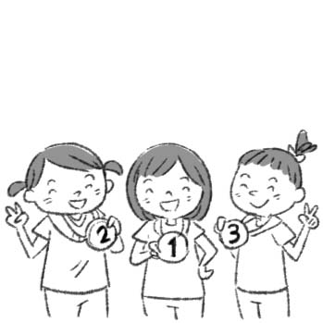  (A) | 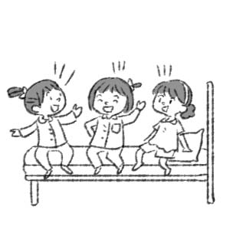  (B)  ) | 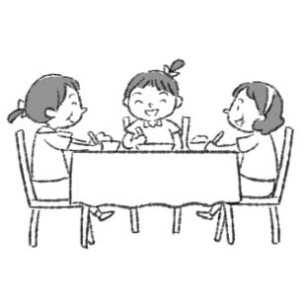  (C)  )

三、根據聽到的內容，選出合適的回應。
11. (A) The movie is great.
(B) It reminded me of my grandmother.
(C) I watched it a few days ago.
12. (A) He did well yesterday.
(B) Are you Okay?
(C) Oh no, that’s terrible.
13. (A) Yes, I did.
(B) Yes, the bread is delicious.
(C) No, we don’t have milk.
14. (A) Dad went to see a doctor last Wednesday.
(B) My dad finally sold the house.
(C) Really? Let’s buy a pair of shoes for dad.
15. (A) It was busy. There were so many classes today.
(B) No, I didn’t go to school today.
(C) I am fine.
四、請根據聽到的對話與問題，選出正確的答案。
(16.~18.請聽完對話再回答問題；19.~20.請直接回應問題)
16. (A) They are the wrong colors.
(B) They aren’t long enough.
(C) They are really expensive.
17. (A) Interesting(有趣的) songs.
(B) Her own books.
(C) Great news on TV.
18. (A) A cook.
(B) A driver.
(C) A nurse.
19. (A) It’s still my favorite holiday.
(B) Oh? Is six weeks too long?
(C) OK. How about Japan?
20. (A) Both of my parents are Chinese.
(B) I am almost six feet, one inch tall.
(C) It’s May 1, 1984.
●綜合測驗 80%
一 、語法選擇 36% (每題2分)
21. _____ you at school five hours ago?
(A) Is (B) Are (C) Was (D) Were
22. We didn’t ______ tombs last year.
(A) swept (B) sweep (C) wash (D) washed
23. ______ there two hundred students in your school ten years ago?
(A) Was (B) Didn’t (C) Were (D) Did
24. Lucy: ______ did you do last Saturday?
Ella: I visited my uncle in Tainan.
(A) What day (B) What (C) Who (D) How
25. Jason ______ his bike to school every day, but this morning he ______ to school.
(A) rides；walked (B) rode；didn’t ride
(C) rode；walked (D) ride；walked
26. The boy was hungry, _____ he _____ four pieces of pizza.
(A) because；eats (B) because；ate
(C) so；ate (D) so；eats
27. Robert: How do people in Mexico celebrate the Day of the Dead?
Willy: They celebrate it ____ a lively way.
(A) with (B) from (C) in (D) of
28. Ally: ____ did Peter go to cram school(補習班)?
Judy: He went there _____ he didn’t get good grades.(分數)

(背面尚有試題)
(A) Why；because (B) Where；and
(C) Why；but (D) When；so
29. Peter: Did you buy the dress?
Alice: No, but__________________.
(A) I bought a pair of shoes (B) I bought a pair
(C) I was still reading it (D) I didn’t buy the dress
30. Andy: ________ you walk to school yesterday?
Bella: Yes, I ________.
(A) Do; did (B) Did; walked (C) Did; walk (D) Did; did
31. Zac broke his arm, he went to the doctor.
(A) So (B) But (C) Because (D) And
32. Rick: Why didn’t you go to the party last Saturday?
Ben: because I was busy at work.
(A) She invited me (B) I didn’t go to the party
(C) I was late for the party (D) I went to the party
33. In Taiwan, people ______ 18 can’t ride a motorcycle.
(A) at (B) over (C) with (D) under
34. Zac: What do people do in Taiwan on Tomb Sweeping Day?
Meg: ______________________________
(A) They burn paper money. (B) They celebrate it with joy.
(C) They clean their houses. (D) They eat sweet candy.
35. Lisa: When did Julia have her first baby?
Marge: ________________________
(A) Because she loved them. (B) At the age of 24.
(C) I didn’t have a choice. (D) With her family.
36. Look! ________ people are singing and dancing in a circle.
(A) Two thousand of (B) Two thousands
(C) Thousands of (D) Thousands
37. Aaron: ____________________________
Milly: Yes, I was.
(A) Are you in the team?
(B) Were you at the bookstore then?
(C) Where were you two hours ago?
(D) Were you and Charles in the same class before?
38. Ted: How was your winter vacation?
Tim: ______________ I stayed at home and studied for my tests every day.
(A) What about you? (B) Sure.
(C) Not so good. (D) It was my favorite.
二、 克漏字選擇 7% (每題1分)
(Harry, Luke, and Simon are on their way to school.)
Harry: I called you many times last Saturday, but you 39. home. Where 40. you go?
Simon: Luke and I helped an old man, Mr. Smith. He’s 92 years old. He lives alone in a big house.
Harry: Really? What did you do?
Simon: I cooked 41. for him.
Luke: Mr. Smith has a parrot(鸚鵡). I 42. its cage(籠子). It’s really noisy. It can speak some Chinese.
Harry: I see. Please take me with you next time.
Simon: OK. You can help him wash the dishes and sweep the floor.
Harry: Can I just teach the parrot some English?
Simon: All right. Can you bring some bird food for it?
Harry: No problem.
P2
39. (A) weren’t (B) wasn’t (C) aren’t (D) didn’t
40. (A) were (B) are (C) do (D) did
41. (A) music (B) dinner (C) candy (D) circles
42. (A) clean (B) cleans (C) cleaned (D) cleaning
(Mr. Su was Tina’s teacher before. She met him on the street.)
Mr. Su: Why are you crying, Tina?
Tina: My husband just hit me. I couldn’t stand him anymore. That’s why I ran out of the house.
Mr. Su: What 43. to you after you left school?
Tina: I got married at the age of twelve because
44. . He was so poor that he needed it to buy
food.
Mr. Su: What a poor girl!
Tina: My husband often hit me 45. any reason. I was very scared and couldn’t sleep at night. I don’t want to live with him anymore.
Mr. Su: Calm down. Let me find a way to help you.
Tina: Thank you very much.
left 離開 so… that…如此…以致於…
reason 理由 calm down 冷靜
43. (A) happen (B) happened (C) happening (D) happens
44. (A) I didn’t want to go to school
(B) my father needed money
(C) my father wanted to have a daughter
(D) I needed love
45. (A) without (B) with (C) before (D) after
三、閱讀測驗 12 % (每題2分)
Tony and his classmates played basketball in the playground during the PE class this afternoon. After the PE class, Tony went back to his classroom and didn’t find his wallet in the desk. Someone stole his wallet! Tony felt angry and told it to his teacher, Miss Chen.
Miss Chen talked to the whole class. She said, “Stealing isn’t right. If you do it, please return Tony’s wallet to him privately. I won’t punish you. Everybody makes mistakes. I hope you won’t do that again.”
However, no one returned Tony’s wallet to him. Luckily, Miss Chen found a trash bag outside of the classroom and inside was Tony’s wallet! Tony was very happy to get his wallet back and thanked Miss Chen for her help. He also learned a lesson: Never leave your valuable things behind you.
wallet 皮夾 steal/stole 偷 feel/felt 感到 return 歸還 privately 私下地 won’t 將不會 punish 處罰mistake 錯誤 leave 留下 valuable 值錢的

(背面尚有試題)

46. What does “it” mean in the reading?
(A) Tony felt angry.
(B) Tony put his wallet in the desk.
(C) Someone put Tony’s wallet in a trash bag.
(D) Someone stole Tony’s wallet.
47. Who took Tony’s wallet?
(A) We don’t know. (B) Tony’s classmate.
(C) Tony’s friend. (D) Miss Chen.
48. What is true about the reading?
(A) Tony’s best friend stole his wallet.
(B) Tom put his wallet in the trash bag.
(C) Tony’s teacher found Tony’s wallet.
(D) Tony didn’t find his wallet at last.
Alice runs a bookstore, and her husband, Bill, is an English teacher. They both enjoy nature. They are busy, so they seldom have time to take a trip. Luckily, this summer, they did. They went to Kenting together and stayed there for three days. On the first day, they visited Kenting National Park. They hiked in the forest and saw some beautiful flowers and birds. That night, they camped at the beach. They chatted all night under the moonlight. The next day, they went to the National Museum of Marine Biology and Aquarium. They saw many sea animals there for the first time. The last day, they went for a bike ride. They also had lots of pictures. Alice made some handmade cards for her family and friends at a local store. In the evening, they enjoyed a big dinner at a famous seafood restaurant. After dinner, they went back home by train. It was a wonderful trip, and they had great fun.
run 經營 both都 nature大自然 hike 健行moonlight月光
marine 海的 biology 生物 aquarium 水族館
handmade 手工的 local 當地的
49. Why do Alice and Bill seldom take a trip?
(A) They don’t live together.
(B) They can’t get together.
(C) They don’t see each other very often.
(D) They are busy.
50. Which activity did they NOT do together during the trip?
(A) Going shopping. (B) Going bike riding.
(C) Eating seafood. (D) Camping at the beach.
51. Which is true?
(A) They never saw sea animals in this trip.
(B) They had many pictures during this trip.
(C) They drove a car back home.
(D) They went to Kenting in November.
四、 非選擇題 25%
( 請將答案寫在右方答案卷內 ，違者不予計分)
(一) 單字 (中翻英) 5%
1. 早餐(n.) 2. 猜；猜測(v.) 3. 分享(v.)
4. 親戚(n.) 5. 好奇的(adj.)
(二) 詞類變化 (寫出下列動詞的過去式) 5%
1. plan 2. take 3. carry 4. play 5. write
(三) 翻譯填充 6%
1. 之前總是我的爺爺在照顧著我，但他去年過世了。
My grandfather looked (1) me all the time, but he
(2) away last year.

2. 她的父親把她賣給了那位老人，因為她們家很窮。 P3
Her father (3) her to the old man because her family was very (4) .
3. 我們彩繪了自己的臉並盛裝打扮。
We (5) our faces and dressed up (6) costumes.
(四)、整句式翻譯 9%
1. 我上星期讀了一本特別的書。
2. 她再也不能去上學了。(使用過去式)
3. 兩個月前，我拜訪了我的朋友羅莎(Rosa)。 (Two……)

(試題結束，請確實將非選擇題答案寫在下方欄位中)

土城國中109上一段八年級英文非選擇題答案卷

班級:______ 座號: ______ 姓名: __________

(一)、單字 5% (每題1分)
1.早餐(n.) |  | 2. 猜；猜測(v.)
3. 分享(v.) |  | 4. 親戚 (n.)
5. 好奇的(adj.)
(二)、詞類變化(寫出下列動詞的過去式) 5% (每題1分)
1. |  | 2.
3. |  | 4.
5.

(三)、翻譯填充 6% (每格1分)
1. | (1) | (2)
2. | (3) | (4)
3. | (5) | (6)

(四)、整句式翻譯 9% (每題3分，分段給分)
1.
2.
3.
(試題結束)

109學年八上一段英文解答 (正卷)

●選擇題：75%
1 | 2 | 3 | 4 | 5 | 6 | 7 | 8 | 9 | 10
C | A | B | B | C | B | C | B | A | A
11 | 12 | 13 | 14 | 15 | 16 | 17 | 18 | 19 | 20
B | C | A | C | A | B | A | A | C | C
21 | 22 | 23 | 24 | 25 | 26 | 27 | 28 | 29 | 30
D | B | C | B | A | C | C | A | A | D
31 | 32 | 33 | 34 | 35 | 36 | 37 | 38 | 39 | 40
C | B | D | A | B | C | B | C | A | D
41 | 42 | 43 | 44 | 45 | 46 | 47 | 48 | 49 | 50
B | C | B | B | A | D | A | C | D | A
51 | 1.~20.每題1分 21.~38.每題2分  39.~45.每題1分 46.~51.每題2分
B
●非選擇題 25%
一、單字 5% (每題1分)
1. 早餐(n.) | breakfast
2. 猜；猜測(v.) | guess
3. 分享(v.) | share
4. 親戚(n.) | relative
5. 好奇的(adj.) | curious
二、詞類變化 寫出下列動詞的過去式) 5% (每題1分)
1. | planned
2. | took
3. | carried
4. | played
5. | wrote
三、翻譯填充 6 % (每格1分)
1. | (1) after | (2) passed
2. | (3) sold | (4) poor
3. | (5) painted | (6) in
四、整句式翻譯 9% (每題3分，分段給分)
1. I read / a special book / last week.
2. She could not / go to school / anymore.
3. Two months ago, / I visited / my friend, Rosa.

土城國中109上 第一次段考 八年級 英文試題聽力稿
一、請選出聽到的單字
1. People in Mexico invites ghosts back to world on the Day of the Dead.
2. The boy fell from the tree and broke his arm.
3. I need a new pair of shoes.
4. He was busy yesterday.
5. The food in that restaurant is terrible.
二、根據聽到的內容，選出正確的圖片代碼
6. The young girl got married to a tall man.
7. Judie planted flowers yesterday.
8. Ms. Lin is a math teacher.
9. Jennifer was sad about the death of her fish.
10. They were happy last night because they won the game.
三、根據聽到的內容，選出合適的回應
11. Why did you cry during the movie?
12. Jerry broke his leg last week.
13. Did you have breakfast this morning?
14. Father’s Day is next Wednesday.
15. How was school today?
四、請根據聽到的對話與問題，選出正確的答案
16. M: Are these blue pants too short for you?
W: Yes. I like these blue pants. But I can’t wear them.
Q: What is the problem with the blue pants?
17. M: What are you listening to?
W: Some music by my favorite band. They’re great!
Q: What is the woman probably enjoying?
18. W: What do you do all day long at the restaurant?
M: I make hamburgers and steaks. Everyone likes them.
Q: Who is the woman talking to?
19. Let’s choose an interesting country to visit this year.
20. Can you please tell me your date of birth?

