新北市立土城國民中學110學年度第一學期 第一次段考 英語科（八年級）P1

●聽力測驗 ( 1-20題) 20%(每題1分) ( 本試題 共3頁 )
一、請選出聽到的單字
1. (A) rains (B) winds (C) clouds
2. (A) smart (B) summer (C) spring
3. (A) wrong (B) right (C) ring
4. (A) science (B) history (C) Chinese
5. (A) fly (B) fun (C) free
二、根據聽到的內容，選出正確的圖片代碼
6.
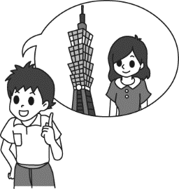  (A) | 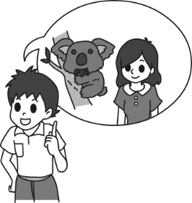  (B)  ) | 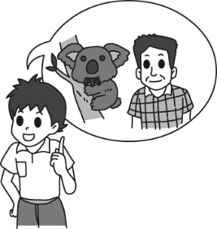  (C)  )
7.
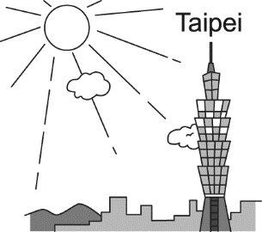  (A) | 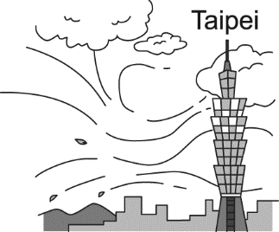  (B)  ) | 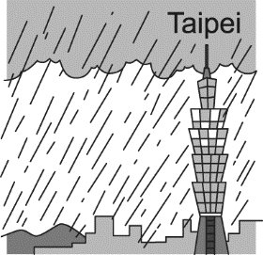  (C)  )
8.
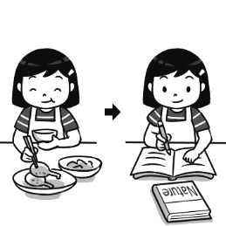  (A) | 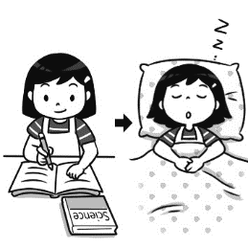  (B)  ) | 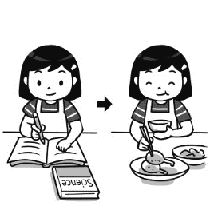  (C)  )
9.
  (A) | 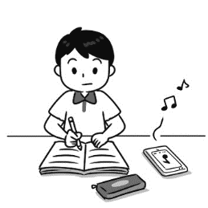  (B)  ) | 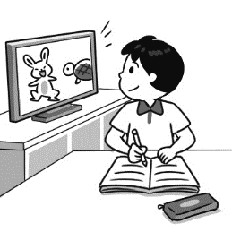  (C)  )
10.
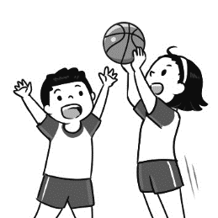  (A) | 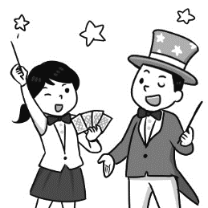  (B)  ) | 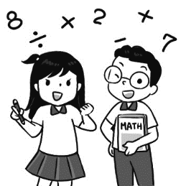  (C)  )

三、根據聽到的內容，選出合適的回應
11. (A) Yes, I did. I bought a new book for him.
(B) No, I bought a nice jacket for her.
(C) No, we are doing the homework together.
12. (A) Yes, it rains a lot in Taiwan.
(B) We will make some snowmen together.
(C) Yes, but most of time we have snow on the mountains.

13. (A) I don’t do anything before dinner.
(B) I usually take a walk with my dog.
(C) I enjoy the dinner very much.
14. (A) She is late for school because she gets up late.
(B) She always gets up at seven.
(C) She always makes the bed after she gets up.
15. (A) She brushes her teeth.
(B) She went to bed early.
(C) She doesn’t watch any movies.
四、請根據聽到的對話與問題，選出正確的答案
(16.~18.請聽完小短文再回答問題；19.~20.請聽完直接回應問題)
16. (A) Kids and pets in Taiwan.
(B) A practice Taiwanese people do with machines.
(C) The ways to keep machines clean.
17. (A) Put bags of a local snack on them.
(B) Paint the machines green.
(C) Say “guai guai” to them every day.
18. (A) Keep offices safer and cleaner.
(B) Make people do their jobs better and faster.
(C) Stop machines from having problems.
19. (A) He isn’t happy about his pencil box.
(B) He is fine without an eraser.
(C) He worries about his notebook.
20. (A) The sugar is too heavy.
(B) The shelf is too tall.
(C) He will help the woman.
●綜合測驗 80%
一 、語法選擇 36% (每題2分)
21. ______ the weather like in Japan last winter?
(A) How is (B) What is (C) How was (D) What was
22. Jim: I don’t like my toys, do you like ______?
Bill: Yes, I do.
(A) ours (B) our (C) yours (D) your
23. How great! We can sing and dance ______ free.
(A) for (B) on (C) in (D) of
24. Mr. and Mrs. Jackson did not know much about Taiwan when they ______ to the island.
(A) get (B) got (C) are getting (D) gets
25. Get everything ready for the picnic ______ we go to the park.
(A) when (B) because (C) before (D) after
26. ________ a lot here in January?
(A) Is it snowy (B) Does it snow
(C) Do you have snow (D) Is there snow
27. Mom, be sure to _____ me _____ at seven tomorrow.
(A) look ; for (B) wake ; up
(C) listen ; to (D) hold ; on
28. _______ his face, he went to bed.
(A) When he’s washing (B) Before he washes
(C) Because he washed (D) After he washed
(背面尚有試題)
29. Who ______ this to you?
(A) made (B) bought (C) gave (D) show
30. Can you give ______ some books, please?
(A) me (B) with me (C) for me (D) to me
31. Lucy: _____________
Leo: It’s windy, and sometimes it rains.
(A) What do you do on windy days?(B) What do you do in fall?
(C) What’s fall like in Taiwan? (D) We have a lot of rain.
32. A: _________ B: Sorry. You have the wrong number.
(A) Hello. How can I help you? (B) Can I talk to Ben?
(C) Hi, nice to talk to you again. (D) May I speak to you?
33. Bill: Is this _____ pencil? Judy: No, it’s _______.
(A) her ; his (B) your ; your (C) your ; my (D) his ; her
34. Lily made ________ on Mother’s Day.
(A) her mother a card (B) her mother for a card
(C) a card her mother (D) a card to her mother
35. The weather is going to be really _______, so I don’t think you should take a heavy coat with you on your trip.
(A) cool and wet (B) clear but windy
(C) cold but dry (D) hot and sunny
36. A: Hello. Can I talk to Jackson Lin? B:_______________
A: Hi, Jackson Lin. This is Lucy from Flower School.
(A) Where are you from? (B) Who are you?
(C) Speaking. (D) Yes, I’m Jackson’s sister.
37. It isn’t cold in January in Australia. ________, it’s summer there in January.
(A) First (B) Once (C) Another time (D) In fact
38. A: Look. Here’s an old picture of me. B:_____________
(A) How are you doing? (B) How old are you?
(C) Wow! You were in a green jacket. (D) See you soon.

二、 克漏字選擇 7% (每題1分)
(In the classroom)
Teacher : Jenny, are those notebooks yours?
Jenny: No, they are Amy’s. 39. are on the desk.
Teacher: 40. bag is it on the desk?
Jenny: It’s Penny’s.
Teacher: Where are Tom’s and John’s bags?
Jenny: 41. are under the desk.
39. (A) Her (B) My (C) Mine (D) Hers
40. (A) What (B) Whose (C) Where (D) Which
41. (A) Theirs (B) Their (C) Your (D) Yours

A long time ago, there was a girl. She lived in a beautiful house and never went out. When she 42. up, it was already eleven thirty. She would have a sandwich and a glass of milk after 43. her teeth and 43. her face. Then, she watched TV for two hours 44. she took a rest in the afternoon. 45. she woke up in the evening, her servant was cooking dinner for her. She would enjoy the meal before going to bed early.
servant 僕人
42. (A) is getting (B) was getting (C) gets (D) got
43. (A) brush ; wash (B) brushing ; washing
(C) brushed ; washed (D) to brush ; to wash

P2
44. (A) after (B) when (C) before (D) because
45. (A) When (B) Because (C) Before (D) After

三、閱讀測驗 12 % (每題2分)
This table tells us about the climates of four places.
City  Month | Potato | Lemon | Guava | Apple
December to February | 3°C  dry | -10°C  wet | 24°C  wet | 28°C  dry
March to  May | 20°C  wet | 12°C  dry | 18°C  wet | 24°C  wet
June to August | 13°C  wet | 6°C  wet | 17°C  dry | 16°C  wet
September to November | 25°C  wet | 20°C  dry | 15°C  wet | -5°C  wet
table 表格 climate 氣候

46. What’s the weather like in Guava from June to August?
(A) It’s cool and dry. (B) It’s cold and snowy.
(C) It’s hot and dry. (D) It’s warm and rainy.
47. When does it snow in Lemon?
(A) In November. (B) In January.
(C) In March. (D) In July.
48. Penny hates cold and rainy days. She wants to take a trip in January. Which place can be the best(最好的) for her?
(A) City Guava. (B) City Lemon.
(C) City Apple. (D) City Potato.

Some people like robots. Robots can help people do many different kinds of things. They can help people do some boring jobs. For example, if you ask them to do chores every day, they will not get bored and tired. Robots can also save people from doing some dangerous work, so people don’t need to take the risk to do the jobs. Robots can do those jobs for them.
Some people are afraid of robots because robots can do a lot of things that people can’t do. They are afraid robots may replace them. However, some people are very confident that they are smarter than robots because they are the ones who invented them.
boring 無趣的 do chores 做家務 dangerous 危險的
risk 危險 afraid 害怕的 replace 取代
confident 有自信的 invent 發明

49. What is the main(主要的) idea of the first paragraph(段落)?
(A) Why are people afraid of robots?
(B) What are robots?
(C) How can people and robots work together?
(D) What robots can do?
(背面尚有試題)

50. What does them mean in the first paragraph?
(A) Robots. (B) Jobs. (C) People. (D) Things.
51. According to(根據) the reading, why do people like to use
robots?
(A) They are boring.
(B) They are very dangerous.
(C) They are smarter than people.
(D) They can give a helping hand when people need them.

四、 非選擇題 25%
( 請將答案寫在右方答案卷內，違者不予計分)

(一) 單字 (中翻英) 10% (每題2分)
1. 健康(n.) 2. 節慶(n.) 3. 困難的(adj.)
4. 奇怪的,陌生的(adj.) 5. 季節(n.)

(二) 翻譯填充 6% (每格1分)
1. 我從澳洲寄了一張明信片給你。(過去式)
I (1) you a (2) from Australia.
2. 你可以從他們身上學到很多東西。
You can l (3) a lot (4) them.
3. 我們的課程一點也不難。
Our lessons are not hard (5) (6) .

(三)、整句式翻譯 9% (每題3分，分段給分)
1. 天氣如何? (過去式) (What…)
2. 歷史是我最愛的科目。(…is……)
3. 你可以設計自己的遊戲。(…..own…….games.)

(試題結束，請確實將非選擇題答案寫在右方欄位中)

P3

土城國中110上一段八年級英文非選擇題答案卷

班級:______ 座號: ______ 姓名: __________

(一)、單字 10% (每題2分)
1. | 健康(n.)  h
2. | 節慶(n.)  f
3. | 困難的 (adj.)  d_________
4. | 奇怪的  陌生的 (adj.)  s
5. | 季節 (n.)  s

(二)、翻譯填充 6% (每格1分)
1. | (1) | (2)
2. | (3) | (4)
3. | (5) | (6)

(三)、整句式翻譯 9% (每題3分，分段給分)
1.
2.
3.

(試題結束)

(這張考卷請整張交回)
110學年八上一段英文解答 (正卷)

●選擇題：75%
1 | 2 | 3 | 4 | 5 | 6 | 7 | 8 | 9 | 10
C | B | A | A | C | C | A | C | B | B
11 | 12 | 13 | 14 | 15 | 16 | 17 | 18 | 19 | 20
A | C | B | C | A | B | A | C | A | B
21 | 22 | 23 | 24 | 25 | 26 | 27 | 28 | 29 | 30
D | C | A | B | C | B | B | D | C | A
31 | 32 | 33 | 34 | 35 | 36 | 37 | 38 | 39 | 40
C | B | A | A | D | C | D | C | C | B
41 | 42 | 43 | 44 | 45 | 46 | 47 | 48 | 49 | 50
A | D | B | C | A | A | B | C | D | C
51 | 1.~20.每題1分 21.~38.每題2分  39.~45.每題1分 46.~51.每題2分
D
●非選擇題 25%
一、單字 5% (每題1分)
1. 健康(n.) | health
2. 節慶(n.) | festival
3. 困難的(adj.) | difficult
4. 奇怪的(adj.) | strange
5. 季節(n.) | season
二、翻譯填充 6 % (每格1分)
1. | (1) sent | (2) postcard
2. | (3) learn | (4) from
3. | (5) at | (6) all
三、整句式翻譯 9% (每題3分，分段給分)
1. What was / the weather / like?
2. History is / my favorite/ subject.
3. You can / design your / own games.
土城國中110上 第一次段考 八年級 英文試題聽力稿
一、請選出聽到的單字  1. Look. There are dark clouds over there.  2. I don’t like the hot weather in summer.  3. Sorry. You have the wrong number.  4. Rita’s favorite subjects in school are English and science.  5. Mr. Wang’s piano class is fun, and the first two classes are free. | 二、根據聽到的內容，選出正確的圖片代碼  6. I visited my uncle in Australia last month.  7. The weather is sometimes hot in Taiwan in November.  8. Cindy does her science homework before she has dinner.  9. When Frank studies, he likes to listen to music.  10. The magic club in our school is very interesting. Do you want to join it?
三、根據聽到的內容，選出合適的回應  11. Did you buy a gift for your dad on Father’s Day?  12. Do you have snow in Taiwan?  13. What do you usually do after dinner?  14. What does Winnie always do after she gets up every day?  15. What does Yuki always do before she goes to bed?  四、請根據聽到的對話與問題，選出正確的答案，16.~18.請聽完小短文再回答問題；19.~20.請直接回應問題  In Taiwan, people say “guai guai” to their kids and pets. They want them to be good and behave. Now, they say it to machines, too. However, they don’t use words. They put bags of a local snack on their high-tech machines. It is called Guai Guai, and it comes in a green bag. They do it because they hope the machines will do their jobs well. They don’t want their machines to break down.  16. What is this reading about?  17. What do Taiwanese people do to high-tech machines?  18. What is green-bagged Guai-Guai can do? | 19. W: Is everything OK? You look upset.  M: I want to take some notes, but my pencil box is not in my bag.  W: Don’t worry. Maybe it’s at home.  M: Maybe you are right. May I borrow a pencil and eraser from you?  W: Yes, you may. Do you need any paper?  M: No, thanks. I have a notebook, and it still has many blank pages.  W: OK. There are pencils and erasers on my desk. You can get them from here.  M: Thank you.  Q: How does the man feel?  20. M: Can you get the sugar for me?  W: Why can’t you get it by yourself?  M: The shelf is too high.  W: OK, fine. I will help you.  Q: What is the boy saying?

