新北市立土城國民中學108學年度第一學期第三次段考英文科八年級試題

【試題共3頁】聽力測驗：25(%)
一、辨識句意：根據聽到的內容，選出符合描述的圖片或符合圖片的描述。(6%)
1.
(Ａ)  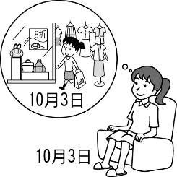 | (Ｂ) 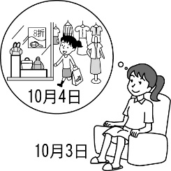 | (Ｃ)  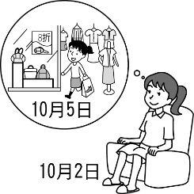

2.
(Ａ) 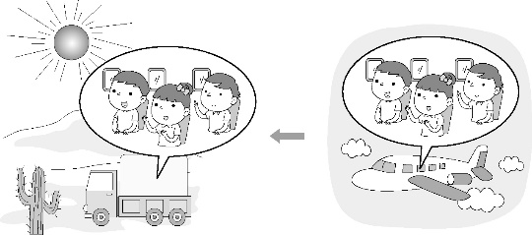
(Ｂ) 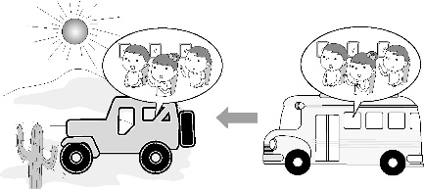
(Ｃ) 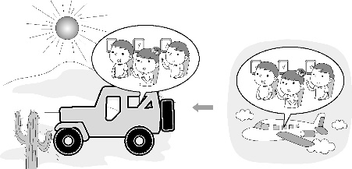
3.
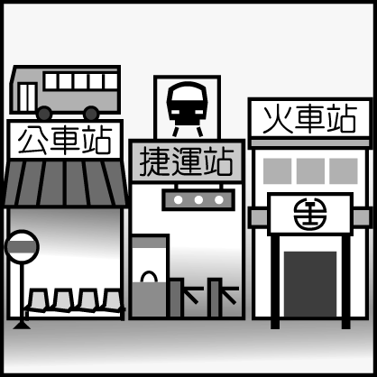
(Ａ) It’s next to the MRT station.
(Ｂ) It’s across from the bus station.
(Ｃ) It’s between the MRT station and the bus station.

4. 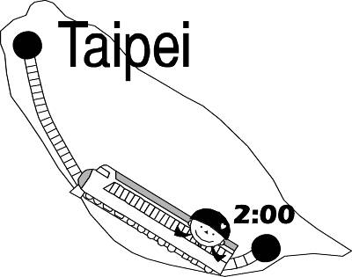
(Ａ) My sister went to Taipei on a plane at 2:00.
(Ｂ) My sister went to Taipei by ship at 2:00.
(Ｃ) My sister took a train to Taipei at 2:00.
5.
(Ａ)  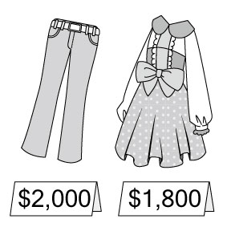 | (Ｂ)  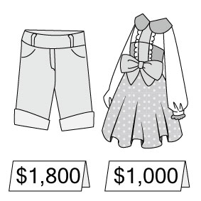 | (Ｃ)  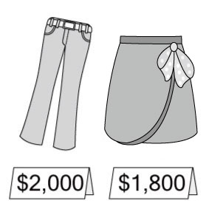
6. 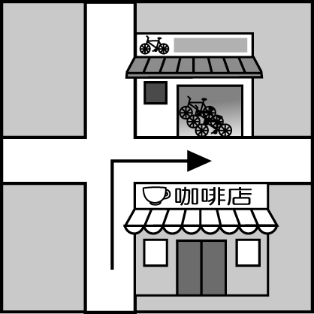
(Ａ) Turn left at the coffee shop, and the bike store is on the right.
(Ｂ) Turn right at the coffee shop, and the bike store is on the left.
(Ｃ) Turn right at the coffee shop, and the bike store is next to the coffee shop.
二、基本問答：根據聽到的內容，選出一個最適合的回應。(3%)
7. (Ａ) Flying a plane is easy for Mr. Wilson.
(Ｂ) They will all ride on a plane with Mrs. Wilson.
(Ｃ) Jane and Tina will be in Japan, so only Jessica can.
8. (Ａ) How much do I need to spend on the meal?
(Ｂ) I’m very full. You really made yummy noodles.
(Ｃ) It’s kind of you to be generous to me all the time.
9. (Ａ) I spent a lot of money.
(Ｂ) It took me about four hours to fly to Japan.
(Ｃ) Flying to Japan cost me thirty thousand dollars.
三、言談理解：根據聽到的內容，選出一個最適合的答案。(6%)
10. (Ａ) It will take the man and the woman fifty minutes to get to the mall.
(Ｂ) The man would like to wait for the bus.
(Ｃ) The man and the woman will walk to the mall.
11. (Ａ) We’re not sure.(Ｂ) Have dinner.(Ｃ) Take a walk.
12. (Ａ) Walking home.(Ｂ) Go jogging.
(Ｃ) Go swimming.
四、根據以下的敘述，回答13~17題(題組一為13-14題;題組二為15-17題) (10%)
13. (A) The facts of news. (B) The job of reporters.
(C) How to do research. (D) How to interview people.
14. (A) Leo, a rich man.
(B) Bob, a shy person.
(C) Lisa, a generous person.
(D) Olivia, a curious person.
15. (A) They may get sick often.
(B) They won’t be healthy.
(C) They can’t remember things well.
(D) All of the above(以上) are correct.
16. (A) Five to seven hours. (B) Seven to nine hours.
(C) Eight to ten hours. (D) No more than (不超過) ten hours.
17. (A) Keep their rooms dark, cool, and quiet.
(B) Turn off the light.
(C) Turn off their phones, tablets or TVs.
(D) Use their cellphones before bedtime.
【聽力測驗結束，請繼續作答】【背面尚有試題】

五、語法選擇：請根據題意選出一個正確或最佳的答案。(24%)
18. Fanny, it’s very cold today. Why don’t you take off your skirt and put on your new ?
(Ａ) jeans (Ｂ) shorts (Ｃ) T-shirt (Ｄ) tie
19. To keep healthy, Steve goes at the park after school every day.
(Ａ) fishing (Ｂ) jogging (Ｃ) sailing (Ｄ) swimming
20. We from our house at 9:30 this morning and arrived at the zoo at 10:00. It took us half an hour to get there.
(Ａ) broke down (Ｂ) got lost
(Ｃ) turned left (Ｄ) started off
21. Vic: Does your dad you to school?
Lucy: Yes, I always go to school car.
(Ａ) fly; in (Ｂ) drive; by
(Ｃ) take; drive (Ｄ) ride; on
22. Tiffany: Washing the dishes does not me too much time.
Jo: Really? How much time do you doing it?
Tiffany: About five minutes.
(Ａ) take; spend (Ｂ) spend; take
(Ｃ) take; take (Ｄ) spend; spend
23. Emily: you have a good time at Wendy’s place tonight?
Emily: You bet. I’m happy I went, and I there again tomorrow evening.
(Ａ) Did; am going (Ｂ) Were; am going to go
(Ｃ) Will; will go (Ｄ) Will; am going to go
24. Rick: When will Grandpa and Grandma arrive Taichung?
Brenda: They’ll arrive the train station（車站）at 6:00 p.m.
(Ａ) in; at (Ｂ) at; in (Ｃ) in; in (Ｄ) at; at
25. My good friend, Alice, Taipei this weekend. I’ll take her to some famous places here in Taipei and eat some yummy snacks.
(Ａ) is coming to (Ｂ) are coming
(Ｃ) will go (Ｄ) are going to come to
26. The railway station your left, the police station.
(Ａ) is on; next to (Ｂ) on; is across from
(Ｃ) is on; is next to (Ｄ) on; across from
27. Luke: Hmm, the tea is great. How much did you it?
Molly: It’s not cheap. It me NT$250.
Luke: Come on ! Isn’t that too much?
(Ａ) cost; cost (Ｂ) cost; spent
(Ｃ) spend on; cost (Ｄ) spend on; spent
28. First, go Apple Road, turn right the corner
of Apple Road and Second Street, and you’ll see the shopping mall the left.
(Ａ) up; at ; in (Ｂ) down; in; on
(Ｃ) straight; at; in (Ｄ) along; on; on
29. Cindy: Will he a plane to Kaohsiung tomorrow?
Anderson: Yes, he will go there plane.
(A) by; by (B) by; drive a
(C) drive; by a (D) take; by
六、克漏字測驗：(30%)

Eva: I am so thirsty. I want something to drink. How about some Panda Milk Tea?
Andrew: Good idea! There is a famous tea shop near the train station.
Eva: (30) do we get there?
Andrew: I am not sure, but we can ask someone for help!
(Here (31) .)
Andrew: Excuse me. Where is the Da Da Tea Shop?
Man: It’s not far from here. Just go along Main Street and turn right on Park Street. There’s a bank (32) the corner of Park Street and First Road. The tea shop is just across from it, so you can’t (33) it!
Eva: How long will it (34) to get to the shop?
Man: About 8 minutes.
Eva: Thanks a lot!
Man: You’re welcome.
30. (A) How (B) When (C) What (D) Where
31. (A) a man comes (B) comes a man
(C)a man came (D) came a man
32. (A) at (B) for (C) to (D) on
33. (A) find (B) miss (C) turn (D) take
34. (A) cost (B) pay (C) take (D) spend

Albert: The weather will be very nice and sunny this Sunday.
Helen: Great! Let’s go (35) in the mountains in Taipingshan.
Albert: That’s a good idea. But (36) will we get there?
Helen: First, we have to (37) the train to Yilan. And then we go to Taipingshan by bus. After that, we can also (38) in the mountains. There are also many special insects and plants all the way.
Albert: Can we also go camping there? That’ll be very (39) .
Helen: No, I don’t think so. We won’t do that in the mountains there.
Albert: Why not?
Helen: We need to protect our Earth.
Albert: Oh, I got it!
35. (A) to bird watching (B) watch birds
(C) bird watching (D) watches the bird
36. (A) why (B) when (C) what (D) how
37. (A) drive (B) fly (C) take (D) ride
38. (A) go sailing (B) go hiking
(C) go surfing (D) go swimming
39. (A) far (B) tired
(C) delicious (D) exciting
（Bertha’s American friend, Cathy, came to visit Taiwan last month. She (40) back to America next week. Bertha and I are planning to buy a qipao for her. We are now talking at a (41) in Taipei.
Bertha: Look at this qipao. It has a nice color. Isn’t it beautiful?
Eunice: Yes, it is. But will it look nice (42) Cathy?
Bertha: I think so. How about the (43) ?
【試題尚未結束，請繼續作答】
Eunice: It’s six thousand NT dollars.
Bertha: Well, it is very expensive. I don’t have enough money to (44) it.
Eunice: Don’t worry. Let’s go to another (另一個) store to look around!
40. (A) goes (B) is going (C) comes (D) is coming
41. (A) bookstore (B) fire station
(C) post office (D) department store
42. (A) at (B) for (C) on (D) in
43. (A) trip (B) turn (C) color (D) price
44. (A) look for (B) try on (C) take off (D) pay for
七、配合題：請根據內容，填入適當的回應(代號)。(9%)
(A) We’ll go there by car.
(B) It’s only two blocks away.
(C) It’ll look good on Skippy.
(D) Don’t worry. Here they are.
(AB) It costs two thousand dollars.
(AC) We’re going to buy some drinks first.
(AD) Go straight for two blocks and turn right.
(BC) She knows everything about desert insects and plants.
(BD) Meg and I rode on the seesaw and played on the swing.
45. Philip: What are you going to do later? Nicole: __.
46. Ada: How much does it cost? Edward: __.
47. Richard: How will we get to Grandma’s house? Leo: __.
48. Rita: How do we get to the ice cream shop? Ted: __.
49. Mark: How long will it take to get to the shop? Mary: __.
50. Mandy: Why do you want to interview Bernice? Joseph: __.
51. Boris: What did you do this afternoon? Diane: __.
52. Rock: Mom, I can’t find my cellphone and wallet. Mom: __.
53. Stella: How about this red qipao? What do you think?
Amy: Great! __.

八、閱讀測驗：(12%)
(一)
To fly in the sky is not a dream for people nowadays(現今),but do you know how did people make it come true? In 1783, two Frenchmen flew in a hot-air balloon(熱氣球) like a bird.
In 2011, Taitung started to hold Taiwan International Balloon Festival. On this festival, balloons from Canada, the UK, France, and other countries flew in the air. Many people go to Taitung to experience(體驗) the feeling of flying. It only costs NT$500 for people to fly in hot-air balloons and enjoy the wonderful view. Every year, from July to August, people visit Taitung by train, plane, or bus. During the Festival, hotels in Taitung are full of people. Besides hot-air balloons, the festival also provides night glow concerts. In the concerts, you can see balloons and fire dance to the rhythm(節奏) of music. It is a feast(饗宴) for your senses(感官).
54. What does “it” mean in line two?
(A) To visit Taitung. (B) To fly in the sky.
(C) To enjoy the view. (D) To fly in hot-air balloons.
55. Daisy lives in Taichung. How can she go to Taitung for the International Balloon Festival?
(A) By bike. (B) By boat.
(C) By plane. (D) By scooter.
56. What CAN’T people do on the festival?
(A) They can take hot-air balloons.
(B) They can buy hot-air balloons.
(C) They can enjoy the beautiful view.
(D) They can join the night glow concerts.
(二) Please look at the map and answer the questions.
 | Jincheng Road | Zhongyang Road  ●D |  | Yuanlin Street
cake  factory | Jincheng Road | restaurant | ice cream shop | Yuanlin Street | Lucy’s School  ●C
cake  factory | Jincheng Road | restaurant | movie theater | Yuanlin Street | Lucy’s School  ●C
 | Jincheng Road | Danuan Road |  | Yuanlin Street
Lisa’s  home | Jincheng Road | bookstore | supermarket | Yuanlin Street | museum
Lisa’s  home | Jincheng Road | Sanmin Road
Tom’s  home  ●A | Jincheng Road | library | clothes shop |  | police Station
Tom’s  home  ●A | Jincheng Road | Xuecheng Road |  | ●B | police Station
57. Where is the museum?
(A) It’s next to the bookstore.
(B) It’s on Zhongyang Road.
(C) It’s across from the supermarket.
(D) It’s on the corner of Jingcheng Road and
Daunan Road.
58. Lisa is at the location(地點) B. Her sister asks her to buy some ice cream on her way home. Which way does she most likely(最有可能) take?
(A) Xuecheng Road→Jincheng Road→Sanmin Road.
(B) Xuecheng Road→Jincheng Road→Danuan Road.
(C) Yuanlin Street→Zhongyang Road→Jincheng Road.
(D) Yuanlin Street→Sanmin Road→Jincheng Road.
59.Man: Excuse me. Where is the cake factory?
Lucy: Go along Yuanlin Road, and then turn left on
the corner of Yuanlin Road and Sanmin Road.
Keep going and turn right on the corner of the
bookstore. Go straight and you can see it on
your left.
Question: Where are the man and Lucy?
(A) A. (B) B. (C) C. (D) D.

【試題結束】
新北市立土城國民中學108學年度第1學期第三次段考英文科八年級
1 | 2 | 3 | 4 | 5 | 6 | 7 | 8 | 9 | 10
B | C | A | C | A | B | C | C | B | C
11 | 12 | 13 | 14 | 15 | 16 | 17 | 18 | 19 | 20
A | B | B | D | D | C | D | A | B | D
21 | 22 | 23 | 24 | 25 | 26 | 27 | 28 | 29 | 30
B | A | A | A | A | A | C | D | D | A
31 | 32 | 33 | 34 | 35 | 36 | 37 | 38 | 39 | 40
B | D | B | C | C | D | C | B | D | B
41 | 42 | 43 | 44 | 45 | 46 | 47 | 48 | 49 | 50
D | C | D | D | AC | AB | A | AD | B | BC
51. | 52. | 53. | 54. | 55. | 56. | 57. | 58. | 59.
BD | D | C | B | C | B | C | C | B

八年級聽力稿

一、辨識句意：根據聽到的內容，選出符合描述的圖片或符合圖片的描述。(6%)
1. Cindy will go shopping tomorrow night.
2. They took a plane to Los Angeles, and then drove a jeep to the desert.
3. Look at the picture. Where is the railway station?
4. Look at the picture. Which is right?
5. A pair of pants and a dress cost three thousand eight hundred dollars.
6. Look at the picture. How can you get to the bike store?

二、基本問答：根據聽到的內容，選出一個最適合的回應。(3%)
7. Jane, Tina, and Jessica can fly a plane, right? Who is going to fly the small plane for Mr. Wilson this weekend?
8. Wait, Lucy. It’s my turn to pay for the meal. Let me, please.
9. How long did it take you to fly to Japan?
三、言談理解：根據聽到的內容，選出一個最適合的答案。(6%)
10. W: How do we get to the shopping mall?
M: We can go there on foot. Just go down the street for three blocks and turn left on Red Street.
W: Can we take a bus there?
M: Come on! It’s not far away. It just takes about 15 minutes. I don’t want to spend so much time waiting for the bus.
W: All right. Let’s go.
Q: Which is true?
11. M: I’ll go to the movies tomorrow afternoon. Would you like to go with me?
W: Of course. After the movie, how about eating dinner together? I want to eat beef noodles.
M: Good idea! We can also take a walk at the park.
Q: What will the man and woman do before the movie?
12. M: Going jogging is a good exercise.
W: Well, we’re old. Going swimming is good for us.
M: You can say that again. Let’s go swimming in the gym first, and then let’s go home on foot.
Q: What won’t the man and woman do?

四、根據以下的敘述，回答13~17題(題組一為13-14題;題組二為15-17題) (10%)
題組一：(13-14)
Molly: Peter, why do you want to be a reporter?
Peter: Reporters is an interesting job. They find, write, and report information. To do their job well, they have to interview people, ask questions and do research.
Molly: Sounds interesting! But why do they need to do research?
Peter: Reporters must tell the truth, so they need to do research to make sure the information is correct.
Molly: Then, what kind of person is suitable to be a reporter?
Peter: I think reporters must be curious. They have to find answers to questions. Sometimes, they ask many people the same questions to make sure their information is correct.
Molly: You really know a lot about reporters. Good for you!

13. What are they talking about?
14. Who may be suitable to be a reporter?
題組二：(15-17)
Getting enough sleep is very important. Sleep gives people the energy for the day. Adults need seven to nine hours of sleep each night. Teens need more. They need eight to 10 hours of sleep every night. If people don’t get enough sleep, they won’t be healthy. They will get sick more often. Sleep also affects people’s memory. If people don’t get enough sleep, they may not remember things well. To get a sound sleep, people should turn their phones, tablets, or TVs off an hour or two before bedtime. Because the light from those things can keep people awake. When it’s time to sleep, the rooms should be dark, cool, and quiet. That may help people sleep better.

15. What may happen to people if they don’t get enough sleep?
16. Renee is a junior high school student. How much sleep should she need?
17. To get a sound sleep, what shouldn’t people do before bedtime?

