新北市立土城國民中學109學年度第一學期第三次段考英文科八年級試題 P1

【試題共4頁】1-53選擇題，請在答案卡劃記作答
Part A、聽力測驗：23% (1-11每題1分，12-17每題2 分)

一、辨識句意- 根據聽到的內容，選出正確的圖片代碼：
- (A) (B) (C)
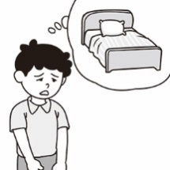 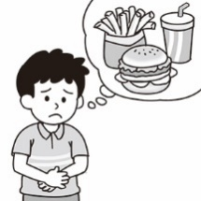 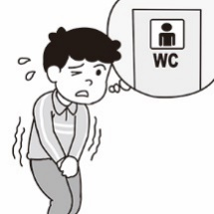
- (A) (B) (C)
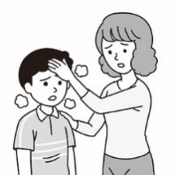 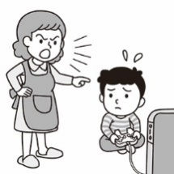 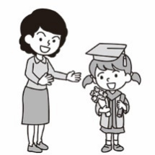
- (A) (B) (C)
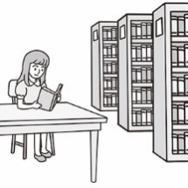 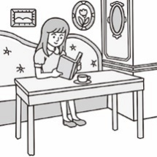 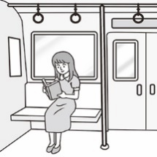
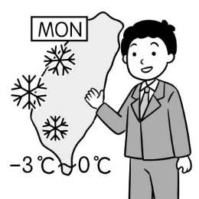
- (A) (B) (C)
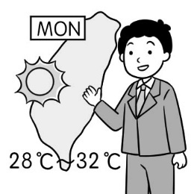 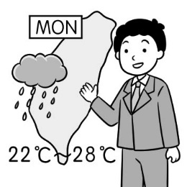
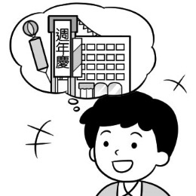
- (A) (B) (C)
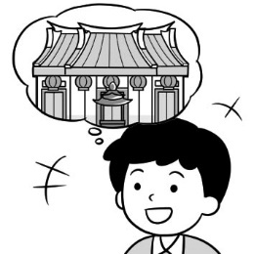 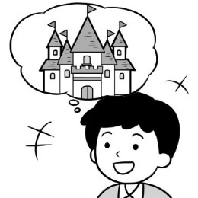

二、基本問答- 根據聽到的內容，選出合適的回應：
- (A) Like what?
(B) I’m so proud of you!
(C) That’s so convenient.
- (A) Of course.
(B) Be careful.
(C) Don’t be sad.
- (A) No, it’s very comfortable.
(B) No, I don’t want to go there.
(C) Yes, it only takes you 5 minutes to get there on
foot.
- (A) It is delicious.
(B) I like to drink milk tea.
(C) It’s not good for my health.

- (A) About five million dollars.
(B) I came here two years ago.
(C) It took me about two hours.
- (A) That’s cool.
(B) I’m not sure.
(C) Are you serious?

三、言談理解- 根據聽到的對話內容與問題，選出正確答
案
（ ）12. (A)They’re talking on the Net.
(B) They are in Starbucks.
(C) At a department store.
（ ）13. (A) Thursday.
(B) Friday.
(C) Monday.
（ ）14. (A) They’e quite rich.
(B) They loves sports.
(C) They’re on vacation.
（ ）15. (A) To a festival.
(B) To an interview.
(C) To a lesson.
（ ）16. (A) Give her a case for the camera.
(B) Take pictures with the camera.
(C) Lower the price of the camera.
（ ）17. (A) Tiny bugs.
(B) A loud noise.
(C) Her dirty pants.
【聽力測驗結束，請繼續作答】
Part B、單題: 字彙與文法測驗 32% (每題2分)
18. ( ) After school, Billy usually sits on the
and plays.
(A) couch (B) coffee (C) lamp (D) heart
19. ( ) When you a cake in our restaurant, you will
get a free drink.
(A) forget (B) cost (C) clean (D) order
20. ( ) Selina’s English is very good, so it’s very easy for her to talk with .
(A) volunteers (B) relatives (C) foreigners (D) husbands
21. ( ) Be . A car is running to us.
(A) free (B) honey (C) comfortable (D) careful
22. ( ) Don’t worry! Your dream can true soon.
(A) come (B) have (C) take (D) play
23. ( ) Who dinner with Lisa tonight?
(A) will has (B) have (C) are having (D) is going to have
24. ( ) Patty is going to visit the night market this weekend, but her sister .
(A) aren’t (B) isn’t (C) wasn’t (D) don’t

25. ( ) There will a good movie on TV tonight.
Don’t miss it!
(Ａ) has (Ｂ) have (Ｃ) be (Ｄ) is
26. ( ) Mary: How much did you on all the new
clothes yesterday?
Mike: They me twenty thousand NT dollars.
Mary: Wow, that’s a lot of money.
(A)cost; cost (Ｂ)spend; spent
(Ｃ)cost; spent (Ｄ)spend; cost
27. ( ) Amy: Does Claire go to the doctor?
Doris: No, she .
(A) have to ； doesn’t (B) has to ； has
(C) has to ； doesn’t (D) have to ； has
28. ( ) Vincent: Taiwan is a beautiful island.
Fiona:
(A) Why not? It’s safe to travel around Taiwan.
(B) You bet. Also, the people there are kind and friendly.
(C) That’s cool! How do you like the town.
(D) It’s convenient to take a bus.
29. ( ) Sally: Can you pick me up when I arrive?
Peter: Sorry, I’m still at work, but Sam you
home. So just wait at the station.
Sally: OK.
(A)drives (B)drove (C)will drive (D)was driving
30. ( ) Alisa: What can people do in 7-ELEVEN ?
Rita: For example, they can get a cup of
coffee and eat tea eggs.
(A) They can make friends.
(B) They can get train tickets.
(C) They can use the restroom for free.
(D) They can buy a hot meal.
31. ( ) Angela:
Erica: They like Taiwanese food and scenery.
(A) How is Taiwan?
(B) Who likes Taiwan?
(C) What about Taiwan?
(D) What draws many visitors to Taiwan?
32. ( ) Gina: I don’t know how to paint my house.
Marc:
(A) I want to visit my grandma’s new house tonight.
(B) My house is big.
(C) Let’s paint my house.
(D) You can look for some information on the Net first.
33. ( ) Kyle: My dream is to travel around the world.
Bryan:
(A) You can take a plane to Thailand and Japan.
(B) Then you need to save money from now on . (C) Traveling in Taiwan is safe and fun.
(D) There are no police officers around.

Part C、克漏字測驗 15% (每題1分) P2
1. Do you have any pets ? 34 fun to keep one at home. Americans love their pets. Every year, they pay 25 billion dollars to take care of their pets.
35 keeping pets, people always think of dogs. Dogs are the most popular pets because they are sweet, smart, and friendly. Remember to 36 some time with your pet dog if you have one. 37 your dog to behave well is important. In fact, keeping a dog 38 just like raising a child. Both of them need rules. Help your pet dog to follow the rules, and it won’t become a troublemaker.

the most popular 最受歡迎的 behave well 規矩良好
raise 養育 troublemaker 麻煩製造者
（ ）34. (Ａ) That’s (Ｂ)There’s (Ｃ)This is (Ｄ)It’s
（ ）35.(Ａ) Lend a hand (Ｂ) When it comes to
(Ｃ) By the way (Ｄ) Besides
（ ）36. (Ａ) spend (Ｂ)cost (Ｃ)take (Ｄ)pay
（ ）37. (Ａ)Teach (Ｂ)Taught (Ｃ) Teaching (Ｄ)Teaches
（ ）38. (Ａ) are (Ｂ) has (Ｃ) have (Ｄ) is

2.
Dear Carol: 2021/01/17
How is everything ? Chinese New Year’s Day 39 soon. When this semester ends, my family will move to Singapore. So, I will live and study in Singapore, too. I haven’t heard from you for a while. You are my best friend. I would really like 40 you and talk with you before I am leaving. My family 41 a good-bye party next week. 42 . Take care and see you soon.
Best Wishes,
Ann
( ) 39. (A) came (B) come (C) is coming (D) was coming
( ) 40. (A) to see (B) see (C) seeing (D) will see
( ) 41. (A) is going to have (B) had (C) have had (D) has
( ) 42. (A) I’ll go to bed early later.
(B) I went to the movies.
(C) I cleaned the house with my family.
(D) I’ll invite all my friends to the party

【試題尚未結束，請繼續作答】

3.
Monica: Peter, Mom’s birthday is coming. What present should
we buy for Mom this year?
Peter: I think Mom spends too much time 43 ,
so we should buy a robot vacuum for her.
What do you think, Iris ?
Iris: I think it 44 Mom a lot of time to wash our clothes in the small old washing machine. 45 a good washing machine, she will have more time to relax.
Monica: I think both of you are correct. But the price of a robot
vacuum or the washing machine is too 46 .
We don’t have enough money.
Peter: Hey, 47
Iris: What's that?
Peter: How about doing all the housework? Mom will be very
happy if we do the housework on our own. Besides , we
can save a lot of money.
Monica: Yes, 48
Iris: I agree, too. If we get Daddy to join us, then we won't
be too tired.

robot vacuum 掃地機器人
( ) 43 (A) to mop the floor (B) mopping the floor
(C) mops the floor (D) mopped the floor
( ) 44. (A) takes (B) costs (C) spends (D) pays
( ) 45. (A) With (B) To (C) At (D) On
( ) 46. (A) low (B) expensive (C) high(D) cheap
( ) 47 (A) I can do anything there.
(B) I come up with an idea.
(C) I am proud of you.
(D) You are serious.
( ) 48 (A) this is an excellent idea.
(B) I don’t like the plan.
(C) I have much money.
(D) She likes the machine.
Part D、閱讀測驗 10% (每題2分)
1. Thanksgiving is celebrated on the fourth Thursday of November. “Black Friday” is the day after Thanksgiving in the United States. It is also the beginning of the Christmas shopping season. On this day, many stores open very early, often at 4 a.m., or earlier, and offer promotional sales to start the shopping season. Black Friday is not really a holiday, but most workers can get one day off to buy what they need. To buy something cheaper, many people will get in line very early in front of the stores.
And now, companies or stores offer another shopping chance ─ just sit in front of the computer and click the mouse. “Cyber Monday” becomes one of the biggest online shopping days of the year.
earlier 更早 offer 提供
click 敲擊 cyber 電腦網路

P3
( ) 49.According to the calendar, when will Black Friday
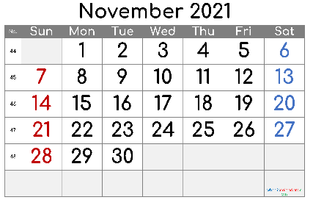
be this year?
(A) November 5
(B) November 12
(C) November 19
(D) November 26
( ) 50.What does “promotional sales” mean in paragraph
one?
- People can buy things at a good price.
- People can buy things without paying any money.
- People need to pay more during the promotional sales.
- People can buy things with 20% off during that time.
( ) 51.Which is true?
(A)Black Friday is a national holiday.
(B)To get better goods, people have to be in the
stores on their own on “Cyber Monday”.
(C) ”Black Friday” happens in summer.
(D) Stores welcome both “Black Friday” and “Cyber
Monday”.
2 Dear Diary,
This is the second day of my trip to Taiwan and I am having so much fun! Taiwan is really a special place.
Today I went to a famous night market with my parents and ate lots of delicious food. I tried bubble tea at a stand called“ Q World”. I asked the owner of the stand what Q means and she told me that Q is a special texture. It means soft and chewy.
After having the bubble tea, we went to buy some Korean Rice Cakes. "Hot, Q Korean Rice Cakes!" the owner of the stand was calling out. It seems that food that can be described as Q is also from Asian countries.
I like the texture "Q" so much that I bought another bubble tea. My parents didn't like the drink because they thought it was quite strange. I will share this special experience with my friends when I get back to America!
Love,
Abigail
stand 攤位 texture 口感
chewy 有嚼勁的 describe 描述
( )52. What do we know from the reading?
(A) Milk tea has the texture “Q”.
(B) Abigail and her parents love Pearl Milk Tea.
(C) Korean Rice Cakes are soft and chewy.
(D) The texture “Q” can only be found in the
Taiwanese food.
( )53. What may Abigail do when she gets back to
America ?
(A) She may help her Asian friends with homework.
(B) She may tell her friends about her trip.
(C) She may invite her friends to make meat balls.
(D) She may call her friends “Q”.【後面還有試題】

班級: 座號: ______ 姓名: P4

Part E、非選擇題 請用黑筆於下方試卷上作答

一、單字中翻英 8% (每題1分)

1 | 圖書館 |  | 5 | 公寓
2 | 祈求；禱告 |  | 6 | 寺廟
3 | 待；停留 |  | 7 | 現代的
4 | 城市 |  | 8 | 漢堡

二、依提示作答 6% (每題2分)

1. The book cost Alice three hundred dollars. (用spend改寫句子)

2. They play basketball in the park every day . (請將畫線部分改成 next week)

3. Using cellphones is easy for students. (請改用It當虛主詞)

三、整句式翻譯 6% (每題2分)

1. 去便利商店好有趣。(請用動名詞當主詞)

2. 你們明天要做什麼?

3. 颱風期間，在我們的房子內你會很安全。

(試題結束) THE END

第三次段考英文科八年級-解答
1 | 2 | 3 | 4 | 5 | 6 | 7 | 8 | 9 | 10
C | C | A | B | B | B | A | C | C | A
11 | 12 | 13 | 14 | 15 | 16 | 17 | 18 | 19 | 20
B | C | B | A | B | C | A | A | D | C
21 | 22 | 23 | 24 | 25 | 26 | 27 | 28 | 29 | 30
D | A | D | B | C | D | A | B | C | D
31 | 32 | 33 | 34 | 35 | 36 | 37 | 38 | 39 | 40
D | D | B | D | B | A | C | D | C | A
41 | 42 | 43 | 44 | 45 | 46 | 47 | 48 | 49 | 50
A | D | B | A | A | C | B | A | D | A
51 | 52 | 53
D | C | B
選擇題

非選擇題
一、單字中翻英 8% (每題1分)
1 | 圖書館 | library | 5 | 公寓 | apartment
2 | 祈求；禱告 | pray | 6 | 寺廟 | temple
3 | 待；停留 | stay | 7 | 現代的 | modern
4 | 城市 | city | 8 | 漢堡 | hamburger

二、依提示作答 6% (每題2分) 分段給分
1. Alice spent three hundred dollars /on the book.
2. They will play basketball/ in the park next week.
3. It is easy for students /to use cellphones.
三、整句式翻譯 6% (每題2分) 分段給分
1. Going to convenience stores/ is so much fun.
2. What are you going to /do tomorrow?
或 What will you / do tomorrow?
3. You will be safe/ in our houses during typhoons.
聽力稿
一、辨識句意-根據聽到的內容，選出正確的圖片代碼：
1. I need to go to the restroom.
2. Mrs. Wang is proud of her kid.
3. Mary is reading a book in the library.
4. It will rain tomorrow.
5. Jack wants to have his own castle.

二、基本問答-根據聽到的內容，選出合適的回應：
6. I won the game again!
7. Can you lend me a hand?
8. Is the department store near here?
9. Why do you never drink milk tea?
10. How much did this apartment cost you?
11. Will you go to the party tomorrow?

三、言談理解：根據聽到的內容，選出一個最適合的答案。
12 W: Look! There are some of this year’s most fashionable
dresses in the window.
M: Yes. I have noticed them, too. However, they are all
expensive. I can’t buy any of them.
W: Maybe we can ask the clerk for a better price.
Question: Where may they be talking?
13. W: It’s time to go to bed. It’s already twelve now.
M: Mom, tomorrow is the weekend. Why not let me
play a little longer?
W: No way. Having a good habit of getting up and going to
bed early is good for your health, especially during
your teenage years.
Question: What day is today?
14. W: Who are your new neighbors?
M: Mr. and Mrs. Chen. They own many successful
businesses. And they have millions of dollars in the bank.
W: Really? How do you know that?
W: My father told me.
Question: What does the man know about his neighbors?
15. M: What are you meeting with Mrs. Lin about today?
W: A job in her shoe store. She needs a new clerk.
She wants to give me the job. But she needs to ask me
questions about my work experience first.
M: What time is your meeting with her?
W: At 2 p.m. That’s just half an hour from now. So I should
leave now.
Question: Where is the woman probably going today?
16. M: Can I help you?
W: Yes. I want to buy this camera. But the sign on it says
two thousand dollars. That’s pretty high. Can you give
me a discount.
M: I can’t give you a big discount.
W: How about a small one?
Question: What is the woman asking the man to do?
17. M: This is a great place for a picnic.
W: There’s just one problem. Look at all of the ants under
this tree. They’re getting on our cakes. There’s even one
in my Coke ! I can’t sit here another minute!
M: Do you want to move to a different place?
W: Let’s just take our cakes back to our apartment and eat
there.
Question: What is the woman unhappy about?

