新北市立土城國民中學110學年度第一學期 第三次段考 英語科（八年級）P1

●聽力測驗 ( 1-20題) 20%(每題1分) ( 本試題 共3頁 )
一、請選出聽到的單字。
1. (A) kites (B) pool (C) dancing
2. (A) still (B) our (C) took
3. (A) markets (B) banks (C) blocks
4. (A) skirt (B) shorts (C) thousand
5. (A) prayed (B) played (C) paid
二、根據聽到的內容，選出正確的圖片代碼。
6.
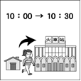  (A) | 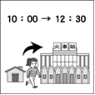  (B)  ) | 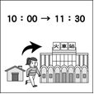  (C)  )
7.
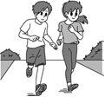  (A) | 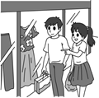  (B)  ) | 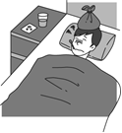  (C)  )
8.
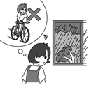  (A) | 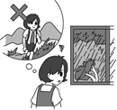  (B)  ) | 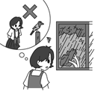  (C)  )
9.
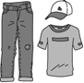  (A) | 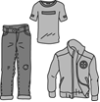  (B)  ) | 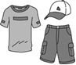  (C)  )
10.
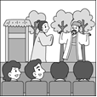  (A) | 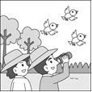  (B)  ) | 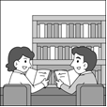  (C)  )

三、根據聽到的內容，選出合適的回應。
11. (A) They are not interesting at all.
(B) I need to buy a belt.
(C) They cost two thousand dollars.
12. (A) I was in the bathroom.
(B) No, I don’t have time tomorrow afternoon.
(C) I am going to have afternoon tea in the coffee shop.
13. (A) He likes to go mountain climbing.
(B) He is going shopping in the afternoon.
(C) Everything is free in this store.
14. (A) I like reading novels in my free time.
(B) About two hours.
(C) Reading the novel was not easy for me.
15. (A) Yes, there is. Would you like to come?
(B) No, I will be very busy tomorrow.
(C) Yes, you need to park the car first.
四、請根據聽到的對話與問題，選出正確的答案。
(16.~17.請聽完小短文再回答問題；18.~20.請直接回應問題)
16. (A) By plane.
(B) By boat.
(C) By train.
17. (A) He swam with his friends.
(B) He played with the dolphins.
(C) He took some pictures of the dolphins.
18. (A) A sound Jason is making.
(B) The man’s questions.
(C) Her tiring work.
19. (A) When the building was built.
(B) What the building is used for now.
(C) What the building used to be.
20. (A) She likes to show her hobbies to others.
(B) She likes to tell stories with pictures.
(C) She likes to make people happy.
●綜合測驗 80%
一 、語法選擇 44% (每題2分)
21. The science homework ____ Jack over one hour.
(A) took (B) cost (C) paid (D) spent
22. There’s a bookstore _____ Apple Road and Lemon Road. You can see it from each road.
(A) above (B) next to
(C) across from (D) on the corner of
23. Go along the street _____ two blocks. And you can see it.
(A) on (B) for (C) in (D) of
24. It _____ five hundred NT dollars.
(A) has (B) spends (C) costs (D) pays
25. Jim: I’m busy with my work. Don’t you have _____?
Ben: Sure I do.
(A) our (B) ours (C) your (D) yours
26. How great! We can have these books _____ free.
(A) of (B) in (C) for (D) on
27. _______ money for a new house, he seldom eats out.
(A) Saving (B) To save (C) Save (D) Saved
28. Kate: What ______ this morning?
Mary: Today is Sunday. I think I’ll just take a rest at home.
(A) are you going to do (B) were you doing
(C) do you do (D) did you do
(背面尚有試題)
29. Jacky’s dream is ______ a good dentist like his dad.
(A) became (B) becomes (C) to be (D) be
30. Our mom _____ to cook, and we like her food very much.
(A) like (B) loves (C) enjoys (D) hate
31. Playing computer games _____ lots of fun for Benson.
(A) have (B) is (C) are (D) has
32. When I _____ up at 4 a.m., it was raining outside.
(A) am waking (B) was waking (C) wake (D) woke
33. A: _____ does it take to go to Green Park by bus from here?
B: About thirty minutes.
(A) How much (B) How often (C) How long (D) What time
34. A: _____ can I go to the City Bank?
B: You can _____ the metro or Bus 21.
(A) How ; take (B) Where ; take
(C) What ; ride (D) How ; play
35. A:______________ B: It’s $1,500.
(A) What’s the total? (B) How much do you have?
(C) Here is the change. (D) How much did you pay?
36. Sue will _____ with her friend at the department store this Saturday afternoon.
(A)shopping (B)shopped (C)goes shopping (D) go shopping
37. The boy always brushes his teeth before he _____ to bed.
(A) goes (B) going (C) go (D) went
38. A: ________ B: Yes, it’s 11:30 now.
(A) Is it three to one? (B) Is it half past eleven?
(C) Is it a quarter to eleven? (D) Is it half past three?
39. A: Where is the supermarket?
B: It’s _____ the fire station _____ the police station.
(A) across ; and (B) between ; and
(C) across ; from (D) next ; of
40. Mom: Matt, be sure to finish your homework before you go to bed.
Matt: OK, Mom, I ______.
(A) do (B) am (C) will (D) have
41. Jason _______ basketball with his classmates now.
(A) plays (B) is going to play
(C) played (D) is playing
42. Lucy made _______ on Mother’s Day.
(A) her mother a card (B) a card to her mother
(C) her mother for a card (D) a card her mother
二、 克漏字選擇 22% (每題2分)
Emma: What do you plan 43. during winter vacation?
Helen: I want to learn baking, like 44. cookies and cakes. How about you?
Emma: I love making videos. I want to be a YouTuber in the future and have my own channel.
Helen: That’s cool! What would you 45. to share in your channel?
Emma: I don’t know. My life is not very interesting. Maybe it is not a good idea 46. share it with people.
Helen: Hey! Don’t 47. . Why don’t we make a baking channel together? I can make cookies and cakes, and you can make a video of it. We can work together.
Emma: 48. Let’s plan it now.
(One week later. Emma and Helen are filming a video for their
YouTube channel.)

P2
Helen: I have butterflies in my 49. now. I can’t talk in front of a camera.
Emma: Come on. You can do this. Just take it easy.

channel 頻道 share 分享 film 拍攝 camera 鏡頭
43. (A) to doing (B) do (C) to do (D) doing
44. (A) to make (B) made (C) make (D) making
45. (A) enjoy (B) like (C) keep (D) practice
46. (A) to (B) X (C) can (D) for
47. (A) believe (B) hope (C) give up (D) decide
48. (A) Finally. (B) I hate it. (C) Don’t worry. (D) Good idea.
49. (A) future (B) stomach (C) truck (D) hope

(On a street in Taipei)
Ken: Wow. Taipei is such a big city. This is our first time to be here. I feel so excited.
Anna: Yeah. Our plan for our first day here is 50. Longshan Temple and 50. some shopping at the department store.
Ken: Good idea. By the way, the temple is around here. How do we get there?
Anna: Don’t worry. 51.
Ken: Sorry, but I left it on the table at the hotel this morning. What can we do next?
Anna: It’s a piece of cake. 52.
Ken: Do we need to go to the police station?
Anna: We don’t need to. 53. I think he can show us the way.
Longshan Temple 龍山寺 a piece of cake 容易之事
50. (A) to visit ; do (B) to visit ; did
(C) visiting ; to do (D) visit ; do
51. (A) I don’t have any idea. (B) Let’s just keep walking.
(C) Stop asking me. (D) We can stop to look at the map.
52. (A) That’s it. Let’s start our day.
(B) Do you have my phone number?
(C) Let’s ask someone for help.
(D) I feel hungry now.
53. (A) There goes a young woman.
(B) Here comes a police officer.
(C) We are sure to find it.
(D) Aren’t you ready to get off?

三、閱讀測驗 14 % (每題2分)
We all have seen rainbows after the rain or near waterfalls during the day, but do you know there are rainbows at night? Night rainbows are known as “moonbows.” Sunlight leads to rainbows, but moonlight leads to moonbows.
We seldom see moonbows because they only happen once in a blue moon. The weather must right for moonbows. To watch moonbows appear, a bright full moon is needed, and the moon has to be very low in the sky. The night sky must be very dark, and of course, there are water drops in the air.
(背面尚有試題)
Moonbows have the same colors as rainbows. However, moonbows appear to be white to naked eyes. This is because their colors are not bright enough due to the weak moonlight. The best way of seeing moonbows is to use a camera. If you want to take photos of a moonbow, the best place is near the waterfall. One of the most famous places in the world is Yosemite National Park, USA. (美國優勝美地國家公園)
If you are lucky enough to see a moonbow, don’t miss it! Moonbows are very brief, so when you look again, they might be gone.

waterfall 瀑布 be known as 以..有名 lead to 導致
appear 出現 water drop 水珠 naked eye 肉眼
due to 由於 gone 消失
54. What does once in a blue moon mean in the reading?
(A) Not very tall. (B) Not very often.
(C) Not very bright. (D) Not very dark.
55. Which is true about rainbows and moonbows?
(A) Sunlight leads to moonbows; moonlight leads to rainbows.
(B) We see a rainbow when the moon is low in the sky, but we see a moonbow when the sky is dark.
(C) Rainbows have more colors than moonbows.
(D) A rainbow appears during the day, but a moonbow happens at night.
56. What does brief mean in the reading?
(A) Gone. (B) Dark. (C) Short. (D) White.

Star Department Store is having a sale from January 5 to January 25. Look at the table and answer the questions.
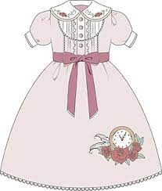 | 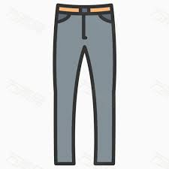 | 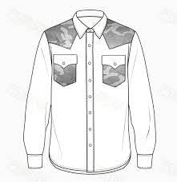
NT$ 4,800  ↓  NT$1,600 | NT$ 2,800  ↓  NT$1,000 | NT$ 2,200  ↓  NT$1,400 (for two)
 | 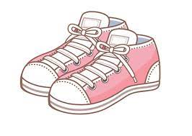 | table 表格
NT$ 990  ↓  NT$1,000 (for three) | NT$2,680  ↓  NT$1,200 | table 表格

P3
57. How many days is the sale?
(A) Three weeks. (B) A month.
(C) Fourteen days. (D) Two weeks.
58. Bill went to the department store on January 8. He bought three T-shirts and a pair of shoes. How much did he pay?
(A) NT$3,190. (B) NT$3,680.
(C) NT$5,650. (D) NT$2,200.
59. Phoebe went to the department store on January 20.
She spent three thousand NT dollars. She got a dress.
What else did she buy?
(A) A pair of shoes. (B) Two shirts.
(C) A pair of pants. (D) Three T-shirts.
60. Jenny bought a pair of pants and a dress at Star Department
Store on January 18. How much money did she save?
(A) NT$1,800. (B) NT$3,200.
(C) NT$5,000. (D) NT$2,000.

(試題結束，請將答案用2B鉛筆畫記在答案卡內)

寒假愉快

110學年八上三段英文解答 (正卷)

●選擇題：100%
1 | 2 | 3 | 4 | 5 | 6 | 7 | 8 | 9 | 10
B | A | C | B | C | A | C | B | B | A
11 | 12 | 13 | 14 | 15 | 16 | 17 | 18 | 19 | 20
C | C | A | B | A | B | C | A | C | B
21 | 22 | 23 | 24 | 25 | 26 | 27 | 28 | 29 | 30
A | D | B | C | D | C | B | A | C | B
31 | 32 | 33 | 34 | 35 | 36 | 37 | 38 | 39 | 40
B | D | C | A | A | D | A | B | B | C
41 | 42 | 43 | 44 | 45 | 46 | 47 | 48 | 49 | 50
D | A | C | D | B | A | C | D | B | A
51 | 52 | 53 | 54 | 55 | 56 | 57 | 58 | 59 | 60
D | C | B | B | D | C | A | D | B | C
1.~20.每題1分 21.~60.每題2分

土城國中110上 第三次段考 八年級 英文試題聽力稿
一、請選出聽到的單字  1. There are some kids swimming in the pool.  2. I’m still tired after ten hours of sleep.  3. The art museum is two blocks from here.  4. The shorts and the belt cost Henry five hundred dollars.  5. Sandy paid a lot of money to fix her car. | 二、根據聽到的內容，選出正確的圖片代碼  6. It takes Teresa 30 minutes to get to the train station.  7. Jack won’t go shopping with you tomorrow because he is sick now.  8. Polly is not going mountain climbing because of the typhoon.  9. Dennis is going to wear a jacket, a pair of jeans and a T-shirt for the trip tomorrow.  10. They saw a wonderful play in London last weekend.
三、根據聽到的內容，選出合適的回應  11. How much did the belt and the tie cost?  12. Where will you go tomorrow afternoon?  13. What does Alex like to do when he has free time?  14. How much time did you spend to finish reading the novel last night?  15. Is there going to be a concert at the park tomorrow evening?  四、請根據聽到的對話與問題，選出正確的答案，16.~17.請聽完小短文再回答問題；18.~20.請直接回應問題  Last month, I went to Yilan and took a boat to Turtle Island. There was once a fisherman’s town there. Now it is a nature park. The boat went around the island before stopping, so I got to see its shape. It has a head, back, and tail, just like a turtle. I also saw dolphins in the water. They swam next to the boat, and I took some pictures of them. It was so much fun.  16. How did the writer go to Turtle Island?  17. What did the writer do when he saw dolphins? | 18. W: I can’t do my work now.  M: Why? Are you feeling tired?  W: No. Don’t you hear that noise?  M: That’s just Jason practicing his flute.  Q: What makes the woman can’t do her work?  19. W: What a beautiful building!  M: Yeah. I really like it, too.  W: I heard that it was once a church.  M: Yeah. That’s what I heard, too.  Q: What is the woman saying?  20. M: What do you like to do in your free time?  W: I like to do many things in my free time. I have many hobbies and interests.  M: What are they?  W: Well, I like to draw and make things.  M: I like to draw, too. It makes me happy. How about you? Why do you like to draw?  W: It also makes me happy, and I can tell stories with my pictures.  M: Can you show me your pictures sometime?  W: Sure, and I want to see your pictures, too.  Q: What does the woman like to do when she has free time?

