新北市立土城國民中學111學年度第1學期 第3次段考 英語科 8年級試題
_______________________________________________________________________________
第一部分 聽力測驗 共26%
- 辨識句意：根據聽到的內容選出符合描述的圖片
(每題2%，共10%)
1. ( )

(A) (B) (C)
2. ( )
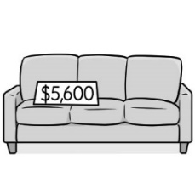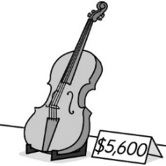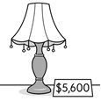
(A) (B) (C)
3. ( )
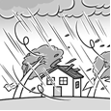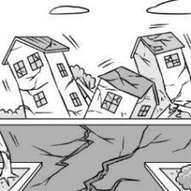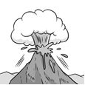
(A) (B) (C)
4.( )
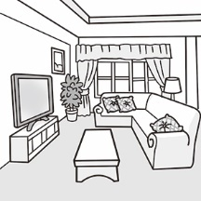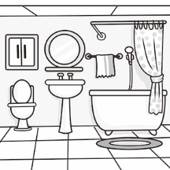
(A) (B) (C)
5.( )
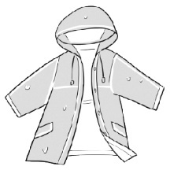   (A) (B) (C)

- 基本問答：根據聽到的內容選出一個最適合的回應
(每題2%，共8%)
6. ( ) (A) Just in time.
(B) Half an hour.
(C) Maybe later.
7. ( ) (A) I’m so proud of you.
(B) You bet.
(C) Don’t worry. Just be careful next time.
8. ( ) (A) I can’t wait to see it.
(B) That would take him a month.
(C) It won’t cost him a cent.
9. ( ) (A) We rode scooters.
(B) Traveling here was fun.
(C) There are many beautiful places here.
三、言談理解：根據聽到的內容選出一個最適合的答案
(每題2%，共8%)
10. ( )(A) Braised pork on rice.
(B) Pan-fried pork buns.
(C) Beef noodles.

11. ( )(A) A convenience store.
(B) A movie theater.
(C) A restaurant.

12. ( )(A) It is convenient to live in Hualien.
(B) People are nice and ready to help.
(C) It has great scenery.

13. ( )(A) They are going to have a barbeque dinner party.
(B) Mike and his wife often dress up for dinner parties.
(C) Only their close friends will come to the dinner party.

第二部分 綜合測驗 共74%
四、單字與文法選擇 (每題2%，共38%)
14.( ) Look! There is a ________ eating leaves in the tree.
(A) koala (B) frog (C) spider (D) pig
15.( ) After school, Amy wants to take a _________.
(A) city (B) heart (C) break (D) guitar
16.( ) Joseph’s mother _________ about him a lot.
He stayed up late every night. stay up熬夜
(A) forgot (B) worried (C) learned (D) printed
17.( ) There is _________ coffee in the cup.
(A) a lot (B) many (C) few (D) little
18.( ) Jimmy caught a cold, so he ________ home today.
(A) designed (B) stayed
(C) remembered (D) thought of
19.( ) I don’t have my _______ bedroom.
I have to share one with my brother.
(A) comfortable (B) foreign (C) serious (D) own
20.( ) There are six families living in this __________.
(A) couch (B) hamburger (C) case (D) apartment
21.( ) My friend, Joe, _________ this T-shirt.
Would you like to try it on?
(A) designed (B) stayed
(C) learned (D) came up with
22.( ) A: Do you know Nancy?
B: Yes. We are ________ classmates.
(A) most (B) anywhere (C) besides (D) actually
23. ( ) The famous night market is near my house, but, ________, I never eat there. I still like to eat at home.
(A) for example (B) when it comes to
(C) by the way (D) so far
24.( ) _________ a mask when you go to the hospital is important.
(A) Wear (B) Wearing (C) By wearing (D) Wore
【背面尚有試題，請翻頁繼續作答】
25.( ) It’s difficult for them ________ the story.
(A) understand (B) understanding
(C) to understand (D) understood
26.( ) John often rides a U-bike to school. It only _______ him 10 minutes _________ here.
(A) takes; to get (B) takes; getting
(C) spends; to get (D) spends; getting
27.( ) A: ___________ did it _________ you to book the concert tickets on this app?
B: About three minutes.
(A) How much; spend (B) How often; take
(C) How long; spend (D) How long; take
28.( ) Irean will _______ dinner later. She is busy with her
homework now.
(A) having (B) to have (C) has (D) have
29.( ) A: __________ did the comic book _________ you?
B: More than one thousand dollars.
(A) How long; take (B) How much; cost
(C) How much; spend (D) How much; pay
30.( ) What ________ they going to _______ for their mother?
(A) are; buy (B) are; buying
(C) will; buy (D) will; to buy
31.( ) Alice ___________ at the party before 4PM.
(A) have to arrives (B) have to arrive
(C) has to arrives (D) has to arrive
32.( ) It was fun __________ with friends last month.
(A) camp (B) camping
(C) to camp (D) camped
五、克漏字(每題2%，共14%)

(33-39)
Lionel Messi was born in Rosario, Argentina on June 24, 1987. He loves soccer from a young age. He has a nickname called “The Flea” because he was small but very quick.

However, (33) the age of nine, Messi stopped (34) because he lacked a growth hormone. His treatment was very (35 ) . Messi’s father had no (36) but (37) Scouts from Barcelona for help. Scouts had seen Messi play and knew his talent. He signed Messi up and (38) for his treatment. In return, Messi (39) his entire career life (21 years!) playing for the team Barcelona.

Messi has won the Ballon d’Or award (an award to the annual best player in the world) 7 times. He has also played in the World Cup 5 times and helped his country Argentina to win the second place in the 2014 World Cup. This year, Messi led Argentina to the World Cup final and beat France at the end. Messi finally got his first World Cup trophy. What a great news for Messi and the fans!

flea 跳蚤lack缺少 growth hormone生長賀爾蒙
treatment治療 talent才華 sign…up簽約 in return作為…回報 entire全部的 award獎項 annual年度的 trophy獎盃

33. ( ) (A) of (B) in (C) on (D) at
34. ( ) (A) grow (B) grew (C) growing (D) to grow
35. ( ) (A) serious (B) hard (C) cheap (D) expensive
36. ( ) (A) choose (B) chose (C) choice (D) to choose
37. ( ) (A) drew (B) asked (C) needed (D) planned
38. ( ) (A) spent (B) paid (C) cost (D) took
39. ( ) (A) spent (B) paid (C) cost (D) took

六、閱讀理解(每題2%，共22%)
A. (40-42)
For homework this week, Lily needs to write a report about endangered animals in Taiwan. Lily wants to write about Formosan black bears. She types ‘Formosan black bears’ into Google, and this is what comes up.
---------------------------------------------------------------------

TEN Things about Formosan black bears – WWF
Do you know there are only 600 Formosan black bears left in Taiwan? Covering with black hair, these bears have a white V-shaped marking on their chests, so they are also called the "moon bears”. Formosan black bears are forest animals and they are mainly seen in the Central Mountain Range…

www.worldlife.org/formosanblackbear

Brown bears Videos- Download Free Video
This video is about a mother Brown bear and her baby fishing in the river. Many thanks to Yellowstone National Park for this great video.

www.freevideo.com/bear

Why Are Formosan black bears Endangered- Yushan National Park
Habitat loss is the biggest threat to the Formosan black bears. What can you do to help these bears? Here are five things you can do to save their lives…

www.ysnp.gov.tw/information

Fun Formosan black bear Games for Kids
Save the baby bears before time runs out.

www.fungame.com/animals

endangered 瀕臨滅絕的 marking 記號
chest胸部the Central Mountain Range 中央山脈 habitat 棲息地 loss 失去threat 威脅

40. ( ) How many Formosan black bears are left in Taiwan?
(A) 6
(B) 60
(C) 600
(D) 6000

41. ( ) Which two websites will Lily use to write her report?
- www.worldlife.org/formosanblackbear & www.ysnp.gov.tw/information
- www.worldlife.org/formosanblackbear &
www.freevideo.com/bear
- www.ysnp.gov.tw/information &
www.fungame.com/animals
- www.freevideo.com/bear & www.fungame.com/animals

42. ( ) Which is NOT true about Formosan black bears?
- They are mainly seen in forests.
- They are also called ‘moon bears’ because they like the moon.
- The loss of the habitats makes their number cut down.
- There are few Formosan black bears left in Taiwan.

B. (43-45)
You might hear of 3D-printed key chains and toys, but did you know that houses can be made with 3D printing, too?

Scientists of the University of Maine have recently built the world’s first 3D-printed recyclable house--- the Biohome3D. It was entirely made out of natural materials. With the use of sawdust (wood waste), the university printed the floors, the walls, and the roof. Because of that, the house is 100% recyclable. The Biohome3D first came in pieces, and later it was put together on site. At 600 square feet, it is safe to live in it because it can stand for fire, strong winds, and earthquakes.

The house is designed to solve the state’s housing problems. First, it made houses more affordable because it brought down the cost of the materials and shortened the construction process. Second, the use of automated manufacturing solved the problem of workers shortage. Third, since Maine is a state of wood and every year they have 1,000 tons of wood waste, turning the waste into something useful is helpful to the environment. Right now, the university is working on more Biohome3Ds, and their goal is to make a house in 2 days. It is sure that by the time it happens, it would change the world of building and housing.

recently最近的 entirely完全的 sawdust 木屑
on site 在工地現場square feet 坪
affordable負擔得起的 construction建造
process過程 automated manufacturing 自動化製造
shortage 缺乏
43. ( ) What is Biohome3D made of?
(A) Glass. (B) Wood. (C) Paper. (D) Water.

44. ( ) Which is NOT the reason for the scientists to build Biohome3D? environmentally 環境地
(A) It is more environmentally friendly.
(B) It is cheaper.
(C) It is safer.
(D) It solves the problem of workers shortage.

45. ( ) Which is NOT true about Biohome3D?
(A) It is recyclable.
(B) It is built in 2 days. off site 不在工地現場
(C) It is made off site and later put together.
(D) It can stand for fire, strong winds, and earthquakes.



【背面尚有試題，請翻頁繼續作答】

C. (46-50)
Before you make any plans for a holiday trip, think about taking a budget airline for traveling! Budget airlines offer ticket prices that are a lot lower than big airlines. However, there are things you need to know before booking these flights.

First, to get the cheapest tickets, you’ll need to fly on weekdays and early mornings. It would be cheaper if you enter a promo code when buying tickets, too.

Second, you cannot change your personal information after booking tickets. So make sure your personal details are correct before clicking the “book” button.

Third, it should be your luggage cost. You can bring a carry-on bag on the plane that fits under your seat. However, anything else will cost money. The price for a checked luggage would be $60, and you will be charged more if your luggage is too heavy. Therefore, always weigh your luggage earlier.

Moreover, you should let the airlines pick seats for you because choosing a seat would cost $50. Besides, the airlines would not offer free meals or drinks, so remember to bring some snacks on the plane.

Most often, budget airlines use smaller planes so you will have very little legroom when traveling. Also, to save money, they usually fly to smaller airports outside city centers. Transportation can be difficult. Therefore, before booking a ticket, keep in mind where your flight is going to land, and think it carefully how you will get to your final stop.

Though flying with budget airlines would have many restrictions, they do offer cheaper tickets than big airlines. With careful planning, we can always enjoy a wonderful trip and also save money.

offer 提供budget airline 廉價航空
promo code促銷碼 correct 正確的luggage 行李
charge收費 therefore因此 transportation交通

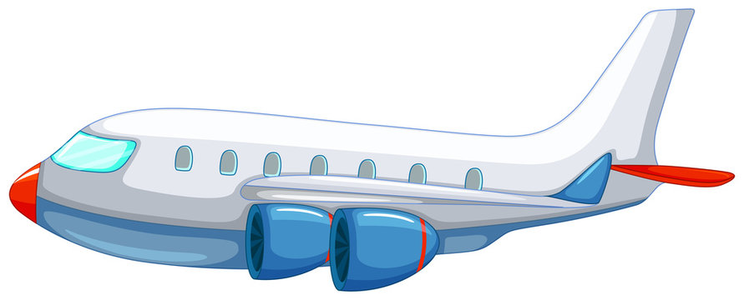

46. ( ) What does the word restrictions mean?
(A) Not convenient acts.
(B) Modern materials.
(C) Useful information.
(D) High prices.

47. ( ) What is the purpose of this reading?
purpose目的 inform知會 discount優惠

(A) To tell readers how an airplane works.
(B) To inform readers of some ticket discounts.
(C) To ask readers not to fly on big airlines.
(D) To give readers some tips on flying with budget airlines.

48. ( ) What is the writer’s attitude toward flying on budget airlines?
attitude態度 positive正面的 negative負面的
(A) Positive.
(B) Negative.
(C) Surprised.
(D) Angry.

49. ( ) Who is most likely to fly on budget airlines?
most likely 最可能 downtown市中心

(A) George, who usually travels in early mornings.
(B) Adam, who is about 190 centimeters tall.
(C) Jane, who loves to try special airline meals.
(D) Connie, who hates transportation and plans to stay at a
downtown hotel in New York city.

50. ( ) Which is TRUE about flying on budget airlines?
(A) You can choose your seats for free.
(B) You can bring two bags with you on the plane.
(C) You can use promo codes to buy tickets at a lower price.
(D) You can easily change your personal details after booking
the ticket.

【試題結束】

新北市立土城國民中學111學年度第1學期 第3次段考 英語科 8年級試題

第一部分聽力測驗
一、辨識句意：根據聽到的內容選出符合描述的圖片
- Jimmy dreamt of having his own castle.
- The lamp cost five thousand and six hundred dollars.
- The power of our house went out during the typhoon.
- John wanted to use the restroom.
- Remember to bring an umbrella with you on rainy days.

二、基本問答：根據聽到的內容選出一個最適合的回應
6. W: How long did it take you to get to the airport?
7. M: I’m sorry. I broke the windows yesterday.
8. W: Peter is going to wear his costumes to school tomorrow.
9. M: How did you travel around Taiwan?

三、言談理解：根據聽到的內容選出一個最適合的答案
10. B: Mom, what are we going to have for dinner tonight?
W: I’m cooking some beef noodles.
B: That’s great! But can I eat something before dinner? I’m starving.
W: Yes, we still have some pan-fried pork buns and bubble milk tea on the table. You can have some.
B: Thanks, mom.
Q: What can the boy eat before dinner?

11. M: Alicia, your mom and I are going to Moon River for lunch. Do you want to come, too?
G: No. I’m going to have lunch with Lisa today.
M: Actually, you can invite Lisa to lunch, too.
G: Really? That’s a great idea. I’ll ask her later.
Q: What is Moon River?

12. W: David, do you like living in Hualien?
M: Yes. It’s usually sunny in Hualien. Besides, we have Taroko Gorge and Qingshui Cliff. The scenery is really beautiful.
People here are friendly, too. They are always happy to lend a hand.
W: Wow, I’d like to move to Hualien, too.
Q: What does NOT David think of Hualien?

- W: Hi Mike, would you and your wife be free next Friday night?
M: I don’t think we have any plans. Why?
W: Well, my husband and I would like to invite you to our dinner party.
M: It would be our pleasure to join you. What kind of party is it?
W: We planned on having it formal. And we’re only inviting close friends.
M: That sounds fun. Usually we only have barbeques and never get a chance to dress up. I’m sure we’ll enjoy a great time.
Q: Which is TRUE?

新北市立土城國民中學111學年度第1學期第3次段考8年級英語科試題解答

選擇題
1 | 2 | 3 | 4 | 5 | 6 | 7 | 8 | 9 | 10
C | C | A | B | B | B | C | A | A | B
11 | 12 | 13 | 14 | 15 | 16 | 17 | 18 | 19 | 20
C | A | C | A | C | B | D | B | D | D
21 | 22 | 23 | 24 | 25 | 26 | 27 | 28 | 29 | 30
A | D | D | B | C | A | D | D | B | A
31 | 32 | 33 | 34 | 35 | 36 | 37 | 38 | 39 | 40
D | C | D | C | D | C | B | B | A | C
41 | 42 | 43 | 44 | 45 | 46 | 47 | 48 | 49 | 50
A | B | B | C | B | A | D | A | A | C

