新北市立土城國民中學110學年度第一學期第二次段考英文科八年級試題

【試題共4頁】聽力測驗：(22%)
一、辨識句意：根據聽到內容，選出符合描述的圖片。(3%)

(Ａ) 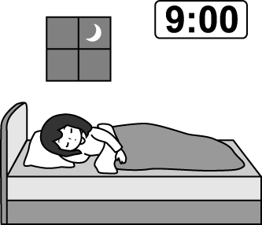 | (Ｂ)  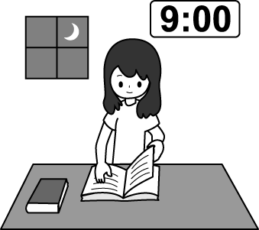 | (Ｃ)  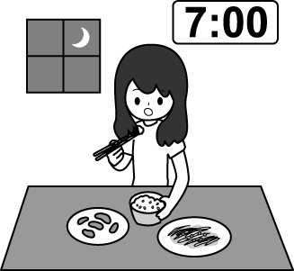

(Ａ)  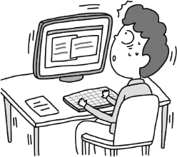 | (Ｂ)  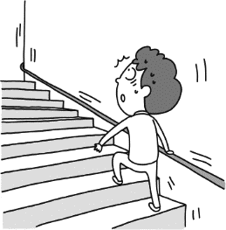 | (Ｃ)  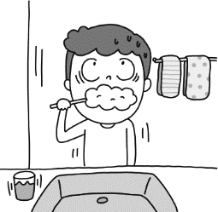

(Ａ)  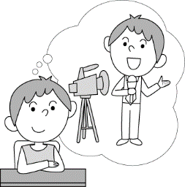 | (Ｂ)  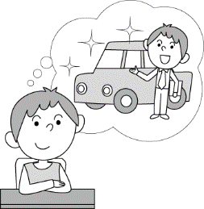 | (Ｃ)  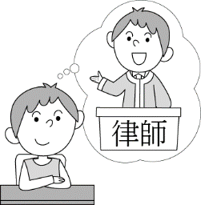
二、基本問答：根據聽到的內容，選出一個最適合的回應。(5%)
- (Ａ) Yes, there is still enough water.
(Ｂ) Yes, it is very important. It’s good for your health.
(Ｃ) No, I don’t really like the drink.
- (Ａ) Yes, I love traveling in the USA.
(Ｂ) Not really. I just practice speaking English for half an hour every day.
(Ｃ) I don’t like to stay at home. I like to go out.
- (Ａ) At half past six.
(Ｂ) It is difficult to get up early.
(Ｃ) I don’t need to get up at 6.
- (Ａ) She had a bad dream last night, so she was crying.
(Ｂ) She is taking a shower.
(Ｃ) She is reading an English book.
- (Ａ) I went fishing in the afternoon.
(Ｂ) I was making a phone call to my mom.
(Ｃ) I am doing my homework in the room.
三、言談理解：根據聽到的內容，選出一個最適合的答案。(6%)
- (Ａ) She likes to have some milk.
(Ｂ) She likes to watch TV.
(Ｃ) She likes to listen to music.
- (Ａ) In the school.
(Ｂ) On the website.
(Ｃ) In the clothing store.
- (Ａ) He is feeding the pet dog.
(Ｂ) He is drawing a picture.
(Ｃ) He is fixing the drawer.
四、根據以下的敘述，回答問題。題組一為12-13題，題組二為14-15題。(8%)
- (A) People celebrate Moon Festival all over the world.
(B) Moon Festival is an important holiday.
(C) Moon Festival is coming soon.
(D) People get together on Moon Festival.
- (A) They need to make moon cakes.
(B) They will go on a picnic for the festival.
(C) They need to make a list of the food.
(D) They will go to the convenient store.
- (A) A special building.
(B) A round wall.
(C) A big hole.
(D) A dome.
- (A) It leads to God.
(B) It has many big holes.
(C) It can move with the light.
(D) Air and light come through it.

【聽力測驗結束，請繼續作答】

五、語法選擇：請根據題意選出一個正確或最佳的答案。(30%)
16. A _______ of 150 is 75.
(A) half (B) quarter (C) minute (D) shape
17. After many years of hard work, Jeremy Lin a great basketball player.
(A) caught (B) grew (C) became (D) worried
18. Eric: Do you like Jessica?
Bill: Jessica? Who is she? I don’t _______ know her.
(A) even (B) just (C) however (D) suddenly
19. Which _______ is you favorite in Asia, Korea or Japan?
(A) right (B) country (C) truck (D) factory
20. After ten minutes trying to get the answer, Nancy _______.
(A) put on (B) gave up (C) made fun of (D) took out
21. Rebecca _______ comic books when her little brother fell off the chair.
(A) read (B) was reading
(C) reads (D) is reading
22. It is important for children enough sleep every day.
(A) get (B) got (C) getting (D) to get
23. I think is more fun（更好玩）to go to the movies with my friends than（比）with my family.
(A) one (B) it (C) that (D) there
24. Watching movies and playing basketball interesting.
(A) is (B) are (C) have (D) has
25. Lucy is good at cakes. She makes cakes for her children every weekend.
(A) cook (B) cooks (C) cooking (D) to cook
26. To learn English, Ella keeps English every day.
(A) practice speaking (B) practicing to speak
(C) to practice speaking (D) practicing speaking
27. Mom planned us out for dinner, so she didn’t need
dinner.
(A) taking; to make (B) to take; to make
(C) to take; making (D) taking; making
【背面尚有試題】
28. When Dad left for his office this morning, Mom ______ the dishes.
(A) washed (B) was washing
(C) washes (D) is washing
- John: Did you go to bed at ten forty-five?
Erin: That’s right. I went to bed at .
(A) a quarter after ten (B) fifteen after nine
(C) a quarter to eleven (D) fifteen to nine
- Frank: Where you your glasses?
Lisa: I it on my desk.
(A) were; finding; was (B) were; looking for; looked for
(C) did; find; found (D) did; found; looked for
六、克漏字測驗：(9%)
Cathy: Where were you at seven last night?
Helen: My sister, Ariel, and I were at the Family Market near our house. We (31) some snacks for our little sister’s eighth birthday then.
Cathy: Did you get all the things?
Helen: No. Ariel and I (32) a kind of chocolate from America, but we (33) it at all.
Cathy: Hey, I know a shop, and it sells many kinds of chocolate. Maybe you can (34) your sister’s favorite chocolate there.
Helen: Great! I hope I can buy some and give my sister a big surprise.
31. (A) buy (B) bought (C) are buying (D) were buying
- (A) are looking for (B) were looking for
(C) are taking out (D) were taking off
- (A) can’t get (B) can get
(C) couldn’t get (D) could get
- (A) sell (B) bought (C) find (D) found
Benson was a farmer. He grew and sold fruit. One day, Benson was selling his fruit on the street. A movie director came to him. (35) Benson could not believe it. He was just a farmer, but now he could be in a movie. However, Benson (36) his two big front teeth. When people saw him in the movie, they might make fun of his teeth. So Benson decided (37) . He used all his money to fix his teeth. On the day of meeting the director, he was so happy and showed the director his teeth. The director was not happy at all. She wanted a person with two big front teeth in her new movie. Now she did not want Benson in her movie. Benson’s dream (38) came to an end. But Benson learned one thing－it is not good (39) yourself for someone else.
35. (A) She taught Benson to make videos.
(B) She helped Benson to sell his fruit.
(C) She wanted Benson to be in her next movie.
(D) She wanted to buy all the fruit from Benson.
- (A) grew out(B) put on(C) believed in (D) worried about
- (A) to brush his teeth (B) to hide his teeth
(C) to go to the dentist(D) to give up his movie dream
- (A) to be his own boss (B) to be in the movie
(C) to be a successful farmer (D) to be a famous director
- (A) change (B) changing (C) to change (D) changes
六、 閱讀測驗：(20%)(40-49每題一分；50-54每題兩分)
(一)
Isn’t English great? You can put two easy words together and get a different meaning. For example, try putting another word with the word ”run.” When you run across something, you find it accidentally(意外地). When you run after something, you chase it. If someone runs away, they leave or escape. When you run out of something, you don’t have any more of it. And when you run into someone, you meet them without planning it.
40. What is the main idea of the reading?
(A) How to run in different ways.
(B) How to use the word “run” to make sentences.
(C) The different usages of “run” as a phrase.(片語)
(D) The magic of English as a wonderful language.
41. Lily: Guess what? I met Bill on the MRT yesterday. We didn’t see each other for a long time.
Susan: Wow! You _______ Bill. It’s such a surprise!
(A) ran into (B) ran after (C) ran away (D) ran out of
42. Tony: Kevin, why were you late for work this morning?
Kevin: I ______ oil on my way to the office, so I had to find a gas station to fill it.
(A) ran after (B) ran out of
(C) ran away (D) ran into
(二)
These days, it’s not enough to be a YouTuber. With over 30 million of them, it’s hard to get people to watch your videos. So, what can you do to get people’s attention?
To make your videos more interesting, you can become a Vtuber. You’ll still be a YouTuber, and you’ll still be in your videos. However, you won’t be a real person.
As a Vtuber, you’ll look like a Japanese anime(動漫) character(角色). With your cute new look, you are sure to get a lot more attention.
Vtuber stands for virtual YouTuber. The first “person” to use the term was Kizuna Al in 2016. People love this young Japanese woman.
Kizuna Al has big blue eyes, long brown hair, and a cute smile. She also has a pink hairband with a big pink heart. She loves looking into the camera and talking to her fans.
When Kizuna Al started, she had about 200,000 fans. Ten months later, she had two million, and now she has over four million. So, become a Vtuber and take your vlogging to the next level.
43. Which is true about Kizuna Al?
(A) She has blue hair.
(B) She doesn’t like to smile.
(C) She has pink eyes.
(D) She has millions of fans.
44. According to the fourth paragraph, what is the meaning of “virtual”?
(A) Vlog. (B) Not real.
(C) Usable. (D) Special.
【試題尚未結束，請繼續作答】
45. What is the reason of the creation of a Vtuber?
- People don’t like YouTuber anymore.
- It’s a way to catch people’s eye.
- Someone just made a video by accident.(意外地)
- Youtubers don’t want people to see their faces.
(三)
We all need to sleep. We do it to give our bodies energy and stay healthy. This is true for both humans and animals.
To sleep, human lie down on beds with pillows under their heads. They cover themselves with blankets to keep warm. Then, they close their eyes and rest.
Except for some pets, most animals don’t sleep that way. For example, horses, elephants, and giraffes stand up when they sleep. They also don’t sleep for very long. That way, they can be ready to run when there’s any danger.
Bats have an interesting sleeping habit, too. They hang upside down from tree branches, cave roofs, and other places. That keeps them safe from hungry animals. It also makes it easier for them to fly away.
Sleep for sea animals can be a challenge. They have to
worry about dangers in the water and breathing. Dolphins have a cool answer for that.
Dolphins only allow half their brains to sleep at a time. They sleep with one eye open as well. Think about these differences the next time you go to sleep.
46. What may be the title of the reading?
(A) Animal Sleeping Time (B) Animal Sleeping Habits
(C) The Importance of Sleep (D) How to Get a Nice Sleep
47. According to the reading, which of the following is true?
(A) Most animals lie down on the ground(地面) to sleep.
(B) Many birds hang upside down from tree branches when they sleep.
(C) Horses, elephants, and giraffes sleep for a long time to get sound sleep.
(D) It is hard for sea animals to sleep because of the dangers in water.
48. What do bats and dolphins have in common when they sleep?
(A) They sleep with one eye open.
(B) They have to worry about danger.
(C) They sleep upside down to keep safe.
(D) They need to think of breathing.
49. What do people NOT to do when they sleep?
(A) Put pillows under their heads.
(B) Cover their eyes with blankets.
(C) Put blankets on their bodies.
(D) Rest their bodies on the beds.
(四)
Many of us like to read books. We read everything from fiction(小說) to nonfiction. In the past, we could only read traditional(傳統的) books. They have front and back covers and many pages in between.
Now, we can also read e-books. They still have covers and pages, but they’re not made of paper. Instead, they’re pictures on a screen. So, we can’t actually touch them or turn them with our fingers.
Some people really love e-books. They can read them on their cell phones and other electronic devices(裝置). Because of that, they can carry a library of books with them all the time. In that way, e-books are great. However, in another way, they’re not so great because they changed the way people read.
With traditional books, we focus on the stories in front of us. Sometimes, we feel like we’re in the stories and forget about the real world. That’s not true with e-books, though. With them, our attention may be on other things.
With e-books, we can look up new words right away. That takes us out of the stories and to an online dictionary. From there, we can check our e-mail, surf the Internet, search for things to buy, and more.
That affects(影響) our reading patterns(模式). Our eyes stop reading everything on the page. Instead, they just look for keywords to get information. Some people don’t mind that, but for others, it takes the fun out of reading.

- What is the main idea of the reading?
(A) E-books are better(較好) than traditional books.
(B) We should not use traditional books anymore.
(C) It is fun to read everything on the same page with
e-books.
(D) E-books are changing the way we read.
- What are e-books NOT different from traditional books?
(A) They don’t have front or back covers.
(B) People can have a library of them on their phones.
(C) People can read them on their electronic devices.
(D) Their pages aren’t made of paper.
- What is the problem with reading e-books?
(A) They don’t have on-line dictionaries.
(B) People forget about the real world when doing that.
(C) They make people take their attention off(遠離) the Internet.
(D) People aren’t in the stories the whole time.
- What is the meaning of the phrase “take…out of” in the last(最後的) paragraph?
(A) Remove(移除).
(B) Change.
(C) Grow.
(D) Reduce.(減少)
- What CAN’T we learn from the reading?
(A) It’s convenient(方便的) to read with e-books.
(B) With e-books, we feel like we’re in the stories.
(C) With e-books, we can send e-mails and surf the Internet at the same time.
(D) Traditional books keep our attention on the stories only.
【試題尚未結束，請繼續作答】
非選擇題(19%)：請將答案寫到答案卷
一、寫出下列的單字或片語(8%)：
1.記得 2. 未來
3.秘書 4. 掃
5.經歷；經驗 6.成功的
7.相信 8. 害怕的(s_____d)
二、翻譯式填空：每格一分(11%)
9. 然而，在那之後我再也睡不著了。
(9) , I couldn’t fall (10) after that.
10. 當人們望著我時，我感到很緊張。
I get b(11) in my (12) when people watch me.
11. 我想要幫助需要幫助的人，為他們爭取權利(劃線部分請 用片語)。
I hope to help people (13 ) (13) and (14) (14) their (15) .
12.你一點十五分時在廚房做什麼?
What (16) you doing at a (17) after one?
13. 我夢遊的時候打破我的杯子。
I was (18) when I (19) my cup.

【試題結束】

新北市立土城國民中學110學年度第一學期第二次段考英文科八年級
非選擇題答案卷

班級： 座號： 姓名：______________
非選擇題(19%)(每格一分)

1. | 2. | 3.
4. | 5. | 6.
7. | 8. | 9.
10. | 11. | 12.
13. | 14. | 15.
16. | 17. | 18.
19.

八年級英文科解答
選擇題：

1 | 2 | 3 | 4 | 5 | 6 | 7 | 8 | 9 | 10
A | B | C | B | B | A | A | B | C | B
11 | 12 | 13 | 14 | 15 | 16 | 17 | 18 | 19 | 20
C | C | C | A | D | A | C | A | B | B
21 | 22 | 23 | 24 | 25 | 26 | 27 | 28 | 29 | 30
B | D | B | B | C | D | B | B | C | C
31 | 32 | 33 | 34 | 35 | 36 | 37 | 38 | 39 | 40
D | B | C | C | C | D | C | B | C | C
41 | 42 | 43 | 44 | 45 | 46 | 47 | 48 | 49 | 50
A | B | D | B | B | B | D | B | B | D
51 | 52 | 53 | 54
A | D | A | B

非選擇題 (19%)(每格一分)

1.remember | 2. future | 3. secretary
4. sweep | 5. experience | 6. successful
7. believe | 8. scared | 9. However
10. asleep | 11. butterflies | 12. stomach
13. in need | 14. fight for | 15. right
16. were | 17. quarter | 18. sleepwalking
19. broke

