新北市立土城國民中學111學年度第1學期 第2次段考 英語科 8年級試題
________________________________________________________________________________

【試題共3頁】
第一部分聽力測驗共25%
一、辨識句意：根據聽到的內容選出符合描述的圖片
(每題1%，共5%)
1. ( )
(A) 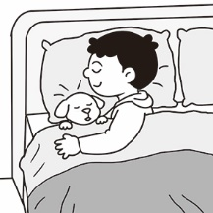 (B) 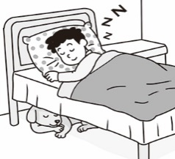(C) 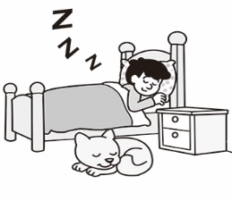
2. ( )
(A) 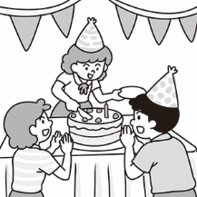 (B) 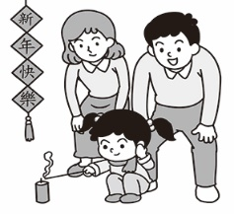 (C) 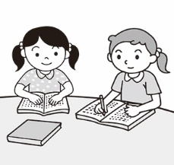
3. ( )
(A) 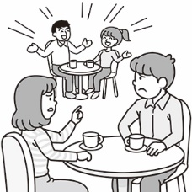 (B) 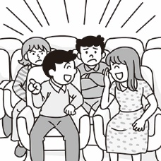 (C) 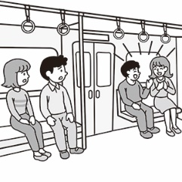
4. ( )
(A) 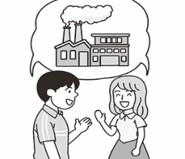 (B) 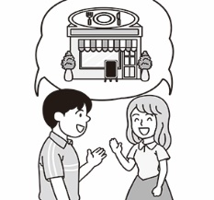(C) 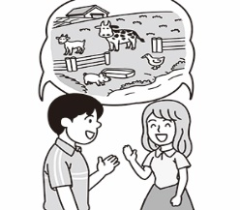
5. ( )
(A) 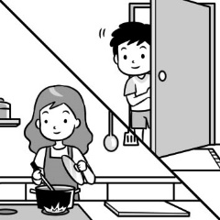 (B) 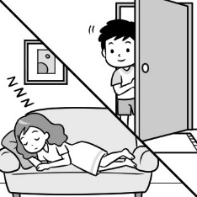 (C) 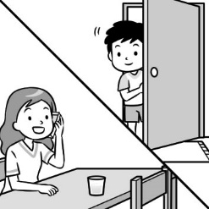
二、基本問答：根據聽到的內容選出一個最適合的回應
(每題2%，共10%)
6. ( )(A) We were reading in the classroom.
(B) We were not sleeping then.
(C) We were at the park.
7. ( )(A) The box was very big and deep.
(B) He passed the box to his mom.
(C) A frog jumped out.
8. ( )(A) From seven o’clock.
(B) One and a half hours.
(C) Twice a week.
9. ( )(A) I don’t like going fishing.
(B) I love going surfing.
(C) I like mountain climbing.

10.( )(A) They practice speaking with foreigners every day.
(B) There are many Americans in Taiwan.
(C) They chat with each other in Chinese.
三、言談理解：根據聽到的內容選出一個最適合的答案
(每題2%，共10%)
11.( ) (A)The man didn’t have a good time on his holiday.
(B) The man held a house-warming party.
(C) The woman prepared some food for her relatives.
- ( )(A)They will cheer the woman on.
(B) They will make a phone call.
(C) They will jump into the hole.
13.( )(A) She is a waitress now.
(B) She went to Australia and got a job there.
(C) She is still in Australia now.
14.( )(A) The woman will get a message from the
restaurant.
(B) The woman must wait outside the restaurant.
(C) The woman is having dinner in the restaurant now.
15.( )(A) In Taiwan, celery and scallion have good meanings for children.
(B) In German, big cones are not important at all.
(C) German first graders only get candy in their cones.

第二部分綜合測驗共56%
四、單字、文法與對話 (每題2%，共26%)
16.( ) My brother likes to drink a glass of ________ juice before he goes to school.
(A) wet (B) fresh (C) deaf (D) clear
17.( ) Ms. Lee is a teacher with lots of __________. I
know for sure that she can solve the problem.
(A) lessons (B) experience (C) jobs (D) hens
18.( ) Look! There are so many monkeys ________ up
and down the trees over there.
(A) arriving (B) surfing (C) climbing (D) cheering
19.( ) Everything is ___________ if you give it a try.
(A) deep (B) tired (C) possible (D) unhappy
20.( ) We cheered the runners on _______ they went by.
(A) when (B) because (C) during (D) after
21.( ) Sean: What ______ John ______ at eleven last night?
Morris: He was chatting online.
(A) were ; doing (B) did ; do
(C) was ; doing (D) does ; do
【請翻頁】
22.( ) My grandparents usually had some wine (紅酒)
___________ to bed many years ago.
(A) after going (B) before going
(C) after they went (D) before they go
23.( ) When my baby______ , I was cooking in the kitchen.
(A) cry (B) cries (C) crying (D) cried
24.( ) We _______to take a two-day trip to Hsinchu next
month. It is our first trip with classmates.
(A) plan (B) enjoy (C) keep (D) begin
25.( ) Our teacher told us that she spent much time _______
Chinese and math exercises when she was a student.
(A) to do (B) do (C) doing (D) does
26.( ) All of us start ____ the classroom at 12:20 every day.
(A) not to clean (B) clean (C) cleaned (D) to clean
27.( ) Gary: Stop ________, everybody. It’s time for lunch.
(A) to talk (B) talk (C) talking (D) to talking
28.( ) Anna: I am not good at ________ volleyball. I need
some help.
Elaine: I can teach you.
(A) to play (B) play (C) played (D) playing
五、克漏字(每題2%，共8%)
I am an animal lover. __(29)_ I was a kid, I went to different zoos to see animals with my family. In order to know all the animal species(物種), I even read many books about animals. When I graduated from junior high school, my parents___(30)__ me to Tanzania to see real wild animals. As I turned 18, I __(31)__ the arctic to see real polar bears. It was quite cold there, but I could see them clearly. My dream is to work in a zoo in the future. I want to be a zookeeper to __(32)_ animals in the world.
29.( ) (A) When (B) Before (C) After (D) Because
30.( ) (A) send (B) to send (C) sent (D) sending
31.( ) (A) was traveling (B) traveled to
(C) travel to (D) am traveling
32.( ) (A) pass by (B) cry for help
(C) laugh at (D) take care of
六、閱讀理解(每題2%，共22%)
(33-34)
Once upon a time, there was a donkey. He had to carry heavy things to the market with his owner every day, and he was
always very tired of this boring work. One day, the donkey
carried many bags of salt, and then he fell into the river. After he was pulled out of the river by his owner, he found the bags on his back became lighter because most of the salt melted in the river. Suddenly, the donkey understood something. He found a smart way to make his bags lighter.
A few days later, the donkey carried some many bags of cotton to the market again. When he got to the river, he tried hard to fall into the water. However, when his owner saved him from the river again, those bags were not lighter but much heavier. From then on, he knew that he should keep his feet on the ground.
*lighter 較輕的 / melt 融化 / cotton 棉花
33.( ) Why do the bags of cotton on the donkey’s back
become heavier?
- Because the owner put some stones in them.
- Because the bags became more and more.
- Because there were water animals in the bag.
(D) Because there was much water in the cotton.
34.( ) What does the idiom “keep one’s feet on the
ground” mean?
- People should do his/her work well.
- People should live a happy life.
- People should be busy working.
- People can’t do anything wrong.
(35~37)
If someone has no arms and legs, can he live a happy life?
In 1982 in Australia, Nick Vujicic was born without arms and legs. His mother was so shocked and sad, and didn’t want to see this baby. Finally, she and her husband accepted the baby boy. They gave this boy lots of love and care, and they raised him up in a positive way. They sent him to normal schools to learn knowledge and to learn how to get along with normal children. Sadly, he was bullied during his school days, and he tried to end his life many times. After learning a Christian story by chance, he knew that he or his parents didn’t do anything wrong, and it is God, who wants him to teach the world something. Because of his parents’ love and his belief in God, he can get through all the ups and downs in his life.
Nick is just like us. He can do many things, like walking, writing, swimming, taking a shower, cooking, and so on. He even finished his studies at university. Now, he is a father of four children, a founder of a charity, and a famous writer and speaker who travels around the world to share his story. In his numerous speeches, he tries his best to tell everyone: Everyone is special and is strong to overcome the limits in life. Don’t give up.
*accept 接受 / raise 養育 / positive 正向的 / normal 正常的 /
*bully 霸凌 / university 大學 / founder 創辦人 / charity 慈善機構

【請換下一張試卷並繼續作答】
35.( ) What does Nick do now?
(A) He is a famous athlete.
(B) He tells his story and gives hope.
(C) He travels around the world to teach children.
(D) He writes children’s books.
36.( ) What does ups and downs mean in the reading?
(A) Bad luck and troubles. (B) Magic and love.
(C) Joy and sadness. (D) Money and power.
37.( ) Which is NOT the lesson from Nick’s story?
(A) Everyone is special.
(B) Don’t give up easily.
(C) The troubles in life do us good.
(D) Always work hard because life is hard.
(38~40)
Surfing is one of the most popular extreme sports in the world. There are many types of surfing. If you want to learn surfing, maybe you can start with windsurfing. It is easier than wave surfing. In windsurfing, you need a sail and a surfboard to move on the water with the help of wind. You have to stand firm on the board and control the sail at the same time.
On the other hand, in wave surfing, all you need is just a surfboard. Wave surfing is more affected by the waves. Usually, you take some lessons from professional coaches before enjoying surfing. By taking these courses, you learn how to climb on top of the surfboard and stay in balance in waves and wind. What’s more, you also learn safety information and how to look for the appropriate surfboard for yourself.
The following shows what items a surfer needs.
 | surf goggles | surfboard leashes | surf wax | surf booties | anti-UV suits
a must |  | V | V |  | V
not a must | V |  |  | V
*extreme 極限的 / sail 帆 / firm 穩固地 / board 板子 / affect 影響 /
*balance 平衡 / appropriate 適合的
38.( ) What is the main idea of this reading?
(A) How important safety is.
(B) Where to buy surfing items.
(C) The differences between two kinds of surfing.
(D) The beaches to go windsurfing and wave surfing.
39.( ) What are the items that a surfer DOESN’T NEED to
buy?
(A) Anti-UV suits and surfboard leashes.
(B) Surfboard leashes and surf wax.
(C) Surf wax and surf goggles.
(D) Surf goggles and surf booties.
40.( )What can we know from the reading?
- Wave surfing is easier than windsurfing.
- Windsurfers don’t need wind to move on the sea.
- Balance is not important for surfers.
- We should know more about safety information before surfing.
(41~43)
The last thing you might expect to find on the top of a machine is a bag of corn cookies. However, it is not surprising to see green bags of coconut-flavored corn cookies in mechanical and electronic devices in Taiwan. This kind of bag is called “Kuai Kuai,” and it is related to the superstition culture in Taiwan.
The word, “Kuai” means “be good” in Chinese, and it is the name that gives this snack the power to protect machines. Many people believe that putting a bag of “Kuai Kuai” on the top of a machine, such as a copy machine and a computer, will keep them from breaking down. It is common to see this bag of cookies in companies, hospitals, government offices, and school offices, of course. In fact, “Kuai Kuai” comes in many flavors and colors, but it is the green one that owns the magic power. That’s probably because a green light on a machine often means it is working well.
Nobody is quite sure the start of this tradition. Some say that an IT graduate student started it after the computer he used kept breaking down. The student placed a pack of “Kuai Kuai” on the computer, and it seemed to work out. As a result, this magical remedy began to spread out in Taiwan.
*expect 期待 / machine 機器 / mechanical 機械的 / electronic 電子的 / *device 設備 / related 相關的 / superstition 迷信 / remedy 解決辦法
41.( ) Which is true about the “Kuai Kuai” tradition?
(A) All of us know the beginning of this remedy.
(B) This tradition is common in the offices.
(C) Every kind of corn cookies can protect machines.
(D) A factory worker started to use it to fix machines.
42.( ) Why is the green “Kuai Kuai” commonly used?
(A) Because this flavor is cheaper.
(B) Because its color is a symbol of “working well”
(C) Because only green bags have “Kuai Kuai”
printed on them.
(D) Because it comes in both large and small packs.
43.( ) According to this reading, which of the following
things wouldn’t people put “Kuai Kuai” on it?
- A trash can (垃圾桶) in a classroom.
- A cash register (收銀機) in a store.
- A computer in a trading company (貿易公司).
(D) A washing machine in a laundry (洗衣店).

【請翻面並繼續完成非選擇題】
第三部分非選擇題測驗共19%
請用黑筆直接書寫在下方並繳回此卷，違者不計分
班級:
座號:
姓名:
得分: /19

七、單字(每格1%，共10%)
1. 感到驚訝的(adj.) | 2. 練習(v.)(n.)
3. 蝙蝠(n.) | 4. 海龜(n.)
5. 訊息(n.) | 6. 元(n.)
7. 困難的(adj.) | 8. 準備 (v.)
9. 露營(v.) | 10. 日落(n.)

八、句子填空與翻譯(填空每格1分，翻譯題3分，分段
給分，共9%)
1.別試了，否則你會掉到洞底而死掉。
Don’t try _______________, or you could fall down to the ______________ and die.
2.當我年紀夠大時，我想去打工度假。
I want to take a working _______________ when I am old _______________.
3.多虧他們，我開始(b…)喜歡這個地方。(過去式)
____________ to them, I _____________ to like this place.
4. 那位業務員喜歡(e…..)閱讀。(表事實)
他上週花很多時間在其中。
___________________________________________________________

____________________________________________

【試題結束，請仔細檢查答案並將此張繳回】
【預祝考試順利】
新北市立土城國民中學111學年度第1學期第2次段考8年級英語科試題解答

選擇題
1 | 2 | 3 | 4 | 5 | 6 | 7 | 8 | 9 | 10
C | B | C | C | A | A | C | B | B | A
11 | 12 | 13 | 14 | 15 | 16 | 17 | 18 | 19 | 20
C | B | B | A | A | B | B | C | C | A
21 | 22 | 23 | 24 | 25 | 26 | 27 | 28 | 29 | 30
C | B | D | A | C | D | C | D | A | C
31 | 32 | 33 | 34 | 35 | 36 | 37 | 38 | 39 | 40
B | D | D | A | B | C | D | C | D | D
41 | 42 | 43
B | B | A

非選擇題

七、單字(每格1%，共10%)

1. 感到驚訝的(adj.)  surprised | 2.練習(v.)(n.)  practice
3.蝙蝠(n.)  bat | 4. 海龜(n.)  sea turtle
5. 訊息(n.)  message | 6. 元(n.)  dollar
7. 困難的(adj.)  difficult | 8. 準備 (v.)  prepare
9. 露營(v.)  camp | 10. 日落(n.)  sunset

八、句子填空與翻譯(填空每格1分，翻譯題3分，分段給分，共9%)

1.別試了，否則你會掉到洞底而死掉。
Don’t try anymore, or you could fall down to the bottom and die.
2.當我年紀夠大時，我想去打工度假。
I want to take a working holiday when I am old enough.
3.多虧他們，我開始喜歡這個地方。
Thanks to them, I began to like this place.
4. 那位業務員喜歡(e…..)閱讀。(表事實)
他上週花很多時間在其中。
That salesman enjoys reading. He spent a lot of/lots of/much time on it last week.

