新北市立土城國民中學111學年度第1學期 第2次段考 英語科 8年級試題(B)
________________________________________________________________________________

【試題共3頁】
第一部分聽力測驗共25%
一、辨識句意：根據聽到的內容選出符合描述的圖片
(每題1%，共5%)
1. ( )
(A) 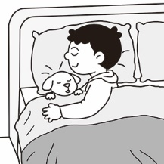 (B) 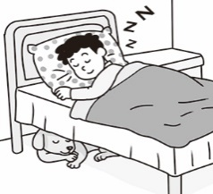(C) 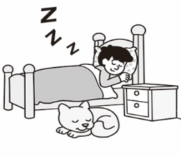
2. ( )
(A) 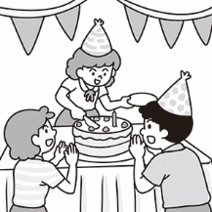 (B) 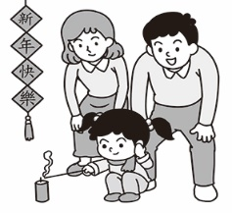 (C) 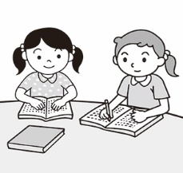
3. ( )
(A) 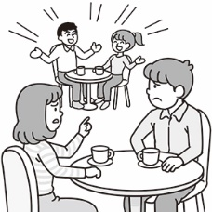 (B) 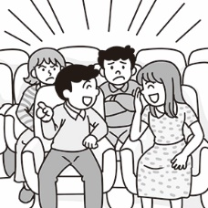 (C) 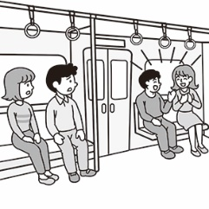
4. ( )
(A) 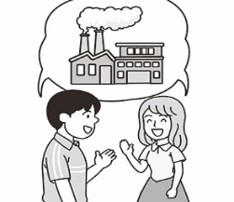 (B) 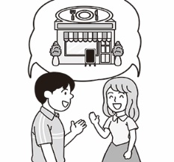(C) 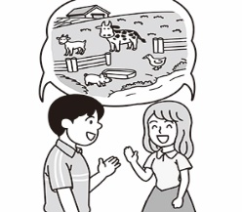
5. ( )
(A) 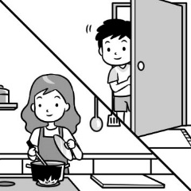 (B) 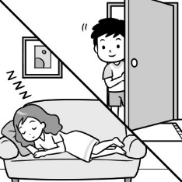 (C) 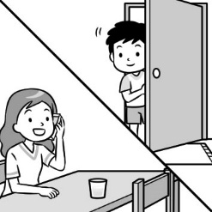
二、基本問答：根據聽到的內容選出一個最適合的回應
(每題2%，共10%)
6. ( )(A) We were reading in the classroom.
(B) We were not sleeping then.
(C) We were at the park.
7. ( )(A) The box was very big and deep.
(B) He passed the box to his mom.
(C) A frog jumped out.
8. ( )(A) From seven o’clock.
(B) One and a half hours.
(C) Twice a week.
9. ( )(A) I don’t like going fishing.
(B) I love going surfing.
(C) I like mountain climbing.

10.( )(A) They practice speaking with foreigners every day.
(B) There are many Americans in Taiwan.
(C) They chat with each other in Chinese.
三、言談理解：根據聽到的內容選出一個最適合的答案
(每題2%，共10%)
11.( ) (A)The man didn’t have a good time on his holiday.
(B) The man held a house-warming party.
(C) The woman prepared some food for her relatives.
- ( )(A)They will cheer the woman on.
(B) They will make a phone call.
(C) They will jump into the hole.
13.( )(A) She is a waitress now.
(B) She went to Australia and got a job there.
(C) She is still in Australia now.
14.( )(A) The woman will get a message from the
restaurant.
(B) The woman must wait outside the restaurant.
(C) The woman is having dinner in the restaurant now.
15.( )(A) In Taiwan, celery and scallion have good meanings for children.
(B) In German, big cones are not important at all.
(C) German first graders only get candy in their cones.
第二部分綜合測驗共56%
四、單字、文法與對話 (每題2%，共26%)
16.( ) My brother likes to drink a glass of ________ juice before he goes to school.
(A) wet (B) deaf (C) fresh (D) clear
17.( ) Ms. Lee is a teacher with lots of __________. I
know for sure that she can solve the problem.
(A) lessons (B) jobs (C) hens (D) experience
18.( ) Look! There are so many monkeys ________ up
and down the trees over there.
(A) arriving (B) surfing (C) climbing (D) cheering
19.( ) Sally was so mean. She _________ at me when I fell
down the bike.
(A) heard (B) laughed (C) cried (D) typed
20.( ) Cindy knew nothing about her teachers ________
she first met them.
(A) after (B) because of (C) when (D) during
21.( ) Peter: What ______ John ______ at ten last night?
Morris: He was chatting online.
(A) were ; doing (B) did ; do
(C) was ; doing (D) does ; do 【請翻頁】
22.( ) My grandparents usually had some wine (紅酒)
___________ to bed many years ago.
(A) after going (B) before they went
(C) after they go (D) before they go
23.( ) When Dad _____ , Mom was cooking in the kitchen.
(A) came back (B) come back
(C) comes back (D) coming back
24.( ) We _________to take a two-day trip to Hsinchu next
month. It is our first trip with classmates.
(A) finish (B) enjoy (C) plan (D) start
25.( ) Our teacher told us that she spent much time _______
Chinese and math exercises when she was a student.
(A) on (B) in (C) at (D) beside
26.( ) All of us start ____ the classroom at 12:20 every day.
(A) not to clean (B) clean (C) cleaned (D) to clean
27.( ) Gary: Stop ________, everybody. It’s time for lunch.
(A) talk (B) talking (C) to talk (D) talks
28.( ) Jeffery: Anna, you should avoid __________ black
tea and coffee, or you can’t sleep well.
(A) drinks (B) to drink (C) drinking (D) drank
五、克漏字(每題2%，共8%)
Miss Lin: I need to talk with your father about your grades.
Edison: He’s very busy these days. In fact, he ___(29)____in his
room when I was ready for school this morning.
Miss Lin: Doesn’t he go home for dinner every day?
Edison: Yes. But he sometimes ____(30)___ home late and has late dinner with my mom.
Miss Lin: What do you do before going to bed?
Edison: I usually ____(31)___ English before going to sleep.
Miss Lin: The, why you don’t do well on your English tests?
Edison: I __(32)__ when I study. Maybe that’s a bad studying
habit.
29.( ) (A) sleeps (B) sleep (C) was sleeping (D) slept
30.( ) (A) goes (B) go (C) is going (D) went
31.( ) (A) studied (B) study (C) to study (D) am studying
32.( ) (A) pass by (B) cry for help
(C) pass away (D) listen to music
六、閱讀理解(每題2%，共22%)
(33-34)
Have you heard of Black Friday? When the thirteenth day of a month falls on Friday, people believe it is a bad day. This is a misunderstanding that most people in Taiwan have for Friday the thirteenth. They think it is an unlucky day and mistake it for Black Friday.
In fact, Thanksgiving falls on the fourth Thursday of
November, and the so-called Black Friday is the day after it. This Friday is a big day for people in the USA because it is time to shop for Christmas presents. On that day, everyone is happy because everything in the department stores is on sale. People can get the same things at a lower price. It’s a day full of joy and happiness.
33.( ) When is Black Friday?
(A) It’s on November 25.
(B) It’s on December 25.
(C) It’s the day after Thanksgiving.
(D) It’s the day before Christmas.
34.( ) Which of the following statements is true?
(A) People usually have a big dinner with family on
Black Friday.
(B) There are many “Black Fridays” in a year.
(C) We can’t get anything cheaper on Black Friday.
(D) On Black Friday, most people in the USA go to
department stores to look for Christmas presents.
(35~37)
If someone has no arms and legs, can he live a happy life?
In 1982 in Australia, Nick Vujicic was born without arms and legs. His mother was so shocked and sad, and didn’t want to see this baby. Finally, she and her husband accepted the baby boy. They gave this boy lots of love and care, and they raised him up in a positive way. They sent him to normal schools to learn knowledge and to learn how to get along with normal children. Sadly, he was bullied during his school days, and he tried to end his life many times. After learning a Christian story by chance, he knew that he or his parents didn’t do anything wrong, and it is God, who wants him to teach the world something. Because of his parents’ love and his belief in God, he got through all the ups and downs in his life.
Nick is just like us. He can do many things, like walking, writing, swimming, taking a shower, cooking, and so on. He even finished his studies at university. Now, he is a father of four children, a founder of a charity, and a famous writer and speaker who travels around the world to share his story. In his numerous speeches, he tries his best to tell everyone: Everyone is special and is strong to overcome the limits in life. Don’t give up.
*accept 接受 / raise 養育 / positive 正向的 / normal 正常的 /
*bully 霸凌 / university 大學 / founder 創辦人 / charity 慈善機構
35.( ) What does Nick do now?
(A) He is a famous athlete.
(B) He writes children’s books.
(C) He tells his story and gives hope.
(D) He travels around the world to teach children.
【請換下一張試卷並繼續作答】
36.( ) What does ups and downs mean in the reading?
(A) Joy and sadness. (B) Magic and love.
(C) Bad luck and troubles. (D) Money and power.
37.( ) What CAN NOT we learn from Nick’s story?
(A) Everyone is special.
(B) Don’t give up easily.
(C) The troubles in life do us good.
(D) Always work hard because life is hard.
(38~40)
Surfing is one of the most popular extreme sports in the world. There are many types of surfing. If you want to learn surfing, maybe you can start with windsurfing. It is easier than wave surfing. In windsurfing, you need a sail and a surfboard to move on the water with the help of wind at the same time. You have to stand firm on the board and control the sail.
On the other hand, in wave surfing, all you need is just a surfboard. Wave surfing is more affected by the waves. Usually, you take some lessons from professional coaches before enjoying surfing. By taking these courses, you learn how to climb on top of the surfboard and stay in balance in waves and wind. What’s more, you also learn safety information and how to look for the appropriate surfboard for yourself.
The following shows what items a surfer needs.
 | surf goggles | surfboard leashes | surf wax | surf booties | anti-UV suits
a must |  | V | V |  | V
not a must | V |  |  | V
*extreme 極限的 / sail 帆 / firm 穩固地 / board 板子 / affect 影響 /
*balance 平衡 / appropriate 適合的
38.( ) What is the main idea of this reading?
(A) Where to buy surfing items.
(B) How important safety is.
(C) The differences between two kinds of surfing.
(D) The beaches to go windsurfing and wave surfing.
39.( ) According to the chart, what doesn’t a surfer need?
(A) Anti-UV suits and surfboard leashes.
(B) Surf goggles and surf booties.
(C) Surf wax and surf goggles.
(D) Surfboard leashes and anti-UV suits.
40.( )What can we know from the reading?
- Wave surfing is easier than windsurfing.
- Windsurfers don’t need wind to move on the sea.
- Balance is not important at all for surfers.
- We should know more about safety information before surfing.

(41~43)
Luck is something that people have different ideas about. Some people think luck is the game of chance, and we can’t decide whether it is meant to happen or not. Some people are superstitious and believe certain items can bring good luck to them. These items may be accessories or clothes. For example, the former NBA superstar, Michael Jordan, always wore his UNC shorts under his jersey to pray for good luck during each game that he played as a professional. Tennis player Serena Williams doesn’t change her socks when she is winning during tournaments. These athletes wear their lucky clothes because they believe the clothes will bring them good luck. But, do you know that sometimes luck itself chooses the clothes?
Gustav Iden is a triathlon athlete from Norway. He has won six races since 2019, which is amazing. But interestingly, he is wearing the same Taiwanese temple hat while winning all of the races. This dark blue hat has the name of Puyan Shunze Temple, a temple located in Changhua City, on it. However, Iden doesn’t see his hat luck. “I don’t really believe in luck. I believe in confidence.,” he said.
* whether是否 / superstitious 迷信的 / accessories 飾品
* jersey 球衣 / triathlon 三鐵
41.( ) Which is true about Gustav Iden?
(A) He feels that Puyan Shunze Temple is the best.
(B) He believes confidence is more important.
(C) He wants everyone to have the same hat.
(D) He wears the same shorts during all of the races.
42.( )Which is Not an example of a lucky item?
(A) Emma uses the same 2B pencil on every test.
(B) Eddy has a pair of shoes that he wears to every
basketball game.
(C) Elaine wears her blue T-shirt for every race.
(D) Anna puts on green glasses on Christmas.
43.( ) According to this reading, which is true about luck?
- We get bad luck because we don’t have lucky items.
- Having lucky items makes our life better.
- Not everyone has the same feeling about luck.
- People can make lucky clothes by themselves.

【請翻面並繼續完成非選擇題】
第三部分非選擇題測驗共19%
請用黑筆直接書寫在下方並繳回此卷，違者不計分
班級:
座號:
姓名:
得分: /19

七、單字(每格1%，共10%)
1. 感到驚訝的(adj.) | 2. 練習(v.)(n.)
3. 抵達/到達(v.) | 4. 可能的(adj.)
5. 訊息(n.) | 6. 元(n.)
7. 困難的(adj.) | 8. 女服務生 (n.)
9. 手機(n.) | 10. 日落(n.)

八、句子填空與翻譯(填空每格1分，翻譯題3分，分段
給分，共9%)
1.Fred也很累了，但他仍不斷嘗試。
Fred was also ____________, but he was still ___________.
2. 我應該做什麼準備呢?
What should I ___________ to ______________?
3.多虧他們，我開始(b…)喜歡這個地方。(過去式)
____________ to them, I _____________ to like this place.
4. 那位業務員喜歡(e…..)聽音樂。(表事實)
他上週花很多時間在其中。
___________________________________________________________

____________________________________________

【試題結束，請仔細檢查答案並將此張繳回】
【預祝考試順利】
新北市立土城國民中學111學年度第1學期第2次段考8年級英語科試題解答(B)

選擇題
1 | 2 | 3 | 4 | 5 | 6 | 7 | 8 | 9 | 10
C | B | C | C | A | A | C | B | B | A
11 | 12 | 13 | 14 | 15 | 16 | 17 | 18 | 19 | 20
C | B | B | A | A | C | D | C | B | C
21 | 22 | 23 | 24 | 25 | 26 | 27 | 28 | 29 | 30
C | B | A | C | A | D | B | C | C | A
31 | 32 | 33 | 34 | 35 | 36 | 37 | 38 | 39 | 40
B | D | C | D | C | A | D | C | B | D
41 | 42 | 43
B | D | C

非選擇題

七、單字(每格1%，共10%)

1. 感到驚訝的(adj.)  surprised | 2.練習(v.)(n.)  practice
3. 抵達/到達(v.)  arrive | 4. 可能的(adj.)  possible
5. 訊息(n.)  message | 6. 元(n.)  dollar
7. 困難的(adj.)  difficult | 8. 女服務生 (n.)  waitress
9. 手機(n.)  cellphone | 10. 日落(n.)  sunset

八、句子填空與翻譯(填空每格1分，翻譯題3分，分段給分，共9%)
1.Fred也很累了，但他仍不斷嘗試。
Fred was also tired, but he was still trying.
2. 我應該做什麼準備呢?
What should I do to prepare?
3.多虧他們，我開始喜歡這個地方。
Thanks to them, I began to like this place.
4. 那位業務員喜歡(e…..)聽音樂。
他上週花很多時間在其中。
That salesman enjoys listening to music.
He spent a lot of/lots of/much time on it last week.

