新北市立土城國民中學109學年度第2學期
第1次段考英文科（8年級）試題
第一部分:聽力測驗 18% 【試題共四頁】
一、辨識句意-根據聽到的內容，選出正確的圖片代碼：3%
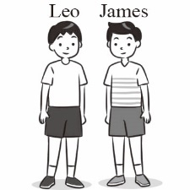
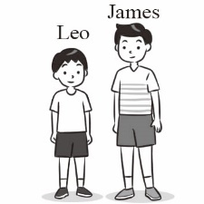
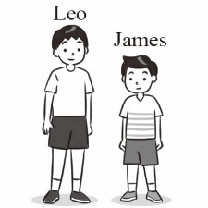
- (A) (B) (C)

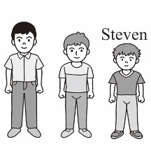
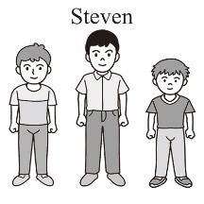
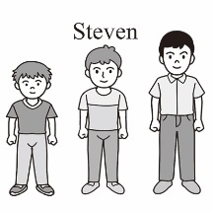
- (A) (B) (C)

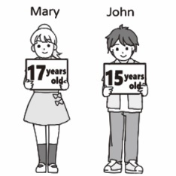
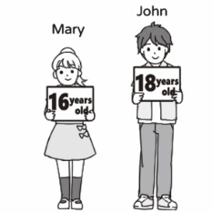
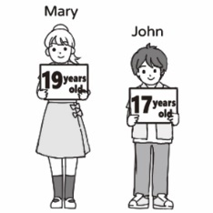
- (A) (B) (C)

二、基本問答-根據聽到的內容，選出合適的回應：3%
- (A) No, it’s white.
(B) You are so nice.
(C) And it’s cheaper, too.

- (A) They are yours.
(B) They look beautiful.
(C) He likes white shoes.

- (A) It’s easier to buy hot dogs.
(B) Pumpkin pie is the most difficult for me to make.
(C) For me, pumpkin pie is the most delicious of the three.
三、言談理解-根據聽到的內容與問題，選出正確的答案：12%
- (A) On a bus.
(B) On a plane.
(C) On a train.
- (A) $200.
(B) $400.
(C) $100.
第一面
- (A) The black skirt is cheaper.
(B) The woman might buy the yellow one.
(C) The woman thinks the price isn’t good.

- (A) It’s the bigger one of the two cars.
(B) It’s smaller than his old car.
(C) It is as powerful as his old car.

- (A) At the international airport in Hong Kong.
(B) The international airport in Singapore.
(C) The international airport in Amsterdam.

- (A) The international airport in Hong Kong.
(B) The international airport in Singapore.
(C) The international airport in Amsterdam.
第二部分:選擇題 58%
- 字彙與文法34%
- Timmy: Linda is ____beautiful than Zoe.
(A) more (B) little (C) most (D) few
- Tim’s house is wider than _____.
(A) you (B) her (C) me (D) ours
- Bella: Why don’t we have a vacation this summer? The scenery of Yushan is quite nice.
Hank: It ______ like a good idea.
(A) tastes (B) hears (C) sounds (D) looks
- Mira: _____ does the rabbit meat taste _____?
Peter: I had no chance to give it a try.
(A) How ; like (B) What ; like (C) How’s ; X (D) What ; X 【背面尚有試題】
- Wendy’s gloves are dirty, but Mike’s _____.
(A) aren’t (B) is (C) doesn’t (D) isn’t
- Have some hot ______. It can warm you up.
(A) deal (B) sushi (C) salad (D) soup
- Pan cleaned the house and took out the _____.
(A) trash (B) bath (C) snow (D) dish
- Some people take the_____Chinese medicine when they get sick.
(A) young (B) traditional (C) free (D) bell
- My grandpa _____ sick after he drank too much last night.
(A) saw (B) sounded (C) felt (D) tasted

- Julie: ____ do you feel about the movie?
Nancy: It’s a sad story. It makes me cry.
(A) Where (B) What (C) When (D) How
- Sera: What does _____feel like?
Pete: It feels like a dream.
(A) winning the game
(B) win the game
(C) wins the game
(D) won the game
- Eva: __________
Tom: Yes. It was also the greatest trip to me.
(A) What a wonderful experience!
(B) I have one with the Gouda Cheese.
(C) He may come back later.
(D) Poor you.
- Alice: Jackson, would you like to eat out with me this evening?
Jackson: Sorry, I still have a lot of work to do. __________
(A) Maybe next time.
(B) Let’s enjoy the cheese from the Netherlands.
(C) You should give it a try.
第二面
(D) Here you go.
- Patty is much _____ now. The pants she bought last year are too short.
(A) older (B) taller (C) hotter (D) longer
- The Turkish houses here are _____ nicer than the houses in Cambodia.
(A) more (B) a few (C) much (D) most
- Fay: Which one is _____, Matt, Timothy or Joe?
(A) better (B) the better (C) best (D) the best
- Eva ate only one bowl of soup. And Wendy ate five bowls of soup. Wendy ate __________ soup than Eva.
(A) very
(B) much
(C) less
(D) much more

- 克漏字 10%
30-34
Before you buy the cheese at the cheese market, be sure to test by 30 on it. 31 , you can also 32 , smell and even eat it. You can make a choice when you and the seller agree on the price. When you make a 33 , you can smile and 34 with the seller.
- (A) looking (B) clapping (C) ringing (D) knocking
- (A) However (B) Besides (C)Therefore (D) Because
- (A) sound (B) feel (C) touch (D) hear
- (A) seller (B) buyer (C) money (D) deal
- (A) turn left (B) laugh at (C) shake hands (D) cool down
35-39
Willy: Do you see my towel in the bathroom?
Sally: No, the gray one with a duck is 35 . Yours 36 the red one with a rabbit.
Willy: But I can’t find 37 . Could you please do me a favor? Get one for me. I am wet now.
Sally: Okay. By the way, 38 do you want to have 39 lunch, paella, Curry rice or Tacos?
Willy: Up to you. I am not so hungry now.
- (A) mine (B) her (C) its (D) their
- (A) was (B) are (C) have (D) is
- (A) them (B) it (C) this (D) ones
- (A) when (B) what (C) which (D) how

- (A) to (B) at (C) in (D) for

- 閱讀題 12%
40-41 The Cooper’s Hill Cheese-Rolling and Wake
The Cooper’s Hill Cheese-Rolling and Wake is a festival at Cooper’s Hill in England once a year. Because it’s becoming more and more popular, players from all over the world join the festival. There are even a lot of people coming to watch the game.
From the top to the hill, one of the players rolls a 7-pound Double Gloucester cheese, and the other players run down after it. The first person reach the finish line at the bottom of the hill wins the cheese. Because of the high and uneven way of the hill, a lot of people get hurt easily and sometimes seriously. So some ambulance vehicles come to the festival, too. If people get hurt, they will pack them off to the hospital right away.
【背面尚有試題】

- What does “pack off” mean here in the reading?
(A) Put in.
(B) Get on.
(C) Turn off.
(D) Take away.
- Which is true about the reading?
(A) From the bottom to the top, one of the players rolls a 7-pound Double Gloucester cheese.
(B) People around the world can enjoy the festival.
(C) Nobody may get hurt in the game.
(D) Only people in England can join the game.
42-43
When it keeps raining
And the days are as gray as they can be
That’s the good time to be alone with ourselves
And think about the way up to you
Life is always not that easy for you and me

Though the days are darker and 43
The warmth in your heart never goes away

No more days of gloom and sadness

The day will become sunny and bright
The sun is shining just for you
And you will beam with joy

No more looking out the window frowning on the rain
No more time thinking of the past
No more time to build castle in the air
And no more time to waste
Seize the day you have now

- Which is the best name of the song?
(A) When Lives Get You Down
(B) Rainy Days
(C) A Lonely Heart
(D) How Times Flies
第三面
- What can we put in 43 ?
(A) nicer
(B) colder
(C) hotter
(D) brighter
44-47
Dear guest,
Your love for Ed’s Place is our greatest joy. Your comments will help us make everything better in this restaurant. Please kindly check and write down your ideas about our food and service here. Thank you very much.
Name: Christ Sinclair | Cellphone:55-98766-3330
Time of Visit: 7:20 PM | Date of Visit: Nov.15,2020
Quality of Food | Good | OK | Poor | Very Bad
Price | V
Taste | V
Quality of Service | Good | OK | Poor | Very Bad
Manners | V
Efficiency |  |  | V
Cleanliness |  |  |  | V
More Comments:
You don’t have enough staff in your restaurant. My wife and I waited at the door for at least ten minutes because we can’t find any waiters. Later at our table, we waited about half an hour for our food to arrive. This was our first time in Ed’s, and we weren’t happy with the service. However, the food was good. We’ll come again.

guest 顧客 comment評論 manners態度、禮節 efficiency 效率

- What do we know about Mr.Sinclair?
(A) He came with some friends.
(B) He had dinner at this restaurant.
(C) He is a regular guest of Ed’s Place.
(D) He will never come to this restaurant again. 【背面尚有試題】

- What does staff mean in the comments?
(A) Cooks and waiters.
(B) Ed and Joy.
(C) Food and music.
(D) Chairs and tables.
- What did Mr. Sinclair most likely think about Ed’s Place?
(A) He didn’t like the food there.
(B) The price was too expensive.
(C) The waiters there were handsome.
(D) The table wasn’t clean enough.
- Ed, the boss of the restaurant, decides to take Mr. Sinclair’s advice. What can he do?
(A) He would close the restaurant.
(B) He would make his food cheaper.
(C) He would teach his waiters good manners.
(D) He would get three more waiters to help the in the restaurant.

答案卷班級:__________ 姓名: __________ 座號:__________
請使用黑色原子筆作答。手寫總分共22分
一、單字題：6%
- 毛衣 |  | - 一起
- 垃圾桶 |  | - 聽起來
- 胃 |  | - 餅乾
第四面
二、請寫出下列形容詞的比較級和最高級：6%
形容詞原級 | 形容詞比較級 | 形容詞最高級
early
little
difficult

三、依提示作答：4%
- What did the bun look like? (以「一朵花」回答。)

________________________________________________
- Yes, Allen is thinner than my sister. (造原問句。)

________________________________________________
三、翻譯 ：6%
- 我的食物比她的美味。
________________________________________________
- 天氣跟冰一樣冷。

________________________________________________
- 身處充滿起司的世界，會是什麼樣的感覺？

_________________________________________________

【😊辛苦了，試題到此結束😊】

土城國民中學109學年度第2學期 第1次段考
英文科（8年級）試題解答

選擇題：
1 | 2 | 3 | 4 | 5 | 6 | 7 | 8 | 9 | 10
B | A | B | C | B | C | B | B | C | B
11 | 12 | 13 | 14 | 15 | 16 | 17 | 18 | 19 | 20
C | A | A | D | C | B | A | D | A | B
21 | 22 | 23 | 24 | 25 | 26 | 27 | 28 | 29 | 30
C | D | A | A | A | B | C | D | D | D
31 | 32 | 33 | 34 | 35 | 36 | 37 | 38 | 39 | 40
B | C | D | C | A | D | B | C | D | D
41 | 42 | 43 | 44 | 45 | 46 | 47
B | A | B | B | A | D | D
非選擇題
一、單字題
- 毛衣 | sweater | - 一起 | together
- 垃圾桶 | trash can | - 聽起來 | sound
- 胃 | stomach | - 餅乾 | cookie
二、請寫出下列形容詞的比較級和最高級：6%
形容詞原級 | 形容詞比較級 | 形容詞最高級
early | earlier | earliest
little | less | least
difficult | more difficult | most difficult

三、依提示作答：4%
- What did the bun look like? (依畫線部分造原問句。)
It looked / like a flower.
- Yes, Allen is thinner than my sister. (造原問句。)
Is Allen thinner / than my sister?
三、翻譯 ：6%
- 我的食物比她的美味。
My food is / more delicious than hers.

- 天氣跟冰一樣冷。
It was(is) / as cold as ice.

- 身處充滿起司的世界，會是什麼樣的感覺？
What does it feel like / to be in a world full of cheese?

109學年度第二學期八年級英文段考 聽力內容
第一部分:聽力測驗 20%
一、辨識句意-根據聽到的內容，選出正確的圖片代碼：3%
- Leo is taller than James.
- Steven is the shortest of the three.
- John is younger than Mary, but he is as tall as her.

二、基本問答-根據聽到的內容，選出合適的回應：5%
- This skirt is prettier than the dress.
- How do my new shoes look?
- Which food is the most delicious for you, French fries, hot dogs, or pumpkin pie?
三、言談理解-根據聽到的內容與問題，選出正確的答案：12%

M: Are we landing soon?
W: Yes, you can see the airport out the window.
Q: Where are these people?

W: Wow! The fish soup here looks delicious. How much is it?
M: Let me see. It’s $200.
W: Great! It’s cheaper than the chicken soup. I’ll take it.
M: No problem.
Q: How much might the chicken soup be?

W: Can I take a look at this yellow skirt?
M: Sure! Here it is. Its color is prettier than the black one. And its design is the most popular.
W: That’s wonderful. Is it expensive?
M: No. In fact, it’s on sale. It’s only NT$1,888 now.
W: Well, that’s still too expensive. Thanks.
Q: What do we know from the dialogue?

W: Your new car is cool. Is it bigger than your old one?
M: No. But it’s more powerful. Look! I can drive it to the high mountain.
W: Wow! That sounds great!
Q: What do we know about the man’s new car?

11-12
Some international airports around the world are famous for their spaces and services. Changi Airport in Singapore has several gardens, a swimming pool and a large space for resting. The international airport in Hong Kong has a small golf course. An airport in Amsterdam has its own museum. You can learn about Dutch art and history while you are waiting for your flight.

- Where can we learn about the art and the history of Dutch?
- Which airport has a small golf course inside?

