新北市立土城國民中學110學年度第二學期 第一次段考 英語科（八年級）

●聽力測驗 ( 1-14題) 20% ( 本試題共4頁 )
一、辨識句意：請根據聽到的內容，選出符合描述的圖片 4%
1.
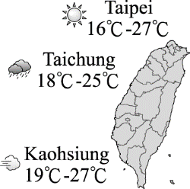  (A) | 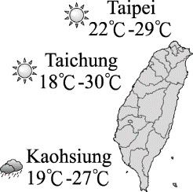  (B)  ) | 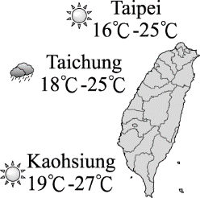  (C)  )

2.
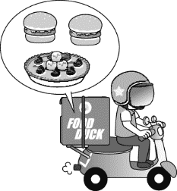  (A) | 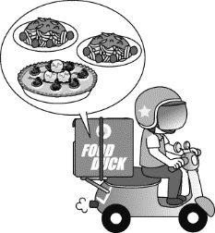  (B)  ) | 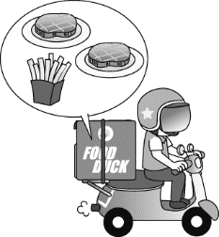  (C)  )
3.
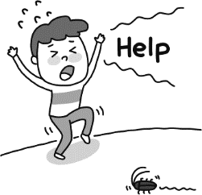  (A) | 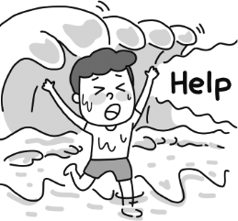  (B)  ) | 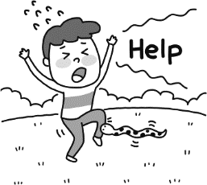  (C)  )
4.
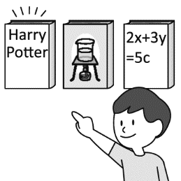  (A) | 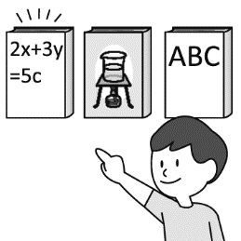  (B)  ) | 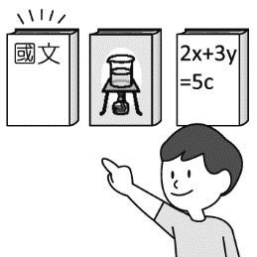  (C)  )
二、基本問答：
請根據聽到的內容，選出一個最適合的回應句 4%
5. (A)Sure. It looks yummy.
(B) Yes. It is very cold.
(C) Yes. I'd like the ham and cheese sandwich.
6. (A) Yes. I don't like the steak.
(B) I would like it medium, please.
(C) We want two steaks, please.
7. (A) You can say that again. It looks like fun.
(B) Let's go inside the house then.
(C) Sure. Safety is the most important.
8. (A) They are the most beautiful ants of all.
(B) Keep away from them.
(C) Kick their nest down and then run away.
三、言談理解:
請根據聽到的內容與問題，選出一個最適合的答案 12%
9. (A) He is a waiter.
(B) He is a clerk.
(C) He is an actor.

10. (A) It is very interesting.
(B) It is very easy.
(C) It is very difficult.
11. (A) It’s cheaper than the other two bags.
(B) His daughter likes its color.
(C) It’s the most popular of the three.
12. (A) They are not sure.
(B) The Burj Khalifa in Dubai.
(C) Taipei 101.
13. (A) The man can’t play the guitar.
(B) The man works as a security guard during the night.
(C) The woman plans to be a fashion designer.
14. (A) Get equal chances.
(B) Do all kinds of traditionally male jobs.
(C) Don’t talk about equal pay.

●綜合測驗 ( 15-51 題 ) 60%
一 、單字選擇 10%
15. Candy treated me to a ______ meal at a nice restaurant.
We had a wonderful day. How nice she is!
(A) spoon (B) greenhouse (C) fork (D) delicious
16. I was scared because one of my friends almost _____ in the swimming pool yesterday.
(A) drowned (B) healthy (C) strong (D) real
17. Eating noodles with _____ is not easy for foreigners.
(A) beef (B) toast (C) butter (D) chopsticks
18. It’s ______ to walk or play on the road. Don’t do that.
(A) nothing (B) worried (C) dangerous (D) kind
19. We can’t get the table into the room. The door is not ____ enough.
(A) far (B) wide (C) popular (D) below
20. To keep healthy, my grandma walks ten ____ a day.
(A) miles (B) grams (C) inches (D) centimeters
21. Leo ____ the ball in the classroom and broke the window. The teacher was very angry with him.
(A) told (B) kicked (C) bit (D) felt
22. Please buy some _____for me in the bakery on your way home.
(A) bread (B) rocks (C) snakes (D) nests
23. Many people like to sit on the ____ and have a picnic on a sunny day.
(A) meat (B) dish (C) team (D) grass
24. The cofffee cost me one hundred dollars. And it ____ terrible.
(A) tasted (B) sounded (C) answered (D) raised
二、文法選擇 20%
25. Turkey is ________ than Taiwan.
(A) so big and cold (B) bigger and colder
(C) the biggest and coldest (D) very big and colder

( 背面尚有試題 ) p.1
26. I make less money than _____. He makes NT$2000, but I only make NT$1500.
(A) he (B) he is (C) he was (D) he does
27. How does Linda look today? She is _____happier than yesterday.
(A) very (B) many (C) a lot of (D) much
28. A: _________________________?
B: Yes. I’d like two hamburgers and one pumpkin pie.
- Can I talk to you?
- May I take your order?
- How do you like your breakfast?
(D) Are you ready to go to the supermarket?
29. To Rose, playing cards ________ than playing video games.
(A) are more interesting (B) are very interesting
(C) is more interesting (D) is many interesting
30. Many people tried it and couldn’t tell it ____ real meat because it tastes just ____ the real thing.
(A) about;likely (B) from; like
(C) from; likely (D) to; like
31. A: Typhoon is coming soon. Are you still going surfing
later?
B: No. ___________________________.
(A) I’m not worried at all.
(B) I don’t think that typhoon will come.
(C) It’s better to be safe than sorry.
(D) It’s nothing special. I don’t care.
32. Of the three stories, the one about the haunted house was
_______. I couldn’t fall asleep after hearing it.
(A) more scary (B) the more scary
(C) most scary (D) the scariest
33. A: Be careful of red fire ants. _________________.
B: Yes, I agree with you.
(A) They are so small; their bites can never cause death.
(B) Killing them with hands is the fastest way.
(C) They are the most dangerous ants of all. Let’s not get
close to them.
(D) Let’s find their nest and kick it down.
34. Which sentence (句子) is correct?
- Jim and Jenny look like brother and sister.
- Sandy is become healthy after she started to exercise.
(C) Everything get more and more expensive.
(D) The soup turned coldly in just ten minutes.

三、克漏字選擇 8%
(35-38)
Dora: How do you like living in a big city?
Tony: I like it so much more than living in the country.
Dora: Oh, really? Can you give me some examples?
Tony: Well, it is 35. out in the city than in the country.
There is so much more to do and see!
Dora: Yes, but the city is more dangerous than the country.
Tony: That’s true. People in the city aren’t 36 those in
the countryside.
Dora: I’m sure that life in the country is more relaxing, too.
Tony: However, life in the country is 37. than in the
city.
Dora: I think it’s a good thing.
Tony: Oh, I don’t think so. The country is so boring.
Dora: How about the cost of living? Is living in the country
38. ?
Tony: Oh, yes. Living in the city is more expensive.
35. (A) interesting (B) very interesting
(C) less interesting (D) more interesting
36. (A) as friendly as (B) more friendly
(C) the most friendly (D) very friendly
37. (A) very slower (B) much slowly
(C) a little slower (D) the slowest
38. (A) more relaxing than in the city
(B) more interesting than in the city
(C) more expensive than in the city
(D) cheaper than in the city
四、閱讀題組測驗 22% ( 39-42 每題1分； 43-51 每題2分)
(39-40)
Hank took some tests last week. Here are his grades.
Hank is a junior high school students. He likes math and science, but he doesn’t like English. He always crams for English test. Last week, he didn’t do well on English test. He was a little sad. Hank was afraid that his parents and teachers might be angry with him. In fact, they were worried about him.  After the test, Hank made up his mind to study harder than before.  He wanted to get good grades in English and he won’t study at the last minute anymore. | 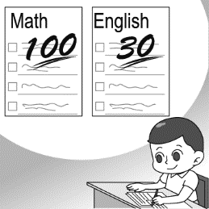  March 15, 2022
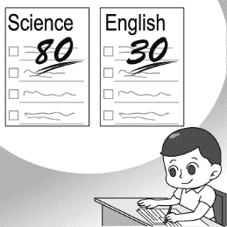
March 16, 2022
39. Hank got the best grade in math, but the worst grade was_________.
(A) Chinese (B) English (C) Math (D) Science
40. What does “cram for “ mean in the reading?
(A) Do the best. (B) Take it easy.
(C) Study harder. (D) Study at the last minute.

(41-42)
Guinness World Records (金氏世界紀錄) only knows of 10 people taller than 243 cm, and the tallest of them is a farmer in Turkey. His name is Sultan Kose. He is 251 cm tall. He first broke this world record in 2009. At the time, he was 246.5 cm. He kept growing until he did a surgery (手術) in 2010. He also holds the record for the largest hands of a living person; each one is 28.5 cm from the wrist (手腕) to the tip of the middle finger. “I’m in the book. It’s amazing! I dreamed about it before, but it is still a big surprise now.” said Sultan.
41. According to the reading, which is true?
(A) Sultan Kose is a driver from Turkey.
(B) More than 10 people are taller than Sultan Kose.
(C) Sultan Kose is the tallest man in the world.
(D) Sultan Kose did a surgery in 2009.
42. How tall is Sultan Kose?
(A) 243 cm. (B) 246.5 cm. (C) 28.5 cm. (D) 251 cm.
( 試題尚未結束) p.2
(43-44)
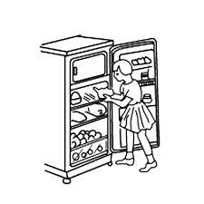 | R1  Size:466×530 ×786 mm  Weight: 35 kg  Color: silver  Door:1  Price: NT$6,000  Capacity:90 l
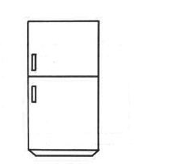 | R2  Size:546×654 ×1490 mm  Weight: 54 kg  Color: black: white  Door:2  Price: NT$15,000  Capacity:240 l
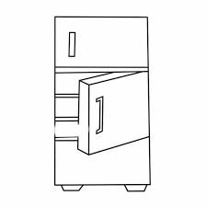 | R3  Size:776×784 ×1830 mm  Weight: 98 kg  Color: red  Door:3  Price: NT$35,000  Capacity:615 l
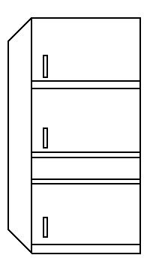 | R4  Size:720×696 ×1820 mm  Weight: 98 kg  Color: pink  Door:4  Price: NT$40,000  Capacity:500 l
43. Lily and her mother need a refrigerator for their new house.
They hope it doesn’t cost more than twenty thousand dollars.
Which refrigerator can they buy?
- R1 or R2. (B) R2 and R3.
(C) R3 or R4. (D) R1 and R4.
44. Which is true?
(A) R1 is heavier than R3.
(B) R3 is as heavy as R4.
(C) R2 is even cheaper than R1.
(D) R4 is less expensive than R3.
(45-46)
I’m Dancing with Tears in My Eyes

I watch those who dance to joy around me on the floor.
They look so happy tonight.
Though their eyes are full of light and love,
Mine are in tears.

My heart is aching,
Because the girl in my arms isn’t you.
I’m dancing with somebody new,
When it’s you that my heart’s calling to.

Trying to smile once in a while,
I feel my heart is aching more.
I’m dancing with tears in my eyes,
Because the girl in my arms isn’t you.
tear 眼淚
45. When one’s heart is aching, how does he or she feel?
(A) Funny. (B) Sad. (C) Proud. (D) Excited.
46. What can we know about the song?
(A) The writer is going to look for the girl he really loves.
(B) The writer does not notice the people around him.
(C) The writer doesn’t love the girl he is dancing with.
(D) The writer has a good time with the girl in his arms.

(47-51)
Traveling to some countries in Europe, you may be surprised at the food that has become popular these days. Take a close look at what you eat; you might be eating bugs! More and more countries in Europe and America are trying to make insects a part of their diet. For some countries, eating insects has been in their food culture for a long time. If you don’t eat insects, you may have to do so soon.
Scientists have said that eating insects may be the best way to save the population. There will be more than 9 billion people in the world by 2050. We won’t have enough food for everyone by then if we keep producing food the way that we do now. Insects are easy to be raised and are rich in protein. What’s more, they’re eco-friendly. Insects needs less food and water than cows, but they have more protein. That means you use the same water and food, but you get a lot more protein from insects. Also, they give out less gas than cows do. They may be an important food in the future.
For most people who have never eaten insects, it may be hard to take a bite of the bugs on their plates. So, cooks are trying hard to make insects look delicious. For example, they make insects into burgers and meatballs. Give them a try. You’ll love it!

population 人口 billion 十億 produce 製造；生產
protein 蛋白質
47. The writer wrote, “If you don’t eat insects, you may have to
do so soon.” What does the writer mean?
- Insects may be a common food in the near future.
- All the burgers will be made of insects.
- If you don’t eat insects, you can’t take a trip to Europe.
- There will be very few people raising insects for food.
48. What have scientists said about eating insects?
(A) Eating insects is healthier than eating cows.
(B) Insects taste good when they’re made into burgers.
(C) Insects can be a famous dish if cooks work harder.
(D) It may be the best way to save the population.
49. According to the reading, which is true?
(A) There will be more than 9 billion people in the world by
2050.
(B) We will have enough food for everyone by 2050.
(C) Insects may not be a kind of important food.
(D) Insects are hard to be raised and are not rich in protein.
50. What is close in meaning to “eco-friendly”?
(A) Nice to friends.
(B) Bad for insects.
(C) Helpful to the environment and the earth.
(D) More popular and friendly.
( 試題尚未結束) p.3

51. What’s the best title for the reading?
(A) Travel in Europe.
(B) Eat Bugs, Save the Earth.
(C) Make Insect Burgers.
(D) Western Food Culture.
●非選擇題 20%
(請用黑筆作答並將答案寫在右方答案卷中)
- 單字 5%

題號 | 中文 | 英文
1. | 便利的
2. | 菜單
3. | 公斤 | k m
4. | 喊叫
5. | 女服務生

二、填空 ( 請寫出下列形容詞的比較級和最高級) 5%

原級 | 比較級 | 最高級
wet | 6. | 7.
yummy | 8. | 9.
little | less | 10.

三、翻譯填空 10%

1. 我可以點牛排加薯條嗎?
May I have the __(1)__with __(2)___?

2.藉由這樣做，就不會有動物喪命。
__(3)__ doing so, no animals lose their __(4)__.

3. 遠離他們是現在最好的辦法。
__(5)__ away from them is the __(6)__ idea for now.

4. 每件事都很完美直到一個可怕的意外發生。
Everything was perfect __(7)__ a terrible ___(8)___
happened.

- 在他們為他做CPR後，Cody 變得有意識了。
Cody __(9)__ __(10)__ after they did CPR on him.

( 試題結束 ) p .4

土城國中 110年度 第二學期 第一次段考
英語科（八年級）非選擇題 答案卷

班級:_______ 座號:_____ 姓名:____________

- 單字 5%

題號 | 中文 | 英文
1. | 便利的
2. | 菜單
3. | 公斤
4. | 喊叫
5. | 女服務生

- 填空 ( 請寫出下列形容詞的比較級和最高級) 5%

6.
7.
8.
9.
10.

三、 翻譯填空 10%

1. | (1) | (2)
2. | (3) | (4)
3. | (5) | (6)
4. | (7) | (8)
5. | (9) | (10)

( 試題結束 ) p .4

土城國中 110學年度第二學期 第一次段考 (八年級) 英語科 解答 (A)

●選擇題 80% ( 1-8 每題1分；9-14每題2分； 15-24 每題1分;
25-38 每題2分；39-42 每題1分；43-51 每題2分 )
1 | 2 | 3 | 4 | 5 | 6 | 7 | 8 | 9 | 10
C | A | B | A | C | B | C | B | B | C
11 | 12 | 13 | 14 | 15 | 16 | 17 | 18 | 19 | 20
A | B | C | A | D | A | D | C | B | A
21 | 22 | 23 | 24 | 25 | 26 | 27 | 28 | 29 | 30
B | A | D | A | B | D | D | B | C | B
31 | 32 | 33 | 34 | 35 | 36 | 37 | 38 | 39 | 40
C | D | C | A | D | A | C | D | B | D
41 | 42 | 43 | 44 | 45 | 46 | 47 | 48 | 49 | 50
C | D | A | B | B | C | A | D | A | C
51. |  |  |  | .
B

●非選擇題 20%
一、單字 5 %
題號 | 中文 | 英文
1. | 便利的 | convenient
2. | 菜單 | menu
3. | 公斤 | kilogram
4. | 喊叫 | shout
5. | 女服務生 | waitress
二、填空 ( 請寫出下列形容詞的比較級和最高級) 5%
6. | wetter
7. | wettest
8. | yummier
9. | yummiest
10. | least

三、翻譯填空 10%
1. | (1) steak | (2) fries
2. | (3) By | (4) lives
3. | (5) Staying  (Keeping) | (6) best
4. | (7) until | (8) accident
5. | (9) became | (10) conscious

土城國中110學年度 第二學期 第一次段考 (八年級 )英文聽力稿
- 辨識句意：請根據聽到的內容，選出符合描述的圖片
- The weather in Kaohsiung is hotter than the weather in Taipei.
- I’ll have two hamburgers and one strawberry pie with ice cream.
3. A big wave hit Jimmy and he started to struggle. He shouted for help.
4. Of the three subjects, English is the easiest for Harry.

二、基本問答：請根據聽到的內容，選出一個最適合的回應句
5. May I take your order?
6. How would you like your steak?
7. Outdoor safety is important. Always be careful when you go out.
8. What should we do when we meet Red Fire Ants?

三、言談理解: 請根據聽到的內容與問題，選出一個最適合的答案
9. W: Excuse me. Do you have spoons for kids?
M: Sure. We have two kinds of spoons for kids. You can see them at the checkout. What else do you need?
W: Are there any chopsticks for kids, too?
M: Sorry, we just sold the last pair yesterday afternoon.
W: That’s OK.
Q: What does the man do?

10. M:English is so hard, especially Lesson Two. Lesson Two is more difficult than Lesson One.
W: How come?
M: I can’t understand what the teacher is talking about.
W: Well, don’t worry. Come to me after class. I can help you with that.
M: That’s very kind of you.
Q: What does the boy think about English?

11. M: Do you have any bags for girls? I want to buy one for my daughter.
W: Sure. These are the three popular ones in our shop.
M: How much is the pink one? My daughter likes pink.
W: They are all $1000, but the blue one is on sale now. It’s only $500.
M: OK. Then I’ll take the blue one.
Q: Why did the man take the blue bag?

12. M: Is Taipei 101 the tallest building in the world?
W: Not anymore. It was the tallest before. Today, the Burj Khalifa is the tallest.
M: The Burj Khalifa? Where is it?
W: Come on. You don’t know that?
M: No.
W: It is in Dubai. It is the tallest and most popular building in the world now.
Q: Which is the tallest building in the world now?

13. M:Did you always want to be a hairdresser?
W: No, but it allows me to be creative. Besides, it helps with my fashion designs.
M: What? Are you also a fashion designer?
W: Not yet, but I’m working on it. That’s my dream job.
M: That’s cool! I work as a security guard during the day, and my nights are for making music.
W: What instrument do you play?
M: I play the guitar.
Q: Which is true?

14. M: There are now more women in the workforce than men.
W: Yes. Women are doing all kinds of traditionally male jobs like cook, taxi driver, and
videographer.
M: I think getting equal pay for equal work is important.
W: That’s right. Women should also get equal chances to move to higher positions.
M: Yeah, I agree.
Q: What should women do to move to higher positions?

