新北市立土城國民中學110學年度第二學期第三次段考八年級英語科試題

第一部分：聽力測驗20% (共15題，1-10每題1分；11-15每題2分)
一、請選出聽到的單字。
1. (A) spoons | (B) knives | (C) chopsticks
2. (A) feet | (B) inches | (C) miles
3. (A) light | (B) news | (C) noise
4. (A) sick | (B) useful | (C) helpful
5. (A) smart | (B) simple | (C) honest
二、根據聽到的內容，選出適合的回應。
6. | (A) No worries. I’m good.
 | (B) Don’t be afraid. You are safe here.
 | (C) It’s okay. You should believe in yourself.
7. | (A) Much better, thanks.
 | (B) I will take some cold medicine.
 | (C) I stayed at home and slept a lot.
8. | (A) No. It’s so dark here.
 | (B) Yes. Where is it coming from?
 | (C) Wow. You have a good sense of smell.
9. | (A) Jack did.
 | (B) Jack can jump really far.
 | (C) Jack jumped the highest.
10. | (A) I agree. It looks like fun.
 | (B) Let’s go inside the house then.
 | (C) Sure. It’s better to be safe than sorry.
三、請根據聽到的對話與問題，選出最適合的答案。
11. | (A) She’ll see a movie.
 | (B) She’ll study for a test.
 | (C) She’ll take a rest.
12. | (A) The skirt will be on sale next week.
 | (B) The skirt is too expensive for her to buy.
 | (C) The skirt is too long for her.
13. | (A) She feels lonely at school.
 | (B) She’s not interested in drawing pictures.
 | (C) She just started going to a new school.
14. | (A) Shopping for clothes for one another.
 | (B) Sharing ideas for the party.
 | (C) Asking for each other’s ideas.
15. | (A) Use designated garbage bags.
 | (B) Throw away the general garbage at the convenience store.
 | (C) Don’t sort out garbage and put it in the garbage truck.

第二部分：綜合測驗 80%
一 、語法選擇 44% (共22題，每題2分)
16. | 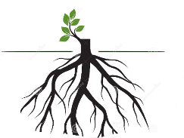  What are under the ground?
 | (A) flowers | (B) leaves
 | (C) roots | (D) fruit
17. | Joe is an _____ boy and everybody likes him.
 | (A) honest | (B) wise
 | (C) healthy | (D) happy
18. | My brother _____ to go to the party with me. In fact, he will drive me there.
 | (A) forgot | (B) raised
 | (C) agreed | (D) passed
19. | My doctor told me to _____ medicine three times a day.
 | (A) eat | (B) drink
 | (C) have | (D) take
20. | Don’t _____ the same mistake over and over again!
 | (A) do | (B) make
 | (C) create | (D) produce
21. | Taking the bus is _____ than riding the bike.
 | (A) more convenient | (B) conveniently
 | (C) convenient | (D) most convenient
22. | The skirt looks _____ on her.
 | (A) good | (B) well
 | (C) nicely | (D) really
23. | My daughter _____ happy because her boyfriend bought her a beautiful ring.
 | (A) looked like | (B) felt like
 | (C) turned | (D) smelled
24. | Zac is taller than Zoe. Zoe is taller than John. It means that Zac is the tallest _____.
 | (A) than the three | (B) of the two
 | (C) than every one | (D) of the three
25. | Mom always tells me that staying away _____ the dangerous things is the best.
 | (A) to | (B) with
 | (C) by | (D) from
26. | Tom: Oh, baby! Please don’t break up with me! I can’t live _____ you!  Mary: I’m sorry but you will find a better girlfriend.
 | (A) with | (B) by
 | (C) without | (D) for
27. | Mr. Lin _____ me close the windows. It’s too cold in the classroom.
 | (A) wanted | (B) asked
 | (C) had | (D) told
28. | I didn’t know the answer, so I chose ____ the question.
 | (A) not to answer | (B) answering
 | (C) to answer | (D) didn’t answer
29. | If the weather _____ good this weekend, we will go swimming.
 | (A) was | (B) will be
 | (C) are | (D) is
30. | My mom _____ us a call if she _____ late.
 | (A) gives; works | (B) will give; will work
 | (C) gives; will work | (D) will give; works
31. | Dora found _____ was a dog sleeping under the sofa.
 | (A) that | (B) there
 | (C) he | (D) X
32. | There is nothing special in this shop, _____ _____?
 | (A) is there | (B) isn’t there
 | (C) is it | (D) isn’t it
33. | Tina has two sons and _____ of them are very tall.
 | (A) two | (B) both
 | (C) one | (D) all
34. | They seldom showed up for class on time, _____ they?
 | (A) didn’t | (B) do
 | (C) did | (D) don’t
35. | Although Ben is not rich, _____ he is very generous.  generous 慷慨的
 | (A) but | (B) X
 | (C) so | (D) and
36. | It is so cold, and now I feel like _____ some hot chocolate milk.
 | (A) drinking | (B) drank
 | (C) to drink | (D) drink
37. | Most of the food in the box _____ smelly! What happened?
 | (A) are | (B) is
 | (C) become | (D) turn

二、 克漏字選擇 10 % (共5題，每題2分)
Cathy: Who’s this man in the picture? And why is he in women’s clothes?
Ryan: That’s not a man. She’s the famous model, Kaur.
Cathy: Why does she have a big beard like that?
Ryan: She has a medical condition, and that causes hair to grow on her face. She tried to remove it, but it just kept growing back. 38 , she hated her beard before. People always made fun of her. But now, she is learning to love the hair on her face.
Cathy: I see. Models like her are not that common, are they?
Ryan: She might not be one of those “common” models, but I like her. Although many people laughed at her and told her that she’s not pretty enough or thin enough to be a model, 39 . She still became a model.
Cathy: Wow! I think she has a really strong will.
Ryan: You’re right. Now she wants to let the world know that women come in different shapes and sizes, and they are all beautiful. 40

model 模特兒 beard 鬍子medical condition 疾病 remove移除 will意志
38. | (A) Luckily | (B) Sadly | (C) Actually | (D) Probably
39. | (A) it didn’t hold her back
 | (B) she always kept that in mind
 | (C) it made her hide her true self
 | (D) she tried hard to break gender stereotypes
40. | (A) Don’t make excuses.
 | (B) Take good care of yourself.
 | (C) Never let others define you.
 | (D) Being a model is never easy.
(Nicole is reporting the weather on TV.)
Nicole: How’s the typhoon in Taiwan now? Let’s hear from Eddy in Hualien. Hello, Eddy.
Eddy: Hi, everyone. I am at the beach. Now the wind is really strong. I can still see several people 41 here and watch the waves. It’s quite dangerous.
Nicole: I can hear the strong wind blowing hard.
Eddy: That’s right. It also blew down a house. Wait! I can see some pots flying in the sky.
Nicole: Oh, how terrible!
Eddy: Stay home and don’t go out. If you are outside, please try to find a place to save 42 .
41. | (A) stand | (B) stood
 | (C) are standing | (D) to stand
42. | (A) yours | (B) you
 | (C) your | (D) yourself

三、閱讀測驗 26 % (共13題，每題2分)
Something to Chew on
Humans have four different types of teeth. Young children have about 20 teeth called milk teeth. They have eight teeth called incisors at the front of the mouth (four above and four below). These can cut food. The next four sharp, pointed teeth are canines, they can tear food. Next to these are the premolars, used for grinding and chewing. Between the ages of 5 and 10, these milk teeth are replaced by adult teeth, that include another 12 teeth called molars. These are also used for chewing.
tear 撕裂 grind磨 chew咀嚼 be replaced被取代
include包含
43. | According to the article, how many teeth does an adult should have in total?
 | (A) 10 |  | (B) 12 |  | (C) 20 |  | (D) 32
44. | 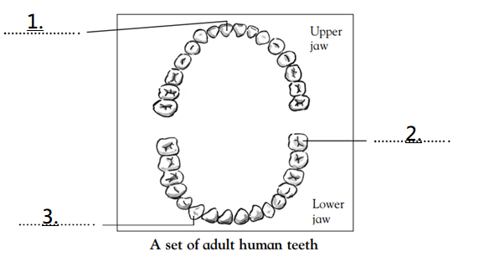  Animals that eat meat have canines and incisors to cut and tear meat. Animals that eat plants have large, flat teeth called molars for grinding and chewing. Humans eat both meat and plants. What kind of teeth do humans have? Level each type of tooth in the picture below.
 | (A) | premolar |  | canine |  | molar
 | (B) | incisor |  | premolar |  | molar
 | (C) | molar |  | canine |  | incisor
 | (D) | incisor |  | molar |  | canine

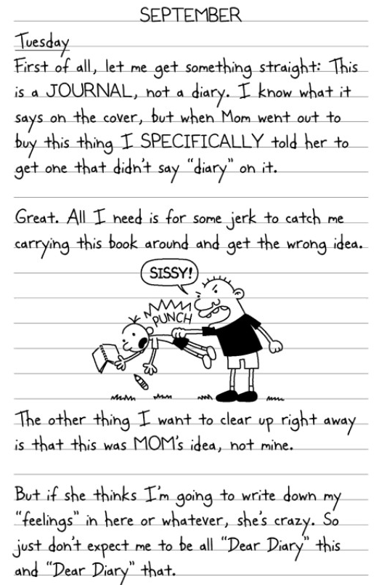

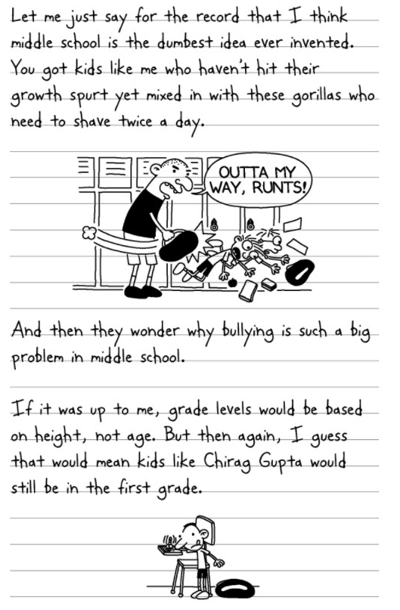

specifically 特地 dumbest 最愚蠢的 growth spurt 成長 gorillas 大猩猩bullying 霸凌 height 身高
45. | According to the reading, which is likely to be true?
 | (A) The writer likes his mom’s idea to write a diary.
 | (B) The writer is probably in the 8th grade.
 | (C) Chirag Gupta is the strongest kid in the 1st grade.
 | (D) In the writer’s school, small and weak students are in the same grade.
46. | The writer may be unhappy with his middle school life. Why?
 | (A) Because he is not specifically strong and other people may hurt him.
 | (B) Because he has to write the diary every day.
 | (C) Because he has no friends at school.
 | (D) Because there are scaring animals like gorillas in his school.

Students collected and recorded the weight of old newspapers for 5 months. Read the following graph and answer the questions.
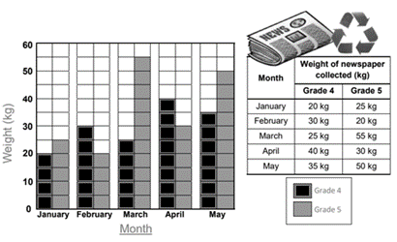
47. | What may be the best title for the graph?
 | (A) Newspaper Collection by Grade 4 and 5 Students.
 | (B) Students can Collect Newspapers.
 | (C) Love the Earth!
 | (D) Stop Reading Newspapers and Save the Trees!
48. | In which month did Grade 5 students collect the least newspapers?
 | (A) January
 | (B) February
 | (C) April
 | (D) May
49. | How many months did Grade 5 students collect more newspapers than Grade 4 students?
 | (A) 1 month
 | (B) 2 months
 | (C) 3 months
 | (D) 5 months
50. | What is the difference between the total collection of Grade 4 and Grade 5?
 | (A) 30 kg
 | (B) 150 kg
 | (C) 180 kg
 | (D) 330 kg

Being Forceful
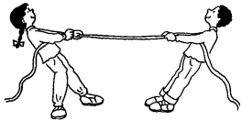
Pushes and pulls are forces. When you push or pull something, you can make it start or stop moving. For example, tug-of-war is a pulling game and kickball is a pushing game. Look at the following pictures and answer the questions.
tug-of-war 拔河

 | (A) 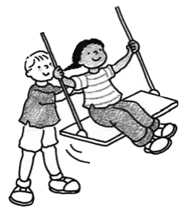 |  | (B) 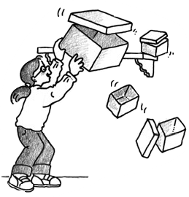
 | (C) 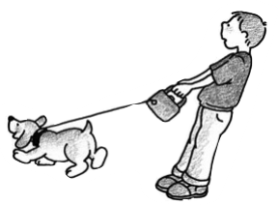 |  | (D) 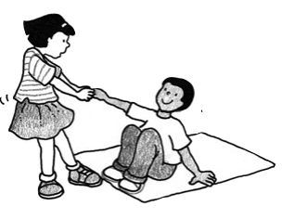
51. |  | In which picture that the person uses the force “push” to “start”?
52. |  | In which picture that the person uses the force “pull” to “stop”?

In every country in the world, people treat women differently from men. Women get less pay than men for the same work. They’re also less likely to reach top positions at work. Women even have to take time off work to have a child, but men don’t. And it’s not just at work. In some countries, women still don’t have the right to vote. And all too often, men even hurt women.
We call this gender discrimination, and it affects the lives of women and girls everywhere. This is all bad for their well-being. However, although people live in countries that gender discrimination is worsen, they are denying that it’s a problem! They don’t even feel it at all! How does this make sense? To find out why people – especially women- deny that gender discrimination happens, we carried out three different studies with over 20,000 people. The results are:
- When women deny gender discrimination, they are happier with their lives.
- When women felt that they faced gender discrimination, they were not happy with their lives.
- Men deny discrimination more than women.
- People were more likely to deny gender discrimination in countries with higher level of sexism! (See Fig. 1) For example, people living in Russia were more likely to deny it than people living in France.

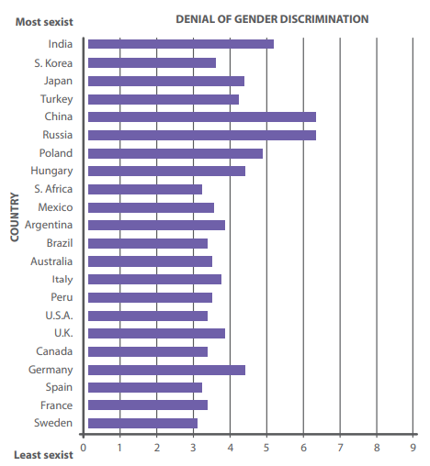
Fig. 1
Gender discrimination is a terrible problem across the world. But we found that when women deny discrimination, they are actually happier. Probably this is a way to make them feel comfortable. But it actually makes gender discrimination even worse. These days, gender discrimination can be a little bit harder to spot. For example, women are far more likely to be stopped while speaking than men are. They also face more sexual harassment at work. People may not even know they’re behaving in a sexist way – but that doesn’t excuse them.
It is not easy for women – especially in countries with higher gender inequality – to face gender discrimination. It is much more difficult to change it! But we shouldn’t deny it, we should fight it. And this isn’t just a problem for women – everyone should take action!
position職位 vote投票 discrimination歧視 affect 影響 deny拒絕 sexism 性別歧視inequality不平等 harassment騷擾
53. | According to Fig. 1, which is likely to be true?
 | (A) It is very common that people of different gender in India get the same pay for the same work.
 | (B) People living in countries with lower level of sexism do not have gender discrimination.
 | (C) Sexism is not common in Asian countries, such as India, S. Korea and China.
 | (D) People in Sweden feel comfortable because gender equality matters.
54. | What may NOT be the same meaning of well-being in this reading?
 | (A) sadness | (B) happiness
 | (C) safety | (D) health
55. | What may be the best title for this reading?
 | (A) Why do some women deny gender discrimination?
 | (B) Things will get better if we deny gender discrimination.
 | (C) How to stop gender discrimination?
 | (D) Ways to define gender discrimination.

試題結束

