新北市立土城國民中學108學年度第2學期 第2次段考 英語科 (8年級)試題

【試題共4頁】
第一部分聽力測驗共28%
- 辨識句意：根據聽到的內容選出符合描述的圖片
(每題1%，共6%)
- ( )
(Ａ) 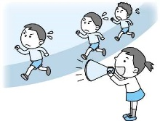(Ｂ) 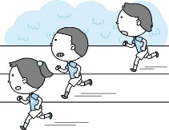(Ｃ) 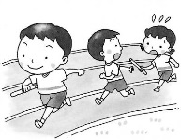
- ( )
(Ａ) 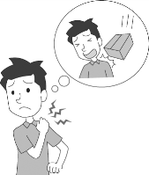(Ｂ) 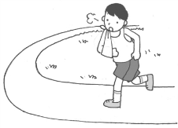(Ｃ) 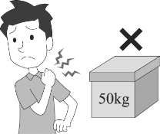
- ( )
(Ａ) 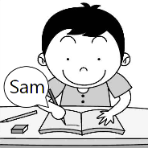(Ｂ) 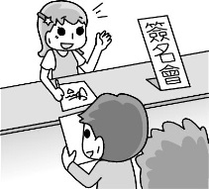(Ｃ) 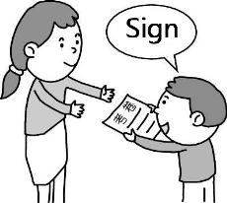
- ( )
(Ａ) 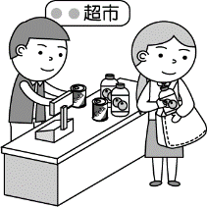(Ｂ) 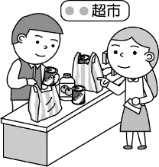(Ｃ) 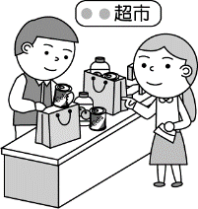
╲
7-11
- ( )
(Ａ) 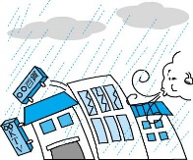(Ｂ) 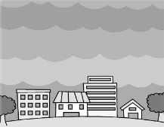(Ｃ) 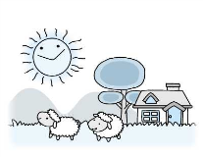
- ( )
(Ａ) 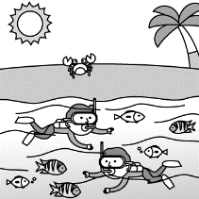(Ｂ) 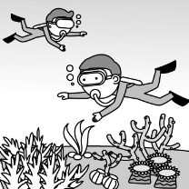(Ｃ) 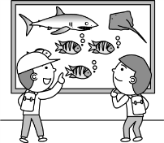

- 基本問答：根據聽到的內容選出一個最適合的回應
(每題2%，共10%)
- ( )(Ａ) He is a nice son.
(Ｂ) He always rides carefully.
(Ｃ) He fell from the bike and broke his legs.
- ( )(Ａ) I’d like to because I play the guitar well.
(Ｂ) She’ll get much better soon.
(Ｃ) Let’s take her back to her place.
- ( )(Ａ) I’ll pay for the plastic bags.
(Ｂ) I’ll eat at home more often.
(Ｃ)I’ll buy lots of clothes on the Net.

10.( )(Ａ) What’s wrong with you?
(Ｂ) Sure. Please help yourself.
(Ｃ) Excuse me. How may I help you?
11. ( )(Ａ) I like the way you express your love.
(Ｂ) We are going out for dinner tonight.
(Ｃ) A bouquet of red roses would be nice.

三、言談理解：根據聽到的內容選出一個最適合的答案
(每題2%，共12%)
12. ( )(Ａ) The girl is wiping the glass bowls carefully.
(Ｂ) The girl asks the boy not to break the glasses.
(Ｃ) The girl needs to walk slowly, or she might
break the things in the box.
13. ( )(Ａ) She is in Taitung.
(Ｂ) She is in Taipei.
(Ｃ) She is in Hualien.
14. ( )(Ａ) He called the police for the woman.
(Ｂ) He shouted at Mary’s daughter.
(Ｃ) He heard Mary shouting.
15. ( )(Ａ) The girl’s father.
(Ｂ) Someone lives in a town or a city.
(Ｃ) The trash in the garbage bag.
16. ( )(Ａ) A whale family.
(Ｂ) A sick pilot whale.
(Ｃ) A pilot whale’s favorite food.
17. ( ) (Ａ) Order a cup of coffee.
(Ｂ) Buy “Doraemon”comics.
(Ｃ) Play Switch with classmates.

第二部分綜合測驗共52%
- 單字、文法與對話 (每題2%，共34%)
18. ( ) An alpaca(羊駝) has a longer ________ than a sheep.
- shoulder (B) cut (C) neck (D) knee
19. ( ) We must take _________ to do something for Mother
Earth.
(A) action (B) promise (C) word (D) habit
20. ( ) Bringing our own shopping bags can help ________
the amount(數量) of plastic garbage.
(A) to reduce (B) rise (C) sort (D) to promise
21. ( ) Ryan’s bedroom is _________, but his living room is
so dark.
(A) clear (B) bright (C) giant (D) careful
22. ( ) Emma didn’t have lunch, so she ________ hungrily now.
(A) feels (B) is eating (C) is looking (D) looks
23. ( ) More and more junior high school students go to bed _________.
- latest (B) last (C) lately (D) late

【請翻頁繼續作答】
24. ( ) Of all the students here, Ivan sings _________.
(A) loudly (B) more loudly
(C) loud (D) loudest
25. ( ) Our teachers always tell us ________ honest on
each and every test.
- be (B) being (C) to be (D) to being
- ( ) Bryan looked _______ at health center because he
looked _______at the nurse and didn’t say anything.
- nervous ; nervously (B) sadly ; sadly
(C) nervously ; nervous (D) sadly ; sad
27. ( ) A: Who has to take care of the fish today?
B: Harry ___________.
(A) has (B) does (C) do (D) is
- ( ) To keep healthy, we should _______ enough water
and have regular meals every day
(A) drank (B) to drink (C) drink (D) drinking
29. ( ) Eva’s son _______ her _______ lunch yesterday.
A. Have you ever noticed that a male driver seldom asks for directions? In fact, according to an interesting study, men drive an extra 444 kilometers on average a year because they don’t ask for help when they are lost.
The study looked into a group of male and female drivers. Over 25% of the men would wait thirty minutes and then ask for directions. However, 12% of the men would never ask for help. What’s more, 40% of the men wouldn’t follow the directions from the strangers. The extra driving time would cost them nearly NT$80,000 over their whole lives. On the other hand, almost 75% of the women drivers wouldn’t have any problems asking for directions. Moreover, 37% of them would even pull over and ask for help right away as soon as they are lost.
On your next trip with a friend, how about going with a female driver? This way, you guys are likely to save much driving time. ※ extra 額外的 /average 平均 / direction 方向
(A) made ; to cook (B) let ; to cook
(C) had ; cooks (D) helped ; cook
30 ( ) A: Honey, look at my belly. I feel our baby ________.
B: Oh yes! How magic!
(A) to move (B) moves (C) moved (D) moving
31. ( ) We enjoy watching NBA players _______basketball.
(A) play (B) played (C) to play (D) plays
32. ( ) A: Max can’t drive us to the train station.
B: That’s not a problem. ___________________.
(A) Sounds nice. (B) We really enjoyed ourselves.
(C) We can go by ourselves. (D) It’s not clear at all.
33. ( )Dad: You can keep a puppy as a pet, but you must take good care of it.
Son: Sure. ___________________.
(A) I don’t get it. (B) I’ll eat my words.
(C) I’ll keep it in mind. (D) Please sign here.
34. ( ) You guys won third place in the swimming race!
________________.
- Way to go! (B) Go ahead!
(C) Let’s cheer them up! (D) Give it a try!


五、文意選填 (每題1%，共4%)
What can we as students do to save Mother Earth? We can do a lot! ______(35)______ Here are some examples:
- ___(36)___ We can walk, ride a bike, take a bus, or take the MRT. Driving less is a great way to help our earth.
- ___(37)___ Bring our own cup or water bottle. Also, bring our own shopping bags. These are all good ways to reduce the trash.
- Remember to turn off our TV, CD player, computer and lights when they are not in use.
___(38)_____ This way, we can have a cleaner and
healthier earth. Let’s do our best!
35. ( )(A Teachers have students sort the trash every day.
- Just some little changes can help Mother Earth a
better place to live.
(C) We can make a promise and sign our name here.
(D) We can eat less meat and plant more trees.
36.( )(A) Share a taxi more often.
(B) Use water more wisely.
(C) Don’t ask our parents to drive us to school.
(D) Be early to school and clean up the classroom.
37.( )(A) Drink more water to be healthier.
(B) Stop using disposable(一次性的) cups and plastic bags.
(C) Don’t buy drinks with sugar.
(D) Sort the trash and throw it away every day.
38.( )(A) I got it ! I couldn’t agree with you more.
(B) It’s no use to make changes in our daily life.
(C) Keep this in mind: It’s too late to save the earth.
(D) We should make these changes a habit in our life.
六、閱讀測驗 (每題2%，共14%)
39. ( ) According to the reading, which statement is TRUE?
(A) Female drivers only turn to other women for help.
(B) Most of the female drivers tend to (傾向於) find
their way out as soon as possible.
- Men and women use the same strategy(策略) to
solve the driving problems.
(D) Men like to solve the problem with others’ help.
40. ( ) What does “pull over” mean in the reading?
(A) To stop driving a car.
(B) To race with other drivers.
(C) To drive the car to the roadside.
(D) To push the car from the backside.
41. ( ) Which is NOT TRUE?
(A) 40% of the men would skip strangers’ help.
(B) 75% of the female drivers ask for directions.
(C) Men would drive extra 444 kilometers a year
because they seldom ask for help.
((D) Only 12% of the men ask for help when they are
lost. 【請換頁作答】
B.
Some Rumors about COVID-19
Now, almost everyone on earth is afraid of COVID-19, but it’s a time for facts, not for rumors. On the Internet, there are numerous ways which teach us how to keep ourselves from getting Coronavirus. However, not every one of them is true. Let’s take a look at some of them.
※ rumor 謠言/Coronavirus新冠病毒
？ People get COVID-19 from animals, so pets are dangerous to their owners.
Ｘ Wrong. Studies say people might get COVID-19 from certain animals, but it’s not been confirmed. Pet owners don’t need to worry too much. Just keep it a habit to wash your hands after touching your pet in order not to get something bad from the pet, and remember that don’t throw away your pet just because you are afraid of COVID-19. ※ confirm 確認

？ Taking Vitamin C can keep us from getting COVID-19.
Ｘ Wrong. A doctor in the USA said taking vitamin C might keep us from catching a cold, but it’s just an argument. We still need more studies to support this argument. Besides, you will still catch a cold even though you take vitamin C every day, but luckily, you might get well sooner than those who don’t take it.
※ argument 論點

？ Washing your nose with salt water or soap is useful.
Ｘ Wrong. We are not sure if it will be useful so far, and washing our nose cannot stop the virus from entering our other body parts. On the other hand, washing the nose with a soap might hurt our nose. Just make sure that don’t touch your eyes, nose, and mouth before you wash your hands thoroughly.
Next time when you see something like these on the Net, DO check it first and be a wise Internet user.

42. ( ) What CAN’T we learn from the reading?
(A) Vitamin C might be good for us in some ways.
(B) Keeping the pets outside the house would be the
best way for pet owners.
(C) We should be more careful about the information on the Net.
(D) Our nose might get hurt if we wash it with a soap.
43.( ) What does the reading want to tell us?
(A) Taking good care of yourself is prior(優先的) to
helping others.
(B) All the information on the Net is not true.
(C) Don’t believe what you see on the Net easily.
(D) It’s not wise to be a Covidiot. (防疫豬隊友)

C.
It seems that more children in Asian cities wear glasses than children living elsewhere. Is it because Asian people have more vision problems? A scientist, Dr. Morgan, studied this phenomenon and found some interesting facts.
Indian kids in Singapore wear glasses as much as the other kids in Singapore. But for those Indian kids who grow up in India, they don’t wear glasses that much. Meanwhile, Chinese kids in Australia wear glasses about as much as the other kids in Australia. So, being Asian is not the reason. There must be something else that causes this problem.
Some people say that time spent on reading or looking at small things very closely are the reasons. But, it is not true, according to Dr. Morgan. His answer is light, both any light and sunlight. He says that going out in the sun and looking around are good for our eyes. He even compared two groups of children. One group spent lots of time doing outdoor activities. The other group didn’t. The result showed that the first group had better vision than the second group. But there’s still one problem: The sunlight in both Hong Kong and Singapore is bright all year long. However, why would children in these two cities have worse vision? Dr. Morgan says that children in Singapore don’t like to spend time going outside because it is a tropic place. And children in Hong Kong don’t have enough space to play outside. Furthermore, in these two places, it’s very common for parents to tell their children to study hard. Therefore, these children would not spend much time on outdoor activities.
In fact, we all need sunlight. When we go outside and get some sunlight, something good happens in our body. Vitamin D will be created, and it helps make our bones stronger and our immune system more powerful to fight against diseases. So, getting enough sunlight is very important, for our vision and body.
※ vision視力 / phenomenon現象 / cause導致 /
compare 比較 / tropic 熱帶的 / bone 骨頭 /
diseases 疾病 / immune system 免疫系統
44.( ) Which is TRUE?
(A) Sunlight is very important for us.
(B) Being Asian is the main reason for worse vision.
(C) There are more glasses on Indian children’s faces.
(D) Asian children spend less time studying.
45.( ) What CAN we know from Dr. Morgan’s studies?
(A) Vitamin D is no use for our body.
(B) Children in tropic places have better vision.
- In Singapore, there are not enough places for
children.
(D) Children spending more time outdoors have better
vision than those who stay indoors.
【選擇題到此結束，請換原子筆並翻面繼續作答】
第三部分非選擇題共20% (請直接書寫)
班級: 得分:
-----------------------
20
姓名:
座號:

六、單字(每題1%，共7%)
1. _______________接力賽 (n.)
2. _______________帶來 (v.)
3. _______________大自然 (n.)
4. _______________秒(n.)
5._______________相同的(adj.)
6._______________
I am an American, but I can eat with c__________ks
very well.
7._______________
Living in a city is more c_______t. You can always find many sorts of things to eat and drink at midnight.

七、完成以下副詞與其比較級表格(每格1%，共5%)
形容詞 | 副詞 | 副詞比較級
bad | badly
terrible
early |  | earlier
happy | happily

八、翻譯填空與翻譯 (每格1%，句子每題2%，
共8%)
1. 坐而言不如起而行。
___________ speak ___________ than words.
2. 你可以幫我丟垃圾嗎?
Could you __________ me throw away the (g)___________?
3.他們看見許多漂亮的魚在海裡悠游。(請使用過去式)
_____________________________________________________________________________________________________

4. 我們決定要許下減少垃圾的承諾。(請使用現在式)

【試題結束，請仔細檢查答案】【~預祝考試順利~】

新北市立土城國中108學年度第二學期第二次段考 八年級英語科 Listening Scripts

一､辨識句意：根據聽到的內容，選出符合描述的圖片
The girl runs faster than the boys in the 100-meter race.
Paul hurt his shoulder, so he couldn’t carry heavy boxes.
The writer signed her name on the novels for her fans.
Using your own shopping bag helps reduce trash.
It’s very cloudy, so we won’t see the sun rise later.
They went snorkeling and saw many fish swimming around them.

二、基本問答：根據聽到的內容，選出一個最適合的回應句

7. What’s the matter with the little boy?

8. Linda got sick and went back home this morning. Someone needs to take her place, or we might lose the talent contest.

9. Anna, what do you plan to do to save more money?
10. Excuse me. May I get one more cup of orange juice?
11.What can I get my girlfriend for Valentine’s Day, Sean?

三、言談理解：根據聽到的內容，選出一個最適合的答案
12. G: Why do I have to hold this box carefully and walk slowly?
B; Because there are glass bowls in the box. You can’t break them.
Q: Which is true?
13. M: Where are you now, Judy?
W: I am in Taitung.
M: Aren’t you in Hualien?
W: No, that was yesterday. I stayed in the Taroko National Park to see the beautiful view there.
M: Thank, God. I watched the news on TV just now. I saw the rocks rolling down in the National Park.
Q: Where is Judy now?
14. M: I heard Mary shouting at her daughter. What happened?
W: She didn’t come home right after school and took away two books at the bookstore.
M: Oh, she can’t do that!
Q: Which is true about the man?
15. M: Jessica, you should sort the trash. Don’t put the glasses and the bottles in the same garbage bag.
W: You are like Dad. He has me reduce the trash, sort the trash, and bring my own chopsticks when eating out.
M: That’s what we should do as a citizen of the Earth.
Q: What does the word “citizen” mean?
16. B:Yesterday was Earth Day, and Ms. Chen played a video of a baby pilot whale.
G: What was the video about?
B: The poor whale was lying on the beach because it ate many plastic bags. The whale’s stomach was full of plastic bags.
He was almost dead.
Q: What are they talking about?
17. In a bookstore, we can find many books about people, history, science and many other subjects. Sometimes we can also find
comic books, too. Besides, a bookstore sells other things like cards, pens and stickers. It even sells games and toys. Some
bookstores have a café. We can buy a drink and spend some time reading a book there.
Q: What CAN’T we do in a bookstore?
新北市立土城國民中學108學年度第2學期第2次段考8年級英語科試題解答
選擇題
1 | 2 | 3 | 4 | 5 | 6 | 7 | 8 | 9 | 10
B | C | B | A | B | A | C | A | B | B
11 | 12 | 13 | 14 | 15 | 16 | 17 | 18 | 19 | 20
C | C | A | C | B | B | C | C | A | A
21 | 22 | 23 | 24 | 25 | 26 | 27 | 28 | 29 | 30
B | B | D | D | C | A | B | C | D | D
31 | 32 | 33 | 34 | 35 | 36 | 37 | 38 | 39 | 40
A | C | C | A | B | C | B | D | B | C
41 | 42 | 43 | 44 | 45
D | B | C | A | D

非選擇題
六、單字(每題1%)

1. relay race 2. bring 3. nature 4. second
5. same 6. chopsticks 7. convenient

七、完成以下副詞與其比較級表格(每格1%)
形容詞 | 副詞 | 副詞比較級
bad | badly | worse
terrible | terribly | more terribly
early | early | earlier
happy | happily | more happily

八、翻譯填空與翻譯(每格1%，句子每題2%)

1. 坐而言不如起而行。
__Actions___ speak ___louder__ than words.
2. 你可以幫我丟垃圾嗎?
Could you __help__ me throw away the ___garbage___?
3.他們看見許多漂亮的魚在海裡悠游。They saw many pretty(beautiful) fish // swim(ming) in the sea.
4.我們決定要許下減少垃圾的承諾。 We decide to make a promise // to reduce trash.

