新北市立土城國民中學110學年度第二學期 第二次段考 英語科（八年級）

●聽力測驗 ( 1-14題) 20% ( 本試題共4頁 )
一、辨識句意：請根據聽到的內容，選出符合描述的圖片 4%
1.
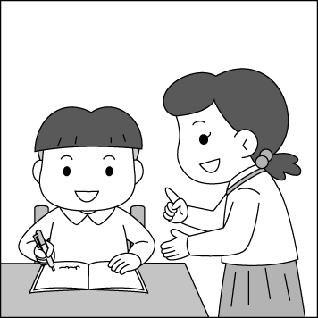  (A) | 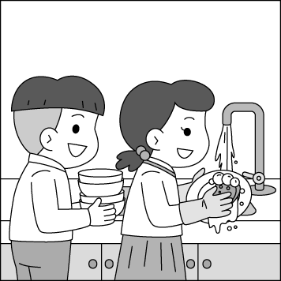  (B)  ) | 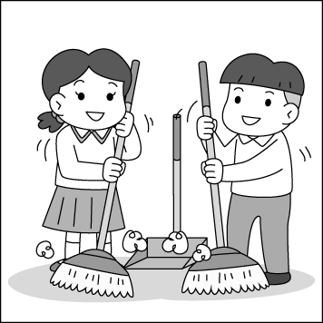  (C)  )
2.
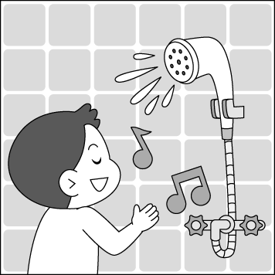  (A) | 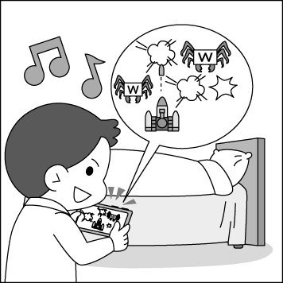  (B)  ) | 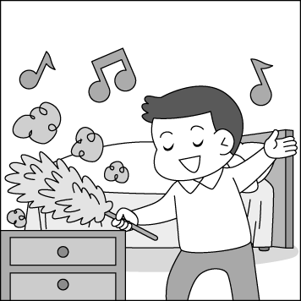  (C)  )
3.
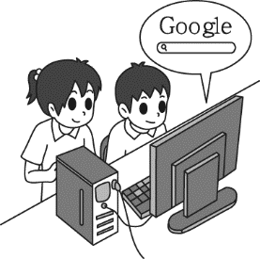  (A) | 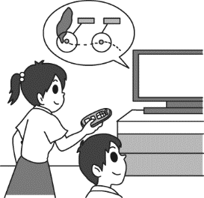  (B)  ) | 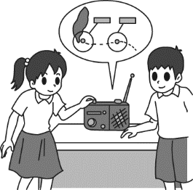  (C)  )
4.
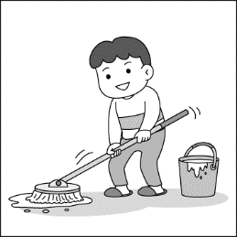  (A) | 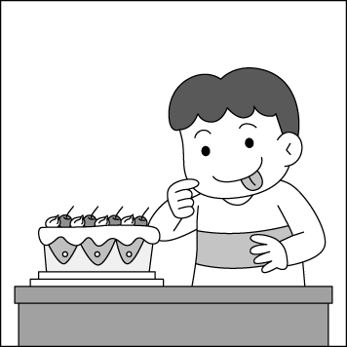  (B)  ) |   (C)  )

二、基本問答：
請根據聽到的內容，選出一個最適合的回應句 4%
5. (A) She was very busy this morning.
(B) She had nothing to do.
(C) She had me clean the table.
6. (A) I practiced the hardest.
(B) I played the worst of all.
(C) I worked more carefully than others.
7. (A) I got some drinks and snacks from the supermarket.
(B) I am ready to go shopping with you.
(C) I heard someone sing the song at the party.
8. (A) Of course not. Going hiking is interesting.
(B) Yes, I will go to the park.
(C) No, I won’t. It’s too dangerous.
三、言談理解:
請根據聽到的內容與問題，選出一個最適合的答案 12%
9. (A) His classmates.
(B) His little brother.
(C) His friend, Wendy.

10. (A) The party starts at eight thirty.
(B) The girl will not go to the party.
(C) Jacky can help the girl finish her homework.
11. (A) Because there’s a fire.
(B) Because there’s an earthquake.
(C) Because there’s a typhoon coming soon.
12. (A) People care about the typhoon very much.
(B) It is very dangerous to go out at night.
(C) People shouldn’t go to the beach during a typhoon.
13. (A) Saint Patrick’s Day is on March 7.
(B) Saint Patrick’s Day is not a religious holiday.
(C) People always dress themselves in green to celebrate
Saint Patrick’s Day.
14. (A) The woman won’t let the man get to work.
(B) The woman tried hard to clean the kitchen sink.
(C) Something is stuck in the pipe.

●綜合測驗 ( 15-52 題 ) 60%
一 、單字選擇 10%
15. Ms. Lin makes five _____ more money than Mr. Lin.
(A) sizes (B) ponds (C) times (D) pears
16. Sandy had a bad cold last night. She is still too _____ to go mountain climbing with you.
(A) young (B) quickly (C) bitter (D) weak
17. When the teacher was not in the classroom, the students talked loudly and made a lot of _______.
(A) excuses (B) break (C) light (D) noise
18. We can see the fish in the river very ______ because the water is clean.
(A) clearly (B) lovely (C) lonely (D) hardly
19. The girl is too short. She can’t _____ the top of the bookshelf.
(A) trick (B) pick (C) reach (D) share
20. Happy birthday, my dear son. Now, blow out the ____ on the cake after making a wish.
(A) grapes (B) candles (C) spaces (D) mouses
21. I think the best way to _______ my English is to pay attention in class, study hard and practice speaking English every day.
(A) turn (B) protect (C) sense (D) improve
22. You can use the ______ when you take a photo indoors.
(A) turtle (B) mice (C) flashlight (D) peach
23. Henry saved a little girl from the _______ dog.
(A) mean (B) survivor (C) slowly (D) meat
24. Our teachers ______ all the students the same.
(A) treat (B) cause (C) produce (D) break
二、文法選擇 20%
25. I think the road ends here; it won’t go any _______.
Shouldn’t we turn back?
(A) closer (B) farther (C) faster (D) longer
( 背面尚有試題 ) p.1
26. We____ enter the dark room because it’s too dangerous.
(A) has to (B) mustn’t (C) shouldn’t be (D) might be
27. Jacky looked_______ at the instant noodles because he didn’t eat anything today. He is as _____ as a bear now.
(A) hungrily ; hungrier (B) angry; angrily
(C) hungrily ; hungry (D)wisely ; wiser
28. A: What time did the boy have to get up this morning?
B: _______________________
- He can get up at 6:30.
- He has to get up at 6:30.
- He didn’t have to get up at 6:30.
(D) He had to get up at 6:30.
29. A: ______________________
B: I like payayas the most.
(A) Which fruit do you like the most?
(B) How many papayas do you eat?
(C) Do you like papayas?
(D) Why do you like papayas?
30. A: Did you enjoy _______ at the welcome party?
B: Yes. We had a very good time.
(A) yourself (B) yourselves (C) myself (D) ourselves
31. Mr. Brown _____ his son to do homwork every day. (選錯)
(A) helps (B) tells (B) wants (D) makes
32. They are watching some insects _______ up the tree.
(A) will climb (B) climbs
(C) climbing (D) to climb
33. Drivers shouldn’t _____ a cellphone when _____.
(A) using ; driving (B) to use ; drives
(C) use ; driving (D) use ; drives
34. Which sentence (句子) is correct (正確的)?
- Joe and Jenny often help his father washing the car.
- Tina always asks her students behave themselves.
(C) Andy made his son to clean the bathroom this afternoon.
(D) Jason works most carefully of all the workers.

三、克漏字選擇 10% (35-38 每題1分； 39-41 每題2分)
(35-38)
(in the living room)
Mom: It’s time to go to bed. Why are you still watching TV?
Amy: I’m waiting for some big news. If the typhoon __35. tomorrow, we won’t need to go to school.
Mom: A typhoon holiday! It’s for you, not for me.
Amy: Why not?
Mom: Before dinner, I moved the roses inside the house, or
the strong wind 36. .
Amy: Is that all?
Mom: Of course not. I bought some food from the supermarket this afternoon. If I don’t buy any food,
37. .
Amy: Did Dad drive you to the supermarket?
Mom: No, he was as busy as a bee in the office, so 38. .
Amy: Poor Mom! You tried your best to do so much for Dad and me. I love you so much. You’re truly my best mother.
Mom: You finally got to know it.
35. (A) hit Taiwan (B) gets stronger and stronger
(C) stopped raining (D) keeping hitting Taiwan
36. (A) might be bright (B) might become less and less
(C) might be stronger (D) might blow them away
37. (A) we might have nothing to eat during a typhoon
(B) we may go on a picnic during a typhoon
(C) there is still some food in the refrigerator
(D) there are so many snacks on the table
38. (A) he drove me there
(B) I stayed at home and watched TV
(C) he did some shopping for us
(D) I rode a scooter there by myself

(39-41)
Dora: What a cute dog! Do you know anything about it?
Lily: You asked the right person! She is Lele, the smallest rescue dog in the world. In Taiwan, we have many of them, and we train them 39. .
Dora: It’s new to me. What do you know about the dog?
Lily: Let me tell you some. In an earthquake rescue , we often see them 40. their job quickly. Their sense of smell is 41. better than ours, so they can
find survivors or dead bodies much more easily.
Dora: Wow! They really help people a lot.
Lily: That’s true. They are very smart. They are truly our best friends.
39. (A) themselves (B) ourselves (C) myself (D) itself
40. (A) doing (B) did (C) does (D) done
41. (A) thousand of times (B) thousand times
(C) thousands of times (D) a thousand times

四、閱讀題組測驗 20% ( 42-43 每題1分； 44-52 每題2分)
(42-44)
Wind
I saw you toss the kites on high
And blow the birds about the sky;
And all around I heard you pass,
Like ladies’ skirts across the grass –
O wind, a blowing all day long,
O wind, that sings so loud a song!

I saw the different things you did,
But always you yourself hid.
I felt you push, I heard you call,
I could not see yourself at all –
O wind, a-blowing all day long,
O wind, that sings so loud a song!

O you that so strong and cold,
O blower, are you young and old?
Are you a beast of field and tree,
Or just a stronger child than me?
O wind, a-blowing all day long,
O wind, that sings so loud a song!

-- Robert Louis Stevenson

toss 上拋
( 試題尚未結束) p.2

42. If Zoe wants to draw a picture for the poem, what may it be?
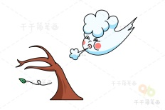  (A) | 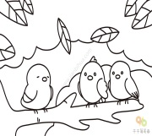  (B) | 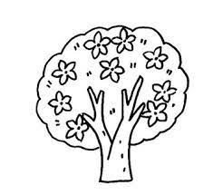  (C) |   (D)
43. What is not mentioned (提到) in the poem?
(A) The bird. (B) The kite. (C) The field. (D) The bell.

44. Which is NOT true about the poem?
(A) The wind is like ladies’ skirts across the grass.
(B) The writer couldn’t see the wind.
(C) The wind always hides itself.
(D) The writer couldn’t hear the wind blowing.

(45-46)
If you’re a fan of chocolate like I am, then you know the delicious treat not only tastes good but is also good for you. However, there’s a dark and sad side to chocolate, and few people know about it. What can be dark about something that’s so delicious?
Cocoa is the main thing in chocolate, and most of the cocoa comes form small farms in West Africa. I don’t know if you know this, but children between 10 to 16 years old or even younger, have worked as slaves on those farms. In fact, the practice has been around for many years, and little has changed.
These days, over two million children are working in the fields of Ghana and the Ivory Coast. Instead of having fun and enjoying school, these children work long hours in dangerous and tiring environments. They may have to carry heavy loads, spray cocoa trees with pesticides, and burn fields to clear them. These are surprising, right?

Even worse is the fact that many of the children in the cocoa industry were sold to the farms to pay off their families’ money problem. Sometimes they are even stolen from their parents, never to see them again. I know I can do something to help those poor children and still enjoy my chocolate treat. With that in mind, I have decided not to buy chocolate from the companies which employ child workers.

slave 奴隸 spray 噴灑 pesticide 農藥 industry 工業
stolen 被偷走的 employ 雇用

45. What is the reading mainly about?
(A) The lives of cocoa farmers.
(B) Child workers in the cocoa industry.
(C) A popular dessert in West Africa.
(D) Good and bad points about chocolate.
46. Which is NOT true about the children in the chocolate
industry?
- Most of them are between the ages of 10 to 16.
- They have no choice but to work long hard hours.
- There are at least two million child workers in West
Africa.
- They work in safe and healthy environments.

(47-49)
Fear Is the Best Medicine
Do you like reading ghost stories or watching scary movies? Do you go to hunted houses just to feel your heart beating? Some people are like that; they like to feel scared, but why? Dr. Margee Kerr and her team have found the possible reason behind that. For years, Dr. Kerr has been studying several hunted places. She also helped set up a haunted house on Halloween. More than 200 people bought tickets and agreed to be a part of the study. Dr. Kerr then studied those people’s feelings and brain activities before and after going into the haunted houses. Although the haunted house was so scary that it made their hair stand on end, most people came out feeling happier and less tired. Dr. Margee Kerr and her team found out that getting scared is like doing exercise. It helps lower brain activities. So people can be less worried. The study also showed that being afraid can help put people in a good mood.

haunted house 鬼屋 brain 大腦 activity 活動
mood 心情

47. How do people feel when something “ make their hair stand on end”?
(A) They feel happy.
(B) They feel afraid.
(C) They feel excited.
(D) They feel less tired.
48. What is the reading mainly about?
- The reason behind people’s interests in being scared.
- Exciting scary movies for people to watch.
(C) The fear of watching scary movies.
(D) The cause of people’s lower brain activities when
feeling scared.
49. Here is some information from another study. What does this study and the reading have in common?
A study shows that when we watch scary movies, it helps our body burn about 113 calories. It is as much as taking a thirty-minute walk. calorie 卡路里
- They both show that getting scared is a way to lose weight.
- They both show that understanding your fear is important.
- They both show that getting scared can be good for people in a way.
- They both show that facing fear is good exercise to keep the brain busy.
(50-52)
Anna Jarvis was American, and she had a very kind mother. At that time, there was a war between the north and the south of America. Because many people got hurt in the war, Ann’s mother went to the hospital and took care of them. To make people show love to each other, she started “ Mother’s Friendship Days” after the war.
Anna loved her mother very much and she always helped her with the housework. However, Anna’s mother died on the second Sunday of May in 1905. Anna was very sad about

( 試題尚未結束) p.3
her mother’s death. In 1907, she asked the government to make a holiday legal to remember her mother and all the others’. In 1914, the day became a national holiday and all the people in the USA celebrated it with a lot of activities.
On Mother’s Day, children show thanks to their mothers in many different ways. Some may make beautiful cards and draw pictures of their mothers. Some may help with the housework, like doing dishes, mopping the floor, or taking out garbage. Many people may send carnations to their mothers because they are in full bloom in May.
Mother’s Day falls on Sunday, May 8, 2022. What did you do on Mother’s Day ? Did you give Mom a warm hug? Did you do anything special to show love to your mother on Mother’s Day? If not, remember to show your love to your mother. In fact, everyday can be Mother’s Day. You can show love to your mother anytime and anywhere. After all, Mom is the greatest person and she loves you like no one else does. Let’s show love to dear Mom.
war 戰爭 government 政府 legal 合法的
carnation 康乃馨 bloom盛開
50. Who started “ Mother’s Friendship Days”?
- Anna Jarvis. (B)Anna’s friends.
(C) The government. (D) Anna’s mother.
51. What can we learn from the reading?
(A) People should show their love to mothers.
(B) Everyone should celebrate national holiday.
(C) People have to take care of those who get hurt.
(D) It’s important to buy flowers on Mother' Day.
52. According to the reading, which is true?
(A) In 1907, Mother’s Day became a national holiday.
(B) Anna went to the hospital on Mother’s Day.
(C) In 1914, Anna asked the government to make a holiday legal to remember her mother.
(D) Anna’s mother died on the second Sunday of May in 1905.
●非選擇題 20% (請用黑筆作答並將答案寫在答案卷中)
- 單字 (中翻英) 10%
題號 | 中文 | 英文 | 題號 | 中文 | 英文
1. | 蔬菜  (n.) |  | 6. | 陽台  (n.)
2. | 閃耀  (v.) |  | 7. | 服務  (n.)
3. | 選擇  (v.) | c | 8. | 機會  (n.) | c
4. | 巨大的  (adj.) | g | 9. | 勇敢地  (adv.)
5. | 西瓜  (n.) |  | 10. | 彩虹  (n.)

二、翻譯填空 10%
1. 瓊斯先生對我們很差，沒有他我們可以過得比較好。
Mr. Jones treats us (1) . We can live (2)
(3) him.

2. 他們比大部分成人還努力工作，但一天只領到大約
65分錢。
They work (4) than most (5) , but only get
about 65 (6) a day.

3. 他們走過穿越瓦礫和尖銳的玻璃。
They walk (7) (8) and (9) glass.

4. 我可以看到街道的樹正在搖晃。
I can see the trees on the street (10) .

土城國中 110年度 第二學期 第二次段考
英語科（八年級）非選擇題 答案卷
班級:_______ 座號:_____ 姓名:____________

一、單字 10%

題號 | 答案 | 題號 | 答案
1. |  | 6.
2. |  | 7.
3. |  | 8.
4. |  | 9.
5. |  | 10.

二、 翻譯填空 10%

1. | (1) | (2) | (3)
2. | (4) | (5) | (6)
3. | (7) | (8) | (9)
4. | (10)

( 試題結束 ) p .4

土城國中 110學年度第二學期 第二次段考 (八年級) 英語科 解答 (A)

●選擇題 80% ( 1-8 每題1分；9-14每題2分； 15-24 每題1分;
25-34 每題2分；35-38 每題1分；39 -41 每題2分；
42-43 每題1分；44 -52 每題2分 )
1 | 2 | 3 | 4 | 5 | 6 | 7 | 8 | 9 | 10
A | A | C | B | C | B | A | C | B | B
11 | 12 | 13 | 14 | 15 | 16 | 17 | 18 | 19 | 20
B | C | C | A | C | D | D | A | C | B
21 | 22 | 23 | 24 | 25 | 26 | 27 | 28 | 29 | 30
D | C | A | A | B | B | C | D | A | B
31 | 32 | 33 | 34 | 35 | 36 | 37 | 38 | 39 | 40
D | C | C | D | B | D | A | D | B | A
41 | 42 | 43 | 44 | 45 | 46 | 47 | 48 | 49 | 50
C | A | D | D | B | D | B | A | C | D
51 | 52 |  |  | .
A | D

●非選擇題 20%
一、單字 10%

題號 | 答案 | 題號 | 答案
1. | vegetable | 6. | balcony
2. | shine | 7. | service
3. | choose | 8. | chance
4. | giant | 9. | bravely
5. | watermelon | 10. | rainbow

二、 翻譯填空 10%

1. | - badly | (2) better | (3) without
2. | (4) harder | (5) adults | (6) cents
3. | (7) through | (8) rubble | (9) sharp
4 | (10) swaying

土城國中110學年度 第二學期 第二次段考 (八年級 )英文聽力稿
- 辨識句意：請根據聽到的內容，選出符合描述的圖片
- Tina helped her brother with his math homework.
- Hank was singing happily in the bathroom.
- We should turn on the radio and listen to the latest news.
4 . Steven looked at the cake hungrily.

二、基本問答：請根據聽到的內容，選出一個最適合的回應句
5. What did your mom have you do this morning?
6. How did you do in the volleyball game?
7. What did you prepare for the birthday party?
8. If it rains tomorrow, will you go hiking with us?

三、言談理解: 請根據聽到的內容與問題，選出一個最適合的答案
9. W: There is a night run next Sunday. Let’s join it.
M: I’d like to, but I run very slowly. I am the slowest in my class. I can only run faster than my
10-year-old brother.
W: You don’t need to run fast. Just enjoy your time there.
M: Maybe you are right, Wendy. I’ll give it a try.
Q: Who runs more slowly than the man?

10. W: What time does the party start,Jacky?
M: Well… It begins at half past eight. Will you come?
W: I am afraid not. I have to do my science homework tonight. It may take me a lot of time.
M: Well, why not do the homework this afternoon? I can come and help you finish it.
W: Really? That will be cool. Then, I think I can finish it early and go to the party with you.
Q: Which is not true?

11. M: Alice, why are you shouting so loudly?
W: Because I feel the house shaking.
M: What? I didn’t feel it.
W: Come on! You should be more alert.
M: Oh, now I feel it. Hide under the table quickly. I will open the door.
W: OK.
Q: Why do the man and the woman sound nervous?

12. M: Did you watch the latest news on TV?
W: No.
M: Someone died at the beach again today.
W: Well, it is so dangerous during a typhoon. People shouldn’t go there.
M: Ya, but some people don’t really care about it.
W: Well, they have to pay for it.
Q: What are the man and the woman talking about?

13. Saint Patrick’s Day is a big holiday for Irish people. It takes place every March 17 and started out as a religious holiday. Over time, it became a celebration of Irish culture. The people there celebrated by going to church. However, that changed with the large Irish populations in North America. They had big public celebrations.
Now, people everywhere turn cities green on Saint Patrick’s Day.
Q: Which is true?

14. M: What’s the problem?
W: The kitchen sink is full of water. I tried cleaning it, but nothing worked.
M: How did you try cleaning it?
W: I used hot water, and then I used vinegar and baking soda.
M: OK. That means something is stuck in the pipe.
W: Do you think that you can get it out?
M: Sure. I just need to get under the sink and take apart the pipe.
W: Great! I’ll let you get to work then.
Q: Which is not true?

